AXIAL COORDINATION INFLUENCE ON THE HYDROGENASE-LIKE ACTIVITY AND REDOX PROPERTIES OF COBALT SUBSTITUTED GLOBINS

Mirco Meglioli ª, Gianantonio Battistuzzi ª, Marco Borsari ª, Antonio Ranieri ^{b},
Carlo Augusto Bortolotti ^{b}, Marco Sola ^{b}

ª Department of Chemical and Geological Sciences, University of Modena and Reggio Emilia, Via Campi 103, 41125, Modena, Italy
^{b} Department of Life Sciences, University of Modena and Reggio Emilia, Via Campi 103, 41125, Modena, Italy
mirco.meglioli@unimore.it

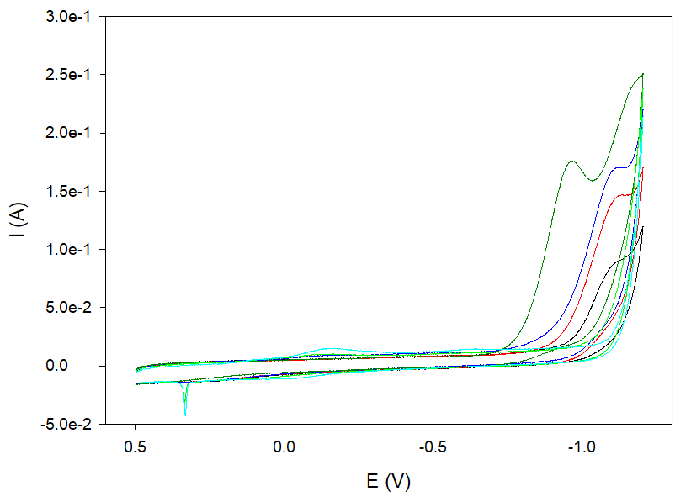
One of the viable alternatives to fossil fuels is green hydrogen, produced by water electrolysis using electricity from renewable sources. Unfortunately, the high overvoltage required for H₂ discharge significantly increases the required energy compared to the theoretical value ^{[1]}. Cobalt coordination compounds have been widely studied as catalysts for H₂ production, due to their ability to reduce the above mentioned overpotential mainly in non-aqueous solvent and aerobic conditions, but they are barely soluble in neutral water. A possible approach to improve their water solubility and maybe their efficiency is to obtain artificial enzymes by embedding these compounds inside protein scaffolds as non-native cofactors ^{[2-4]}. Within this framework, our interest focuses on globins, metallo-proteins that contain a non-covalently bound heme b as prosthetic group. We have replaced the native metal-cofactor with Co(III)-protoporphyrin IX to obtain the corresponding Co-adducts, which were characterized by spectroscopic (UV-Vis, MCD and fluorescence emission) and electrochemical techniques (cyclic and square wave voltammetries with a working pyrolytic graphite electrode). The aim of the work is to understand the influence of axial metal coordination on the electrocatalytic activity of Co-substituted globins towards hydrogen H₂ production and on the redox properties of the Co(III)/Co(II) couple inside the protein scaffold. The investigation was carried on Co-myoglobin complexes featuring water, ammonia, imidazole as Co(III) distal axial ligands and on the bis-histidine Co-adducts of human neuroglobin and its C46AC55A mutant, lacking a structurally relevant intramolecular disulfide bridge.
Figure 1: CV curves for the catalytical reduction of H₃O⁺ on PGE at increasing pH for Co-Mb + imidazole
____
[1] M. El-Shafie, Results in Engineering 2023, 20, 101426.
[2] S. Neya et al., Inorganic Chemistry 2013, 52, 7387-7393.
[3] M. Bacchi et al., Inorganic Chemistry 2014, 53, 8071-8082.
[4] A. Onoda et al., Current Opinion in Chemical Biology 2015, 25, 133-140.

