Cobalt-Globins as possible hydrogen evolution electrocatalysts

Mirco Meglioli* (Presenting and Corresponding Author), Marco Borsari, Gianantonio Battistuzzi, Giulia Di Rocco, Antonio Ranieri, Carlo Augusto Bortolotti and Marco Sola (Co-Author)

Department of Chemical and Geological Sciences, University of Modena and Reggio Emilia,

Via Campi 103, 41125, Modena, Italy

In the current scenario, hydrogen represents one advantageous alternative to fossil fuels due to its unique properties.^{[1]} Green H₂ production relies on the electrolytic water splitting, but its application is limited by the low energy conversion and high costs associated to noble metal electrodes. Over the last few years, several studies have shown that cobalt coordination compounds and bioinorganic catalysts decrease the overpotential associated to H₂ evolution.^{[2,3]} We therefore obtained cobalt-substituted myoglobin and neuroglobin, by replacing heme b with Co(III)-protoporphyrin IX. Both cobalt-globins were characterized with a combination of spectroscopic (electronic absorption, MCD and Resonance Raman) and electrochemical (cyclic voltammetry, square wave voltammetry and chronoamperometry) techniques. The latter were used to analyze the Co(III)/Co(II) redox behavior and the electrocatalytic activity towards dihydrogen evolution from aqueous protons. Upon adsorption onto pyrolytic graphite electrode, both cobalt-globins induce a significant lowering of the overpotential for H₂ evolution and an increase in the intensity of the corresponding electrocatalytic peak. Moreover, the electrocatalytic activity is affected by protein acid-base equilibria and different axial ligands, providing useful hints about the catalytic mechanism of H₂ evolution.^{[4]}

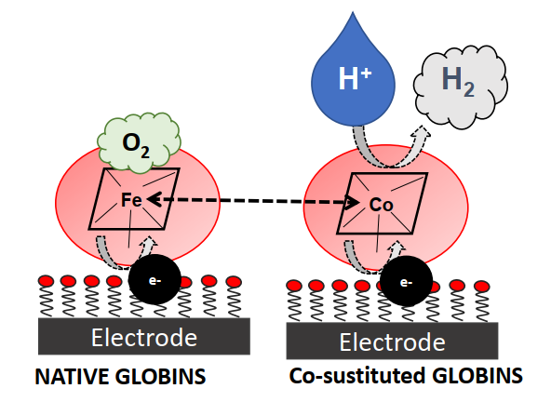

[1] K. Mazloomi, C. Gomes, Renew. Sust. Energ. Rev. 2012, 16, 3024-3033.

[2] S. Neya et al., Inorg. Chem. 2013, 52, 7387-7393.

[3] J. G. Kleingardner et al., J. Am. Chem. Soc. 2014, 136, 4-7.

[4] M. Meglioli et al., ChemElectroChem 2024, e202300821.

