Effect of melt/lithosphere interactions on MORB chemistry at the easternmost Southwest Indian Ridge (61 to 67°E)
M. Paquet^{1*}, M. Cannat¹, D. Brunelli^{2,3}, C. Hamelin⁴, and E. Humler⁵
¹Equipe de Géosciences Marines, Institut de Physique du Globe de Paris, Sorbonne Paris Cité, Université Paris Diderot, UMR7154 CNRS, 1, rue Jussieu, 75238 Paris cedex 05, France
²Dipartimento di Scienze Chimiche e Geologiche, Università di Modena e Reggio Emilia, Via Campi 103, 41125 Modena, Italy
³Institute for Marine Sciences, CNR – ISMAR, Bologna, Italy
⁴Centre for Geobiology, University of Bergen, Allegaten 41 5007, Bergen, Norway
⁵Laboratoire de Planétologie et Géodynamique, UMR 6112, CNRS, Université de Nantes, 2 rue de la Houssinière, 44322 Nantes, France

Corresponding author: Marine Paquet (paquet@ipgp.fr)

Key Points: ultraslow spreading mid-ocean ridges, MORB petrogenesis, melt-mantle reactions

Abstract
The easternmost part of the Southwest Indian Ridge (61°-67°E) is an end-member of the global ridge system in terms of its very low magma supply. As such, it is a good laboratory to investigate the effect of melt-rock interactions on the composition of erupted basalts: for a given volume of erupted basaltic melt, the volume of reacted mantle is potentially greater than at more magmatically robust ridges. We analyzed major, trace element and isotopic compositions in three groups of rocks : plagioclase-bearing ultramafic and gabbroic rocks dredged in nearly amagmatic corridors; basalts from the sparse volcanic cover of these corridors ("ultramafic seafloor basalts"); and basalts dredged from the intervening, more volcanically active domains ("volcanic seafloor basalts"). Ultramafic seafloor basalts have significantly lower CaO and Al₂O₃ contents at a given MgO than most volcanic seafloor basalts. We propose that both types of basalts are derived from similar parental melts, but that the ultramafic seafloor basalts are more affected by reactions between these parent melts and the mantle rocks in the lithosphere below the ridge. We infer that these reactions occur in the walls of conduits that allow the aggregated melts extracted from the melting mantle to rise through the axial lithosphere and to the eruption sites. The principal effect of these reactions is to enrich the asthenospheric melts in MgO through olivine dissolution. This effect is not expected to be as noticeable, but could still play a role in basalt petrogenesis at more magmatic regions of the global slow-spreading MOR system.

1 Introduction
During its ascent beneath mid-ocean ridges, hot mantle material undergoes decompression and partial melting [Bottinga and Allègre, 1973; Carmichael et al., 1974]. Mid Ocean Ridge basalts (MORB) result from the eruption of these melts at the seafloor. Their chemical composition depends on the composition of the mantle source [Jaques and Green, 1980; Kinzler and Grove, 1992a, 1992b, 1993] and on the degree and depth of partial melting [e.g. Dick et al., 1984; Klein and Langmuir, 1987; Langmuir et al., 1993]. However, several other processes also determine MORB composition: mixing and aggregation of melts during their ascent to the eruption site [e.g. Grove et al., 1993], melt/rock interactions in the melting mantle and in the axial lithosphere [e.g. Rubin and Sinton, 2007], and fractional crystallization [e.g. Klein and Langmuir, 1987; Langmuir et al., 1993; Grove et al., 1993]. Unraveling the chemical effects of these processes is key to better constrain the composition of the Earth's mantle. It is also a way to approach the dynamics of mid-ocean ridge magmatic systems. Melt-rock reactions can occur in the melting region, and further up in the cooled mantle lithosphere below the ridge. This paper focuses on the latter, and is based on a petrological and geochemical study of a suite of ultramafic, gabbroic and MORB samples collected on- and off-axis the Southwest Indian Ridge (SWIR) between longitude 61°E and 67°E (Figure 1).
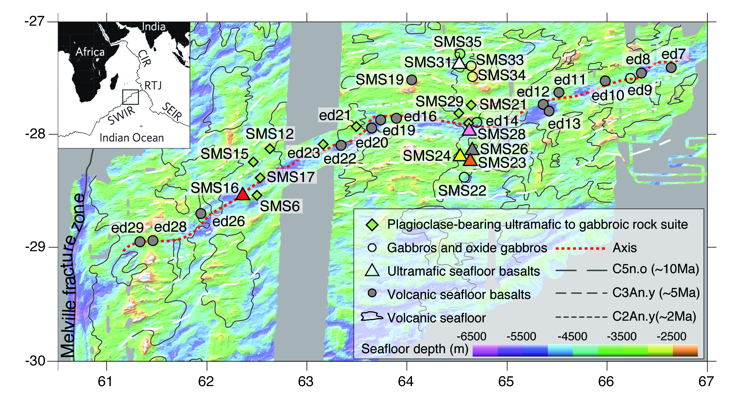

Figure 1. Location of the dredged samples considered in this study on a bathymetric map of the 61° to 67°E region of the Southwest Indian Ridge (east of the Melville FZ). SMS6 to SMS35 are dredges from the Smoothseafloor cruise [Sauter et al., 2013]; ed7 to ed29 are dredges from the EDUL cruise [Mével et al., 1997]. The outlines of the volcanic seafloor domains are from Cannat et al. [2006].

Melt/rock interactions inferred to have occurred in the mantle part of the lithosphere at mid-ocean ridges have been documented from the study of troctolite-olivine gabbro suites sampled in ophiolites [Kelemen et al., 1995, 1997; Borghini et al., 2007; Borghini and Rampone, 2007; Renna and Tribuzio, 2011; Sanfilippo and Tribuzio, 2013; Sanfilippo et al., 2014] and at present-day ridges [Cannat et al., 1990; Suhr et al., 2008; Drouin et al., 2009; Sanfilippo et al., 2013]. The interpretation that prevails, particularly in the most recent studies, is that these troctolite-olivine gabbro suites result from assimilation and fractional crystallization processes involving MORB-like melts and a dunitic residual host rock [e.g. Cannat et al., 1990; Kelemen et al., 1995, 1997; Suhr et al., 2008; Drouin et al., 2009; Renna and Tribuzio, 2011; Sanfilippo and Tribuzio, 2013; Sanfilippo et al., 2013, 2014]. These dunites are proposed by many authors to have formed at an earlier stage, due to the reaction between Si-depleted melts and mantle harzburgite or lherzolite [e.g. Dick, 1977; Hopson et al., 1981; Quick, 1982; Kelemen et al., 1990; Suhr et al., 1999]. Trace element modeling consistently supports a MORB-like chemistry for the melt involved in forming the studied troctolites and olivine gabbros [Suhr et al., 2008; Drouin et al., 2009; Renna and Tribuzio, 2011; Sanfilippo et al., 2013, 2014]. However, the possible effects of such melt-rock interactions on the composition of erupted basalts have not yet been investigated. In fact, several authors suggest that the reacted melts have remained trapped in the axial lithosphere [Godard et al., 2009; Drouin et al., 2009; Renna and Tribuzio, 2011; Sanfilippo et al., 2014], and have therefore no effect on the composition of erupted basalts.
Interactions between MORB-type melts and harzburgitic or lherzolitic mantle peridotites in the axial lithosphere have also been proposed [Cannat and Casey, 1995; Cannat et al., 1995, 1997b; Seyler et al., 2007]. Experimental studies by Tursack and Liang [2012], and Saper and Liang [2014] show that MORB-type melts reacting with residual lherzolites, over the range of temperatures and pressures expected for the base of the mantle lithosphere at slow-spreading ridges, are indeed capable of producing the clinopyroxene-rich mineral assemblages and the textures observed in natural melt-impregnated and reacted mantle rock suites, be they plagioclase-bearing as in the case of the troctolite-olivine gabbro suites, or plagioclase-free. In particular, their experiments produce clinopyroxene oikocrysts that enclose olivine, very similar to what is observed in natural samples [see microphotographs in Suhr et al., 2008; Drouin et al., 2009; or Sanfilippo et al., 2013]. Seyler et al. [2007] proposed that clinopyroxene-rich harzburgites drilled at 15°N at the Mid-Atlantic Ridge (MAR) formed due to a reaction with MORB-like melts, leading to the dissolution of residual orthopyroxene (opx) and its replacement by clinopyroxene (cpx), olivine (ol) and spinel (sp). These authors also proposed that such melt-rock reactions could explain why residual peridotites in the 15°N region of the MAR have more refractory compositions than predicted from the composition of erupted MORBs sampled in the same region. They do not, however, investigate the effects these reactions could have on erupted MORB composition.
In this paper, we discuss the potential for melt-mantle interactions in the axial lithosphere to produce the suite of gabbroic and plagioclase-bearing ultramafic rocks sampled in the study area (Figure 1) and to modify the composition of erupted basalts. The two types of seafloor (volcanic and nearly-amagmatic) exposed in the 61°-67°E SWIR region have been dredged during the EDUL [Meyzen et al., 2003; Seyler et al., 2003], and Smoothseafloor [Sauter et al., 2013] cruises. This study is based on samples from both cruises (Figure 1): plagioclase-bearing ultramafic and gabbroic rocks dredged from nearly amagmatic corridors, basalts dredged from the sparse volcanic cover of these corridors (“ultramafic seafloor basalts”), and basalts dredged from the intervening, more volcanically active domains ("volcanic seafloor basalts"). This sample set allows us to address the following questions: are basalts from nearly amagmatic corridors different from those erupted at the volcanic centers? If so, could the difference be explained by enhanced interactions of the parent melts with residual ultramafic rocks, to produce the plagioclase-bearing ultramafic to gabbroic rock suite? What could then be the range of melt to rock ratio in the melt/mantle reaction zones beneath nearly amagmatic spreading corridors? And what are the consequences of these melt/mantle reactions on the plumbing system? Being aware that these corridors represent an extremely low melt budget end-member for mid-ocean ridges, we then introduce a discussion of the extent to which these observations in the SWIR 61°-67°E region may be significant for other, more magmatically active ridges.

2 Geological and basalt geochemistry background of the study area
The easternmost region of the ultraslow SWIR [~14mm.yr⁻¹; Patriat and Segoufin, 1988] is an end-member of the global ridge system in terms of its very low magma supply. As such, it is a good laboratory to investigate the effect of melt-rock interactions on the composition of erupted basalts: for a given volume of erupted basaltic melt, the volume of reacted mantle is potentially greater than at more magmatically robust ridges.
The low overall melt budget of the SWIR in the 61°-67°E (east of the Melville Fracture Zone) region is supported by the seismic crustal structure [Muller et al., 1999], and by gravity data [Cannat et al., 1999, 2006]. Underway geophysics, seafloor imagery and dredging [Cannat et al., 2006; Sauter et al., 2013] in the 61°-67°E region also show that the modes of seafloor spreading are variable along-axis. There are large volcanic centers, where most the low overall melt influx to the ridge is actually focused [Cannat et al., 2003; Standish et al., 2008], leaving corridors of essentially amagmatic spreading. In these corridors, the seafloor exposes wide expanses of partially serpentinized mantle-derived peridotites, with a small proportion of gabbroic rocks (4% in volume of the dredged material; Sauter et al., [2013]) and a thin and discontinuous basaltic cover (Figure 2). Off-axis dredging shows that mantle-derived material has been continuously exhumed in these corridors over the past 8 to 10 Myrs. The proposed tectonic interpretation is that mantle exhumation is accommodated by successive large offset normal faults that persist for 1 to 3 Myrs and dip alternatively to the north beneath the African-Somalian plate, or to the south beneath the Antarctic plate [Sauter et al., 2013].

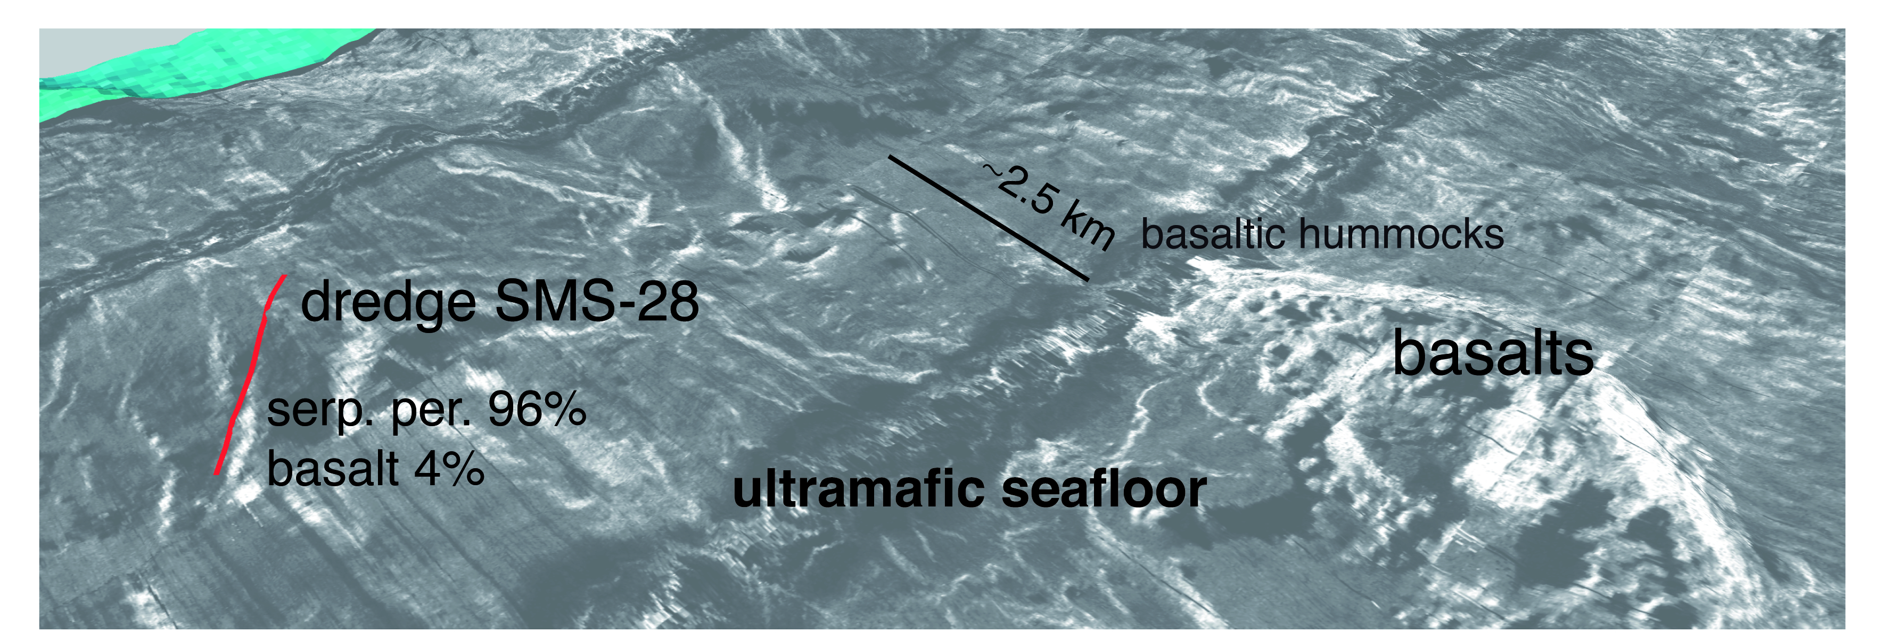

Figure 2. Perspective view of the reflectivity of the axial valley seafloor at 64°E on the Southwest Indian Ridge (side-scan sonar imagery acquired with the Towed Ocean Bottom Instrument, TOBI; Sauter et al., [2013]). The track line for dredge SMS28 is shown in red. The smooth grey areas correspond to outcrops of tectonically exhumed serpentinized peridotites, and the more reflective hummocky areas are basalts directly erupted on these serpentinized peridotites (“ultramafic seafloor basalts”).

Basalt major element compositions [Meyzen et al., 2003; Cannat et al., 2008] also supports a very low degree of melting of the mantle in the 61°-67°E region of the SWIR. Basalt samples included in these earlier studies come from volcanic seafloor domains. They plot at the lowest CaO/Al₂O₃ end of the global MORB trend (which can be interpreted in terms of the degree of partial melting; [Klein and Langmuir, 1987]). They also have low FeO contents at a given MgO, and are enriched in most incompatible elements, including Na₂O. However, these basalts differ from the global MORB trend in that they contain significantly less TiO₂ at a given MgO content, and have peculiar Rare Earth Elements (REE) compositions [Meyzen et al., 2003]. These characteristics have been interpreted by Meyzen et al. [2003] as due to melting of a refertilized depleted mantle. It is worth noting that these east of Melville, volcanic seafloor basalts are similar in major element composition to the so-called low K/Ti basalts sampled in the most oblique section of the SWIR between 9 and 16°E [Standish et al., 2008]. The composition of residual peridotites sampled in the 61°-67°E region also points to complexities in the melting and metasomatic history of the sub-axial mantle [Seyler et al., 2003, 2011], suggesting that low degrees of decompression melting in this region was accompanied by pervasive percolation of enriched liquids produced in the garnet field [Brunelli et al., 2014].

3 Analytical methods
In situ major element concentrations in basaltic fresh glasses and in olivine, plagioclase, clinopyroxene, orthopyroxene and spinel from the gabbroic and plagioclase-bearing ultramafic rocks were measured using the Cameca SX-100 electron microprobe (CAMPARIS service, Paris).
In situ trace element compositions in basaltic samples were determined at Montpellier 2 University on a ThermoFinnigan Element 2 High Resolution-Inductively Coupled Plasma-Mass Spectrometer (HR-ICP-MS) using a single collector double-focusing sector field Element XR (eXtended Range) coupled with laser ablation (LA) system, a Geolas (Microlas) automated platform housing a 193 nm Compex 102 laser from LambdaPhysik.
In situ trace element compositions of clinopyroxene, orthopyroxene and plagioclase in the impregnated and reacted ultramafic rocks were measured at the CIGS (Centro Interdipartimentale Grandi Strumenti) in Modena University on a Thermo Fisher Scientific Quadrupole- Inductively Coupled Plasma-Mass Spectrometer (Q-ICP-MS) XSeries 2 coupled with laser ablation (LA) system UP213.
Nd and Pb isotopic compositions in basalts were measured at Institut de Physique du Globe de Paris using a Thermo-Scientific Neptune.
Details on analytical methods can be found in the Supplementary Materials Text S1.

4 Composition of basalts from volcanic and nearly amagmatic seafloor
We consider the whole set of 110 available basaltic glass samples from 20 dredges at locations shown in Figure 1. Most samples are aphyric, with variable amounts of vesicles. Only 14 of these samples come from six dredges in nearly-amagmatic corridors. The other 96 samples come from 14 dredges in volcanic domains. Of these volcanic seafloor basalt samples, 21 have been analyzed as part of the earlier work of Meyzen et al. [2003, 2005]. We have acquired major and trace element data for the other EDUL cruise samples, as well as for 16 volcanic seafloor and nearly amagmatic seafloor basalt (“ultramafic seafloor basalts”) samples collected during the Smoothseafloor cruise. We also acquired isotopic data for 27 samples (13 from the EDUL cruise, and 14 from the Smoothseafloor cruise). This new isotopic data complements the data published by Meyzen et al. [2005]. Upon publication of this paper, this compiled dataset will be contributed to the Petrological Database [www.earthchem.org/petdb, Lehnert et al., 2000]. A selection of the most representative basalt compositions is presented in Table 1 (see Table S1 for complete dataset in the Supplementary materials).
In order to discuss the composition of the eastern SWIR samples relative to global MORB trends, we have also compiled published major and trace element data for basalt glasses from other regions of the SWIR [Meyzen et al., 2003; Standish et al., 2008], from the ultraslow Gakkel Ridge [Gale et al., 2014], from Cayman Trough, from the Mid-Atlantic Ridge and from the East Pacific Rise [Petrological Database, Lehnert et al., 2000]. Further details on the selection of these samples and complete references may be found in the Supplementary material (Text S2).

4.1 Major elements
Compared to the global MORB trend, volcanic and ultramafic seafloor basalts from the 61°-67°E region plot in the highest Na₂O and Al₂O₃, and lowest CaO and FeO ranges (Figure 3). Basalts from most dredges also have maximum MgO contents (up to 8.6%) that are significantly lower than basalts from the compilation for the MAR and EPR and for other regions of the SWIR (with the exception of the so-called low K/Ti basalts from the 9°E and 16°E SWIR region [Standish et al., 2008]). However, basalts dredged at three locations in volcanic seafloor domains (ED20, ED22, and ED26; Figure 1) have higher maximum MgO contents (up to 9.5 wt%; Figure 3). Several samples from these three dredges also have lower CaO and higher FeO at a given MgO content than the other 61°-67°E SWIR basalts.

Table 1. Major element compositions (wt%) of representative ultramafic and volcanic seafloor basalts. Error bars: ±1 std.

Sample | ED8-1-2 |  | ED10-3-16 |  | ED12-2-2 |  | ED22-2-1 |  | ED26-1-2 |  | SMS19-4-4 |  | SMS16-3-5 |  | SMS16-3-14 |  | SMS23-2-2 |  | SMS24-2-3 |  | SMS26-3-1 |  | SMS28-3-3 |  | SMS31-2-4
Lat. (°) | -27.35 |  | -27.57 |  | -27.74 |  | -28.11 |  | -28.80 |  | -27.51 |  | -28.54 |  | -28.54 |  | -28.23 |  | -28.19 |  | -28.15 |  | -27.96 |  | -27.38
Long. (°) | 66.34 |  | 65.98 |  | 65.35 |  | 63.36 |  | 61.93 |  | 64.06 |  | 62.36 |  | 62.36 |  | 64.63 |  | 64.54 |  | 64.65 |  | 64.63 |  | 64.55
Depth (m) | 4550 |  | 4320 |  | 5550 |  | 4950 |  | 4600 |  | 2650 |  | 3850 |  | 3850 |  | 3870 |  | 3830 |  | 3960 |  | 4550 |  | 3200
Age (My) | <0.78 |  | <0.78 |  | <0.78 |  | <0.78 |  | <0.78 |  | 5.30 |  | <0.78 |  | <0.78 |  | 4.9 |  | 3.8 |  | 2.6 |  | <0.78 |  | 8.8
 | Mean | ± | Mean | ± | Mean | ± | Mean | ± | Mean | ± | Mean | ± | Mean | ± | Mean | ± | Mean | ± | Mean | ± | Mean | ± | Mean | ± | Mean | ±
SiO₂ | 50.8 | 0.8 | 50.6 | 0.5 | 50.3 | 0.5 | 49.0 | 0.3 | 48.7 | - | 51.1 | 0.3 | 50.4 | 0.4 | 50.7 | 0.3 | 50.5 | 0.0 | 50.4 | 0.0 | 50.7 | 0.1 | 50.5 | 0.1 | 51.4 | 0.2
TiO₂ | 1.5 | 0.0 | 1.3 | 0.0 | 1.2 | 0.0 | 1.0 | 0.0 | 0.9 | - | 1.3 | 0.0 | 1.3 | 0.0 | 1.4 | 0.0 | 1.3 | 0.0 | 1.6 | 0.0 | 1.7 | 0.0 | 1.3 | 0.0 | 2.0 | 0.0
Al₂O₃ | 16.8 | 0.2 | 17.4 | 0.1 | 17.3 | 0.1 | 17.8 | 0.1 | 17.5 | - | 17.1 | 0.1 | 17.2 | 0.1 | 17.6 | 0.1 | 16.9 | 0.0 | 16.2 | 0.1 | 16.1 | 0.1 | 17.1 | 0.1 | 15.1 | 0.0
MnO | 0.1 | 0.0 | 0.1 | 0.0 | 0.2 | 0.0 | 0.2 | 0.0 | 0.2 | - | 0.2 | 0.0 | 0.1 | 0.0 | 0.1 | 0.0 | 0.2 | 0.0 | 0.2 | 0.0 | 0.2 | 0.0 | 0.2 | 0.0 | 0.2 | 0.0
FeO | 7.9 | 0.1 | 7.8 | 0.1 | 8.8 | 0.1 | 9.9 | 0.2 | 8.6 | - | 7.7 | 0.1 | 7.6 | 0.0 | 7.5 | 0.0 | 7.9 | 0.1 | 9.0 | 0.1 | 9.0 | 0.1 | 8.0 | 0.1 | 10.1 | 0.0
MgO | 8.1 | 0.2 | 8.1 | 0.2 | 8.1 | 0.1 | 8.3 | 0.1 | 9.5 | - | 7.9 | 0.1 | 8.6 | 0.1 | 7.6 | 0.2 | 8.2 | 0.1 | 7.9 | 0.1 | 7.6 | 0.1 | 8.4 | 0.2 | 6.5 | 0.1
CaO | 10.2 | 0.1 | 10.4 | 0.1 | 10.4 | 0.2 | 10.4 | 0.1 | 10.4 | - | 10.3 | 0.1 | 9.8 | 0.1 | 10.2 | 0.1 | 10.2 | 0.1 | 9.8 | 0.1 | 9.8 | 0.1 | 10.0 | 0.1 | 9.4 | 0.1
Na₂O | 4.0 | 0.1 | 3.9 | 0.1 | 3.6 | 0.1 | 3.3 | 0.1 | 3.2 | - | 3.8 | 0.1 | 4.2 | 0.1 | 4.2 | 0.1 | 3.8 | 0.1 | 4.1 | 0.1 | 4.0 | 0.1 | 3.9 | 0.1 | 4.1 | 0.1
K₂O | 0.3 | 0.0 | 0.2 | 0.0 | 0.2 | 0.0 | 0.1 | 0.0 | 0.0 | - | 0.1 | 0.0 | 0.2 | 0.0 | 0.2 | 0.0 | 0.2 | 0.0 | 0.3 | 0.0 | 0.3 | 0.0 | 0.2 | 0.0 | 0.2 | 0.0
P₂O₅ | 0.2 | 0.0 | 0.2 | 0.0 | 0.2 | 0.0 | 0.1 | 0.0 | 0.2 | - | 0.2 | 0.0 | 0.2 | 0.0 | 0.2 | 0.0 | 0.2 | 0.0 | 0.2 | 0.0 | 0.2 | 0.0 | 0.2 | 0.0 | 0.2 | 0.0
Cl | 0.0 | 0.0 | 0.0 | 0.0 | 0.0 | 0.0 | 0.0 | 0.0 | - | - | 0.0 | 0.0 | 0.0 | 0.0 | 0.0 | 0.0 | 0.0 | 0.0 | 0.0 | 0.0 | 0.0 | 0.0 | 0.0 | 0.0 | 0.0 | 0.0
Total | 99.8 | 1.2 | 100.0 | 1.0 | 100.2 | 0.7 | 100.0 | 0.6 | 99.2 | - | 99.6 | 0.5 | 99.7 | 0.6 | 99.7 | 0.6 | 99.4 | 0.0 | 99.6 | 0.2 | 99.5 | 0.2 | 99.7 | 0.2 | 99.1 | 0.3

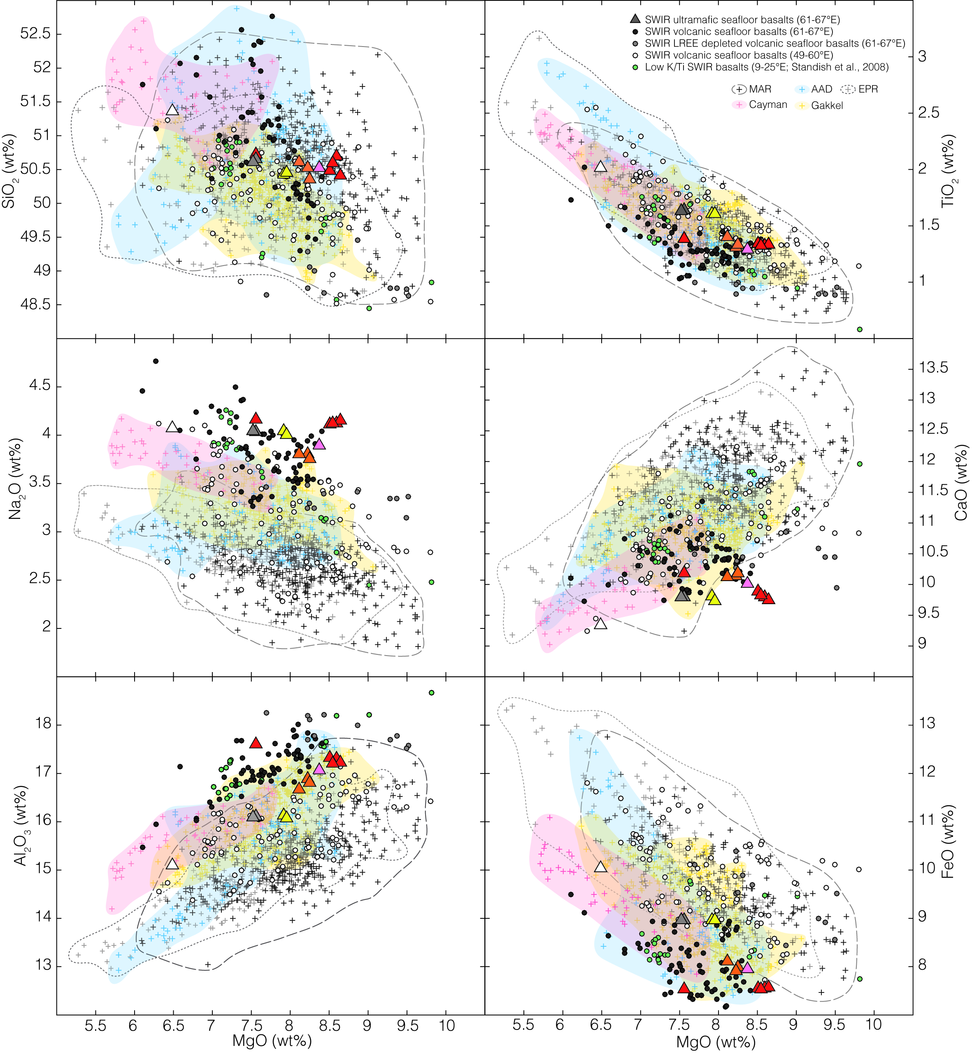

Figure 3. Major element compositions for basaltic samples from the easternmost part of the Southwest Indian Ridge (SWIR; 61° to 67°E) and from other regions of the SWIR and global mid-ocean ridge (MOR) system. SiO₂ (a), TiO₂ (b), Na₂O (c), CaO (d), Al₂O₃ (e) and FeO (f) contents as a function of MgO content. Triangles represent basalts collected in ultramafic seafloor areas of the 61°-67°E SWIR region (colored by dredge number as in Figure 1), and dark grey circles correspond to basalts collected in volcanic seafloor areas (pale grey symbols correspond to the LREE-depleted basalts sampled in dredges ED20, ED22 and ED26; Figure 1). The open circles are basalts collected in other regions of the Southwest Indian Ridge [Meyzen et al., 2003; Humler et al., unpublished data]. The green circles correspond to the low K/Ti basalts of Standish et al. [2008]. All the crosses correspond to PetDB (www.earthchem.org/petdb, Lehnert et al., 2000) data for the Mid-Atlantic Ridge (MAR), East Pacific Rise (EPR), Australian-Antarctic Discordance (AAD), Mid-Cayman Rise, and Gakkel ridge [PetDB, Gale et al., 2014]. Details on the selection of these other samples and complete references can be found in the Supplementary material.

Most 61°-67°E SWIR basalts are richer in Na₂O and Al₂O₃ at a given MgO content than basalts from other ultraslow and deep ridges such as Cayman Trough or Gakkel (Figure 3a and c), suggesting that they represent a global end-member in terms of low degrees of mantle partial melting. Their CaO/Al₂O₃ ratio is also in the lowermost range (<0.67) for the global MOR system (Figure 4b and c). However, they are not, as could be expected for melts produced by low degree of mantle melting, also richer in TiO₂ at a given MgO content (Figure 3f). This is consistent with the conclusions of Meyzen et al. [2003] that the 61°-67°E SWIR basalts derive from a titanium-depleted mantle source.
Ultramafic seafloor basalts have high Na₂O contents (3.8 - 4.2 wt%) and low CaO contents (9.4-10.2 wt%) over a range of MgO contents (6.5 and 8.6 wt%). Compared to the volcanic seafloor basalts, they tend to have higher Na₂O and TiO₂ contents at a given MgO content (Figure 3a and f), which would be consistent with a lower degree of mantle melting. Yet most also have lower Al₂O₃ and higher FeO contents at a given MgO content (Figure 3c and d), which is not consistent with the lower degree of melting interpretation. Their CaO content is also significantly lower at a given MgO than most volcanic seafloor basalts (Figure 3b). Basalt major element compositions are homogeneous in most nearly amagmatic seafloor dredges. Dredge SMS16, however, shows significant variability, with one sample (SMS16-3-14) that has a lower MgO content than the other 4 analyzed samples, and CaO, Al₂O₃, FeO and TiO₂ contents in the range of most volcanic seafloor basalts (Figure 3).

4.2 Trace elements
A small number of basalt samples from the volcanic domains have LREE-depleted patterns (Figure 4a, Table 2). These depleted samples come from dredges ED20, ED22 and ED26 (Figure 1) and also have higher maximum MgO contents, as well as lower CaO and higher FeO at a given MgO content than the other 61°-67°E SWIR basalts (Figure 3). However, most basalts from the 61°-67°E SWIR region, including those from nearly amagmatic corridors, have flat to slightly LREE-enriched REE patterns (Figure 4a). The (Ce/Sm)_{n} ratio in these samples is ≥ 1 and they plot in the high (Ce/Sm)_{n} and low CaO/Al₂O₃ range, compared to other MORBs (Figure 4b). However, their (Sm/Yb)_{n} ratio is generally lower, at a given CaO/ Al₂O₃ ratio, than that of basalts from other ultraslow and deep ridge regions (Gakkel or Cayman Trough; Figure 4c). This indicates a slight relative enrichment in the heaviest REE, which has been discussed by Meyzen et al. [2003] who interpreted it as due to melting of a refertilized depleted mantle.

Table 2. Trace element compositions (ppm) of representative ultramafic and volcanic seafloor basalts.
Sample | ED  12-2-2 | ED  22-2-1 | ED  26-1-2 | SMS  19-4-4 | SMS  16-3-5 | SMS  16-3-14 | SMS  23-2-2 | SMS  24-2-3 | SMS  26-3-1 | SMS  28-3-3 | SMS  31-2-4
Lat. (°) | -27.74 | -28.11 | -28.80 | -27.51 | -28.54 | -28.54 | -28.23 | -28.19 | -28.15 | -27.96 | -27.38
Long. (°) | 65.35 | 63.36 | 61.93 | 64.06 | 62.36 | 62.36 | 64.63 | 64.54 | 64.65 | 64.63 | 64.55
Depth (m) | 5550 | 4950 | 4600 | 2650 | 3850 | 3850 | 3870 | 3830 | 3960 | 4550 | 3200
Age (My) | <0.78 | <0.78 | <0.78 | 5.3 | <0.78 | <0.78 | 4.9 | 3.8 | 2.6 | <0.78 | 8.8
Sc | 34.5 | 39.4 | 35.5 | 33.1 | 29.1 | 30.5 | 31.7 | 34.6 | 35.3 | 32.9 | 39.0
V | 207.4 | 157.1 | 164.5 | 223.4 | 203.8 | 211.9 | 214.3 | 236.9 | 248.5 | 203.5 | 304.8
Cr | 307.3 | 286.2 | 343.0 | 309.3 | 371.9 | 354.7 | 357.2 | 297.4 | 292.3 | 335.4 | 174.3
Co | 43.9 | 49.7 | 50.8 | 37.8 | 41.5 | 40.8 | 39.8 | 40.3 | 39.4 | 39.6 | 47.0
Ni | 156.2 | 144.8 | 221.0 | 129.4 | 212.7 | 175.1 | 161.8 | 151.1 | 127.3 | 158.5 | 166.5
Cu | 66.2 | 96.5 | 93.8 | 61.7 | 64.3 | 64.5 | 67.2 | 65.9 | 64.2 | 64.2 | 56.9
Zn | 67.5 | 62.6 | 56.2 | 59.4 | 61.4 | 62.0 | 62.7 | 72.8 | 72.1 | 58.4 | 81.9
Rb | 2.5 | 0.8 | 0.4 | 1.2 | 1.0 | 1.1 | 1.6 | 3.1 | 2.6 | 1.6 | 2.0
Sr | 160.3 | 116.3 | 117.6 | 180.1 | 220.3 | 229.6 | 171.6 | 173.9 | 177.8 | 198.5 | 145.7
Y | 31.3 | 27.7 | 28.1 | 30.5 | 37.7 | 38.3 | 23.2 | 31.2 | 31.1 | 24.2 | 25.4
Zr | 85.6 | 55.5 | 49.9 | 91.3 | 101.5 | 107.6 | 94.4 | 127.7 | 128.6 | 100.6 | 151.6
Nb | 3.5 | 1.6 | 0.9 | 2.2 | 2.6 | 2.7 | 2.8 | 4.9 | 4.3 | 3.2 | 3.5
Ba | 21.7 | 7.9 | 5.2 | 12.4 | 11.3 | 11.6 | 16.4 | 28.7 | 25.2 | 17.5 | 18.8
La | 4.3 | 2.2 | 1.7 | 4.1 | 4.8 | 5.1 | 4.3 | 6.1 | 6.0 | 4.8 | 6.1
Ce | 12.8 | 6.8 | 6.0 | 12.6 | 14.8 | 15.4 | 13.2 | 17.6 | 17.9 | 13.5 | 18.9
Pr | 1.9 | 1.0 | 1.0 | 1.9 | 2.1 | 2.2 | 2.0 | 2.6 | 2.7 | 2.0 | 3.0
Nd | 9.3 | 5.6 | 5.7 | 9.7 | 10.3 | 10.9 | 10.1 | 13.4 | 13.5 | 10.1 | 15.7
Sm | 2.8 | 1.9 | 2.0 | 2.9 | 2.9 | 3.1 | 3.0 | 4.0 | 4.0 | 2.9 | 4.9
Eu | 1.0 | 0.8 | 0.8 | 1.1 | 1.1 | 1.2 | 1.1 | 1.4 | 1.4 | 1.1 | 1.6
Gd | 3.7 | 3.1 | 3.1 | 3.9 | 3.7 | 3.9 | 4.0 | 5.3 | 5.4 | 4.0 | 6.7
Tb | 0.7 | 0.6 | 0.6 | 0.7 | 0.7 | 0.7 | 0.7 | 1.0 | 1.0 | 0.7 | 1.2
Dy | 4.6 | 4.6 | 3.9 | 4.5 | 4.2 | 4.5 | 4.6 | 6.1 | 6.1 | 4.7 | 7.8
Ho | 1.0 | 1.1 | 0.9 | 0.9 | 0.9 | 0.9 | 1.0 | 1.3 | 1.3 | 1.0 | 1.6
Er | 2.9 | 3.2 | 2.6 | 2.7 | 2.5 | 2.7 | 2.7 | 3.7 | 3.7 | 2.9 | 4.8
Tm | 0.5 | 0.5 | 0.4 | 0.4 | 0.4 | 0.4 | 0.4 | 0.6 | 0.6 | 0.4 | 0.7
Yb | 3.0 | 3.5 | 2.7 | 2.6 | 2.4 | 2.6 | 2.7 | 3.7 | 3.7 | 2.8 | 4.6
Lu | 0.5 | 0.5 | 0.4 | 0.4 | 0.4 | 0.4 | 0.4 | 0.5 | 0.5 | 0.4 | 0.7
Hf | 2.0 | 1.4 | 1.3 | 2.2 | 2.2 | 2.3 | 2.1 | 3.0 | 3.0 | 2.2 | 3.8
Ta | 0.2 | 0.1 | 0.1 | 0.2 | 0.2 | 0.2 | 0.2 | 0.3 | 0.3 | 0.2 | 0.2
Pb | 0.7 | 0.4 | 0.3 | 0.7 | 0.8 | 0.8 | 0.7 | 0.9 | 0.9 | 0.7 | 0.9
Th | 0.3 | 0.1 | 0.1 | 0.2 | 0.2 | 0.2 | 0.2 | 0.4 | 0.3 | 0.2 | 0.3
U | 0.1 | 0.0 | 0.0 | 0.1 | 0.1 | 0.1 | 0.1 | 0.1 | 0.1 | 0.1 | 0.1

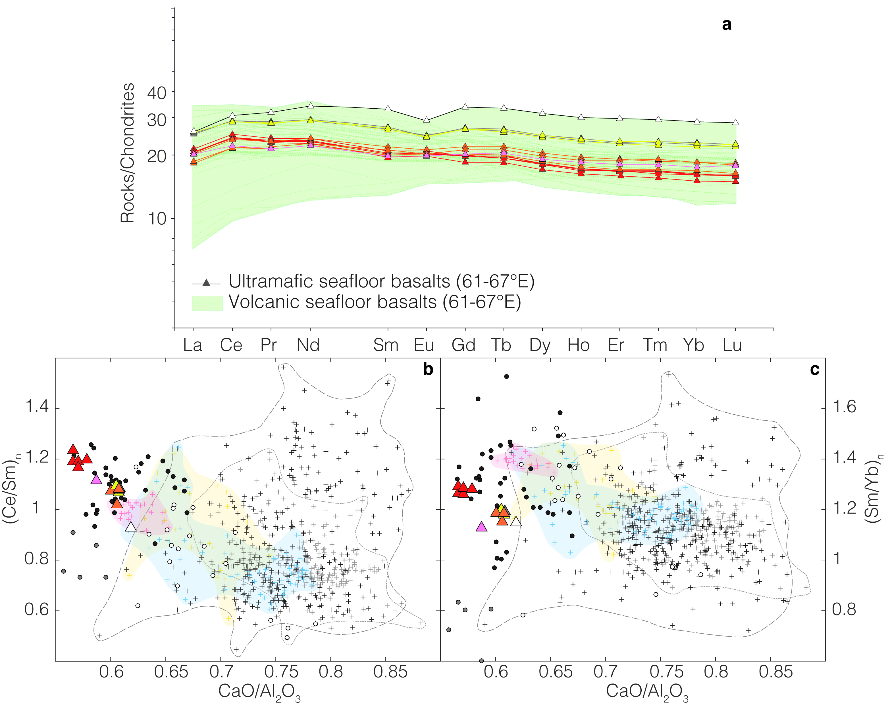
Figure 4. (a) Chondrites-normalized Rare Earth Element (REE) diagram for basalts of the 61° to 67°E region of the Southwest Indian Ridge. Ultramafic seafloor basalts are colored by dredge as in map of Figure 1. Volcanic seafloor basalts (this study, and Meyzen et al., 2003) are shown as thinner lines and green field. (Ce/Sm)_{n} (b) and (Sm/Yb)_{n} (c) (normalized to chondrites) as a function of CaO/Al₂O₃ (same symbols as in Figure 3). Normalizing values from McDonough and Sun (1995). The open and green circles and the crosses are basalts from the SWIR and global mid-ocean ridge (MOR) system, as in Figure 3.

A stricking characteristic of the 61°-67°E SWIR basalts, which was also reported by Meyzen et al. [2003], is that the flat to slightly enriched REE patterns are nearly parallel. They do not, therefore, show evidence for a progression from less to more LREE-depleted samples, as would be expected for a suite of melts derived from different degrees of partial melting. Instead, the most enriched patterns, with rock to chondrite ratios ≥ 25 for most REE (Figure 4a) also present distinctly negative Eu anomalies (Figure 4a), suggesting significant fractionation of plagioclase. Among basalts from the nearly amagmatic domains, this is the case for samples from dredges SMS24, SMS26 and SMS31. By contrast, REE patterns for samples from dredges SMS16 (including the sample that plots at lower MgO than the other 4 analyzed samples; Figure 3), SMS23, and SMS28 have lower rock to chondrite ratios, and no Eu anomaly (Figure 4a).
The trace element abundances for the 61°-67°E SWIR basalts show the expected depletion for Rb, Ba, Th, U, Nb, Ta and Pb compared to LREE, as these trace elements are more incompatible than LREE. Ultramafic and volcanic seafloor basalts have similar contents in Sr (between 116 and 260 ppm), Sc (between 29 and 39.4 ppm) and Zr (between 49.9 and 152.7 ppm). Moreover, we note that the compositions measured in basalt samples from a given dredge are in most cases homogeneous.

4.3 Isotopic signature
Pb, and Nd isotopic data for basalts dredged in nearly amagmatic corridors (Table 3) are ranging from 17.69 to 17.79 for ²⁰⁶Pb/²⁰⁴Pb, from 15.44 and 15.45 for ²⁰⁷Pb/²⁰⁴Pb, from 37.5 and 37.59 for ²⁰⁸Pb/²⁰⁴Pb, and from 0.513082 to 0.513098 for ¹⁴³Nd/¹⁴⁴Nd, similar to the isotopic compositions reported by Meyzen et al. [2005] for volcanic seafloor basalts.

Table 3. Isotopic compositions of representative on-axis ultramafic and volcanic seafloor basalts.
Sample | ¹⁴³Nd/¹⁴⁴Nd | 2σ | ²⁰⁶Pb/²⁰⁴Pb | 2σ | ²⁰⁷Pb/²⁰⁴Pb | 2σ | ²⁰⁸Pb/²⁰⁴Pb | 2σ
ED DR8-1-2 | 0.513039 | 0.000005 | 17.78 | 0.00050 | 15.45 | 0.00044 | 37.71 | 0.00110
ED DR10-3-16 | 0.513044 | 0.000005 | 17.80 | 0.00054 | 15.45 | 0.00049 | 37.70 | 0.00120
ED DR12-2-2 | 0.513049 | 0.000004 | 17.89 | 0.00047 | 15.46 | 0.00041 | 37.81 | 0.00107
ED DR22-2-1 | 0.513110 | 0.000005 | 17.90 | 0.00062 | 15.46 | 0.00056 | 37.73 | 0.00142
ED DR26-1-2 | 0.513053 | 0.000005 | 17.96 | 0.00662 | 15.47 | 0.00558 | 37.84 | 0.01418
SMS DR16-3-4 | 0.513098 | 0.000004 | 17.77 | 0.00093 | 15.44 | 0.00068 | 37.59 | 0.00197
SMS DR16-3-5 | 0.513093 | 0.000004 | 17.76 | 0.00105 | 15.44 | 0.00058 | 37.50 | 0.00171
SMS DR16-3-7 | 0.513082 | 0.000005 | 17.79 | 0.00099 | 15.45 | 0.00094 | 37.52 | 0.00246
SMS DR16-3-9 | 0.513087 | 0.000004 | 17.76 | 0.00087 | 15.44 | 0.00091 | 37.53 | 0.00220
SMS DR16-3-14 | 0.513098 | 0.000004 | 17.76 | 0.00070 | 15.44 | 0.00058 | 37.58 | 0.00135
SMS DR28-3-3 | 0.513078 | 0.000004 | 17.69 | 0.00042 | 15.44 | 0.00034 | 37.55 | 0.00097

5 Petrology and composition of the plagioclase-bearing ultramafic and gabbroic rock suites
For this work we examined thin sections of 107 samples (Table S2 Supplementary Material) of plagioclase-bearing ultramafic and gabbroic rocks dredged in the nearly amagmatic corridors at locations shown in Figure 1. Modal proportions of the principal mineral phases were determined using line drawings made from high resolutions photographs of whole thin sections. The primary assemblage for all the samples consists in clinopyroxene + plagioclase ± olivine ± orthopyroxene ± spinel. Samples from most dredges display a great variability in terms of modal composition, ranging from plagioclase lherzolites, plagioclase websterites, to troctolites, olivine gabbros, gabbros and gabbronorites (Figures 5 and 6). This variability commonly occurs over scales of a few centimeters to a few decimeters, within a single sample (Figure 5b and 5c), suggesting that the most plagioclase-rich assemblages form veins or irregular impregnations in the ultramafic rocks.
Based on cursory examination of the 108 samples in thin section, we selected 19 samples of plagioclase lherzolites, plagioclase websterites, olivine gabbros, gabbros and gabbronorites (Table 4) for detailed petrological and chemical analyses, based on their lower degree of alteration and deformation. We excluded from this selection several samples of gabbros and oxide gabbros from dredges ED9, ED14, SMS22, SMS33, SMS34 and SMS35 (Figure 1). These gabbros have more evolved mineral compositions than the suite of rocks presented in this paper and are best interpreted as products of MORB fractional crystallization in the shallower axial lithospheric mantle of the nearly amagmatic corridors [Paquet et al., 2014].

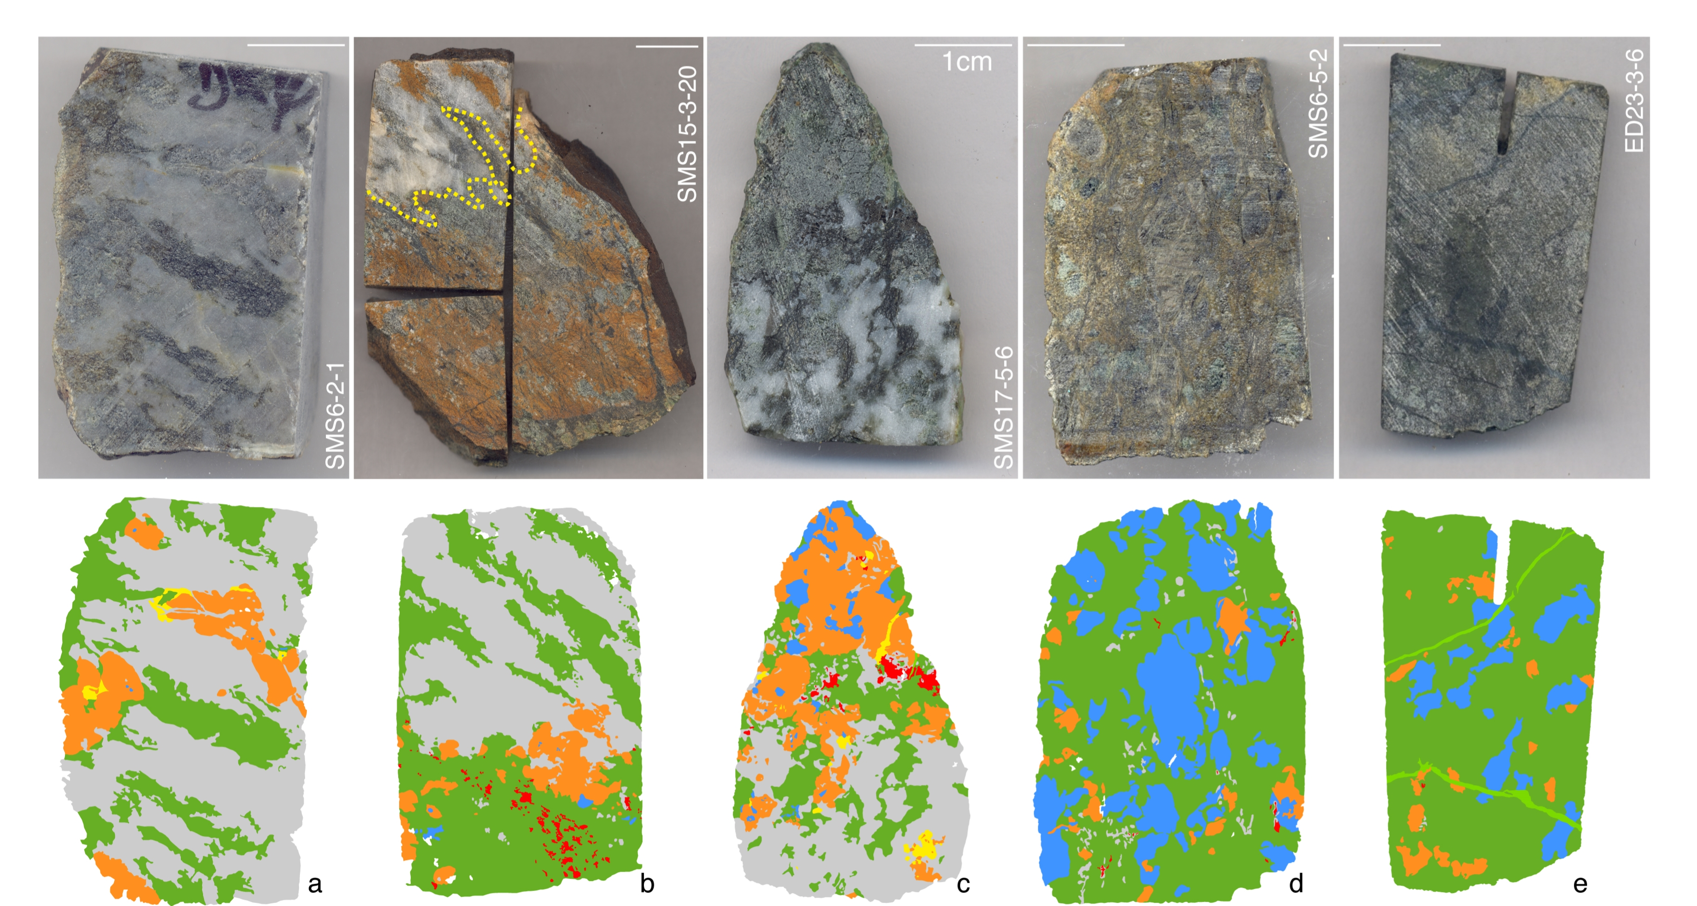
Figure 5. Representative photographs of samples of the plagioclase-bearing ultramafic to gabbroic suite. Modal proportions of plagioclase increase from right (e- plagioclase-bearing lherzolite) to left (a- olivine gabbro) and within a few centimeters in (b) and (c). Line drawings made from high resolution photographs of whole thin sections are used to determine the modal proportions of the principal mineral phases in each sample (Table 4): plagioclase or altered plagioclase in grey, olivine or serpentine after olivine in green, orthopyroxene or serpentine after orthopyroxene in blue, clinopyroxene in orange and spinel in red. Altered phases with undetermined protolith in yellow; serpentine veins in pale green.

In order to compare the mineral composition of these samples to other ultramafic and gabbroic rock suites from slow spreading ridges, we compiled published major and trace element data for residual plagioclase-free peridotites from the 61°-67°E region of the SWIR [Seyler et al., 2003], for the troctolite to olivine gabbros suite drilled at ODP Site U1309D at 30°N at the MAR [Drouin et al., 2009], and for the gabbros drilled at ODP Site 735 at 57°E on the SWIR [Ozawa et al., 1991; Dick et al., 2002].

5.1 Petrographic description
Plagioclase. Plagioclase-bearing lherzolites (Figures 5e and 6a) and websterites (Figures 5d and 6b) have less than 10% of plagioclase, while troctolites (Figure 5b), olivine gabbros (Figures 5a, 5c, and 6c) and gabbros (Figure 6d) have more than 40% (Table 4). The plagioclase distribution is heterogeneous even at the scale of a thin section (Figures 5b and 5c). Plagioclase forms small interstitial grains (<500µm) associated with mafic minerals, or larger grains (up to one cm) in plagioclase-rich lenses (Figures 5a and 6c). In some samples, these plagioclase-rich lenses have a preferred orientation (Figure 5a). Except for sample SMS6-5-7 and SMS12-3-1B (Table 4), no textural evidence of gabbroic veins or dykelets was observed. Plagioclase grains are irregular in shape, with widespread evidence for intracrystalline deformation (mechanical twins and undulose extinction) and for dynamic recrystallization into smaller grains (Figure 6c). Interstitial plagioclase also forms rims around spinel in the most ultramafic samples (Figure 7a), or crystallizes as small irregular grains that appear to partially replace orthopyroxene (Figure 7b).

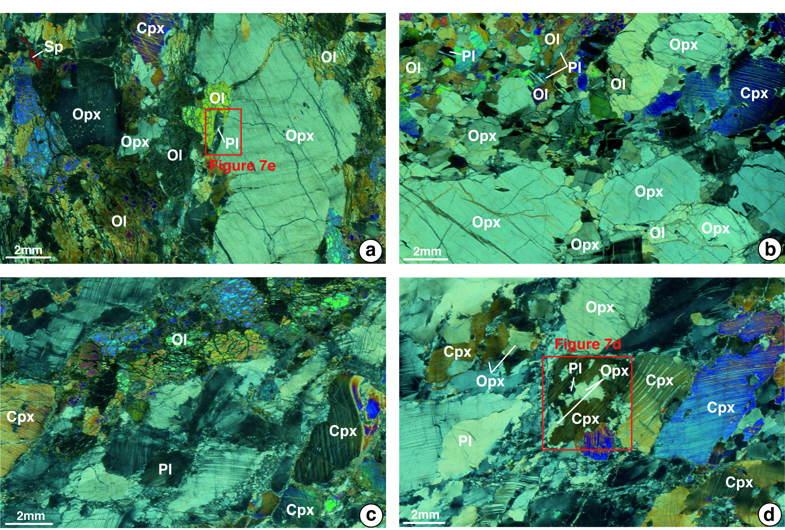
Figure 6. Representative microphotographs of samples of the plagioclase-bearing ultramafic to gabbroic suite. Crossed nicols. (a) Sample SMS6-5-2 (Figure 5d): plagioclase-bearing lherzolite with small interstitial grains of plagioclase (Pl) and large orthopyroxenes (Opx) with fine clinopyroxene (Cpx) exsolutions; olivines (Ol) are irregularly-shaped with subgrains boundaries and undulose extinction; contacts between olivine and orthopyroxene are lobate; spinels (Sp) appear with elongated shapes. (b) Sample SMS17-4-22: plagioclase-bearing websterite with large kinked orthopyroxenes which have lobate contacts with olivine; plagioclase appear as small droplets (<1mm) between olivines, clinopyroxenes and orthopyroxenes. (c) Sample SMS6-2-1 (Figure 5a): olivine gabbro with plagioclase-rich lenses, kinked clinopyroxenes and equant to elongated olivines. (d) Sample SMS6-5-7: gabbro with a large proportion of orthopyroxene which occurs as large grains, smaller grains in the plagioclase matrix or next to a clinopyroxene crystal enclosing orthopyroxene and plagioclase inclusions. In (c) and (d), plagioclase occurs as relatively large grains, with common mechanical twins, and small (few tens of µm to hundred of µm) recrystallised neoblasts, and clinopyroxenes show orthopyroxene exsolutions and undulose extinction.

Table 4. Mineral abundances for selected representative samples.

Samples | Lithologies | Mineral Abundances (vol%)
Samples | Lithologies | Olivine | Orthopyroxene | Clinopyroxene | Spinel | Plagioclase
SMS6-2-1 | Olivine gabbro | 27.74 | 0.06 | 13.59 | 0.00 | 57.76
SMS6-5-2 | Plagioclase-bearing lherzolite | 62.79 | 30.27 | 4.54 | 0.002 | 2.03
SMS6-5-7A | Plagioclase-bearing websterite | 7.43 | 12.89 | 70.60 | 0.16 | 8.93
SMS6-5-7B | Gabbro | 0.00 | 21.24 | 20.70 | 0.00 | 58.05
SMS6-5-7C | Gabbro | 0.30 | 11.74 | 32.47 | 0.00 | 55.22
SMS7-4-2 | Troctolite | P | - | P | P | P
SMS10-2-1 | Gabbro | - | - | P | - | P
SMS12-3-1B | Olivine gabbro | P | P | P | - | P
SMS15-3-20 | Olivine gabbro | 43.98 | 0.45 | 8.45 | 1.49 | 40.93
SMS17-4-22 | Plagioclase-bearing websterite | P | P | P | P | P
SMS17-4-53 | Olivine gabbro | P | P | P | - | P
SMS17-5-6 | Olivine gabbro | 22.64 | 5.03 | 28.57 | 1.64 | 40.23
SMS21-3-1 | Olivine gabbro | 17.12 | 0.95 | 16.11 | 0.00 | 65.24
SMS29-3-5 | Plagioclase-bearing websterite | P | P | P | - | P
SMS29-3-9 | Plagioclase-bearing websterite | 0.00 | 43.10 | 28.62 | 0.51 | 27.77
ED14-1-1 | Plagioclase-bearing lherzolite | P | P | P | - | P
ED14-1-3 | Plagioclase-bearing lherzolite | P | P | P | P | P
ED21-4-1 | Plagioclase-bearing lherzolite | P | P | P | P | P
ED21-10-3 | Troctolite | 17.64 | 0.00 | 1.94 | 0.00 | 80.43
ED23-3-6 | Plagioclase-bearing lherzolite | 79.82 | 12.14 | 5.32 | 0.02 | 0.08
ED23-4-1 | Plagioclase-bearing lherzolite | 41.18 | 11.11 | 4.29 | 0.28 | 2.13

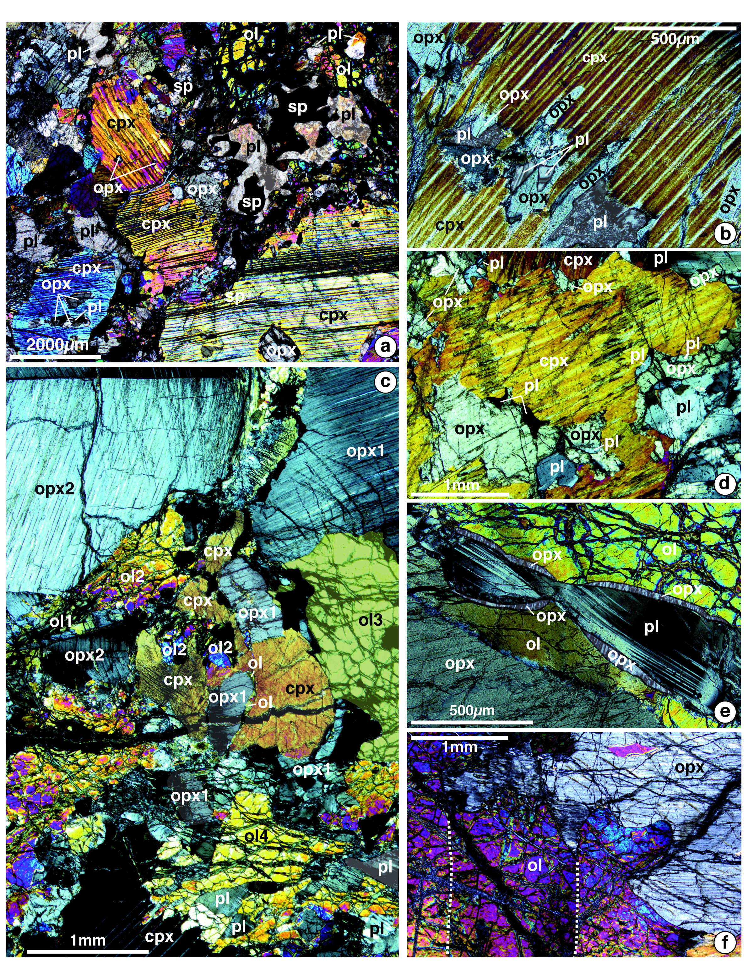
Figure 7. Representative microphotographs of samples of the plagioclase-bearing ultramafic to gabbroic suite. Crossed nicols. (a) Sample SMS17-5-6: olivine gabbro. Clinopyroxene with orthopyroxene exsolutions forms millimeter-sized anhedral to poekilitic crystals that commonly contain inclusions of plagioclase and orthopyroxene (fragments that share a common crystallographic orientation). Spinels appear to be amoeboid to vermicular, and mostly surrounded by plagioclase aureoles. (b) Sample SMS6-2-1: olivine gabbro. (d) Sample SMS6-5-7: gabbro. In (b) and (d), clinopyroxenes with orthopyroxene exsolutions are enclosing orthopyroxene and plagioclase inclusions. Additionally, in (d) orthopyroxenes also occur as irregularly shaped to oval in the plagioclase matrix, or next to a clinopyroxene crystal with orthopyroxene and plagioclase inclusions; all the orthopyroxene fragments have the same crystallographic orientation. These textures indicate that clinopyroxene replaced orthopyroxene porphyroclasts, following plagioclase-forming melt-rock reactions. (c) Sample SMS6-5-2: plagioclase-bearing lherzolite. Orthopyroxenes form large grains with fine clinopyroxene exsolutions, and kinks. Plagioclase occurs as small interstitial grains. In the center of the picture, the clinopyroxene is enclosing fragments of two different olivine grains and of orthopyroxene. The fragments of olivine and orthopyroxene share a common crystallographic orientation with Ol2 and Ol3 (small grains stuck between the clinopyroxene and the orthopyroxene fragment), and Opx1 respectively. Some of the orthopyroxene relicts in clinopyroxene show kink bands or undulose extinction, while the host clinopyroxene appears undeformed. This indicates that clinopyroxene crystallized after an episode of deformation of the orthopyroxene porphyroclasts. (e) Sample SMS6-5-2: plagioclase-bearing lherzolite. Contacts between olivine and plagioclase are commonly underlined by reactional orthopyroxene. These rims of secondary orthopyroxene are observed in most samples, independent of the modal proportion of plagioclase and indicate that the impregnating melt was Si-enriched relative to the host peridotite. (f) Sample ED23-3-6: plagioclase-bearing lherzolite. Relations between residual kinked (dashed lines) olivine with undulose extinction and orthopyroxene show lobate contacts possibly due to episodes of incongruent melting [e.g. Kelemen, 1990; Kinzler and Grove, 1992b; Seyler et al., 2007].

Clinopyroxene. Clinopyroxene forms millimeter-sized anhedral to poikilitic crystals that commonly contain inclusions of orthopyroxene and plagioclase (Figures 7a and 7b). Orthopyroxene inclusions within a given clinopyroxene commonly share the same crystallographic orientation. These textural relations suggest that clinopyroxene replaced former orthopyroxene porphyroclasts, following plagioclase crystallization. Some of the orthopyroxene relicts in clinopyroxene show kink bands (Figure 7c) or undulose extinction, while the host clinopyroxene appears undeformed. This indicates that clinopyroxene crystallized after an episode of deformation of the orthopyroxene porphyroclasts. However, in several samples, clinopyroxene grains are also kinked, bent (for example in Figures 6c and 6d) and locally recrystallized in association with plagioclase neoblasts.
Orthopyroxene. Orthopyroxene porphyroclasts comprise up to 43.1% of the mode in the plagioclase-bearing websterites, and typically 10 to 30% of the mode in plagioclase-bearing lherzolites (Figures 5d and 5e, Table 4). They are kinked and commonly contain thin clinopyroxene exsolution lamellae (Figure 7c). In gabbroic samples, we also observed small (<300 µm) irregularly shaped to oval orthopyroxene in the plagioclase and clinopyroxene matrix (Figure 7d). These small orthopyroxene grains tend to share a common crystallographic orientation (Figures 7a, 7b, 7c and 7d) and could represent isolated relicts from preexisting orthopyroxene porphyroclasts. Finally, rims of secondary orthopyroxene (up to 50 µm-thick) are common between olivine and plagioclase (Figure 7e).
Olivine. Olivine occurs as irregularly-shaped grains, from a few tens of micrometers to one centimeter in size, with subgrain boundaries and undulose extinction (Figure 7f). Olivine grains tend to have curvilinear contacts with orthopyroxenes (Figure 7f), a texture that is common in residual abyssal peridotites and has been interpreted as resulting from incongruent melting of the pyroxene [e.g. Seyler et al., 2007]. In plagioclase-rich samples, olivine forms lens-shaped aggregates (Figure 6c), with grain shapes and subgrains that are similar to those observed in the more ultramafic samples.
Spinel. Spinels are present in several samples (Table 4), forming amoeboid to vermicular grains that range in size between a few tens of micrometers and a few millimeters. These spinels are brown and partially altered into magnetite. One sample (SMS6-2-1) contains very small spinels (<100µm), enclosed in olivine grains. Most spinels are larger and surrounded by plagioclase. We did not observe the large poikilitic grains enclosing olivine described by Seyler et al. [2003] in plagioclase-free serpentinized lherzolites from the same region, which suggests spinels in the plagioclase-bearing ultramafic rocks might result from reaction processes with a percolating melt.

5.2 Mineral major element compositions
Plagioclase. Plagioclase anorthite (An) contents range between 80.6 and 91.6% in samples the modal proportions of a plagioclase lherzolite or plagioclase websterite, and between 58.8 and 69.6% in troctolites, olivine gabbros, gabbros and gabbronorites (Figures 8a and 8b, Table 5). The An content in these samples therefore appears to be inversely correlated with the modal proportion of plagioclase.
In order to further investigate this relation, we selected a sample in which plagioclase abundance varies significantly over scales of a few centimeters, and in which the range of measured An values is large (66.5 to 85.2%; Figure 9a). In this sample, we compared the composition of plagioclase grains measured in two parallel thin sections cut within 1.5 centimeters of one another, one with a plagioclase-websterite modal mineralogy (A), the other with a gabbronorite mineralogy (B; Figure 9b). Plagioclase grains belong to three types: small grains isolated in the mafic mineral assemblage (thin section A), small grains enclosed into clinopyroxenes (thin sections A and B), and larger grains (≥ 500µm to 1mm; thin section B). The small plagioclase grains (inclusions in the clinopyroxenes or in the mafic groundmass) have similar anorthite contents, between 73.5 and 85.2% (mean An value of 80.8±4.1%) (Figure 9c). The larger grains have lower anorthite content, between 66.5 and 74.1% (mean An value of 68.8±2.4%) (Figure 9c).
Plagioclase in this sample, similar to other samples that plot in the 65-91.6 range of An contents, has low (<0.03 wt%) K₂O contents (the dispersion is interpreted as due to analytical error at these low concentrations). By contrast, large plagioclase grains in several samples of troctolite, olivine gabbro and gabbro have yet lower plagioclase An contents (58.8 to 62.9%), and slightly higher K₂O (and TiO₂) contents (up to 0.05 wt% for K₂O, and between 0.03 and 0.08 wt% for TiO₂) (Figure 9a). This sample-scale study therefore indicates that the highest An values (73.5 to 85.2%) are measured in small plagioclase grains isolated in mafic mineral assemblages, and that these small An-rich grains can be preserved as inclusions in clinopyroxenes in gabbroic samples that also contain plagioclase-rich domains with lower An contents. Additionally, we identify a subgroup of troctolites, olivine gabbros and gabbros that contains plagioclase with yet lower An content (58.8 to 62.9%) and higher K₂O contents (Figure 9a).
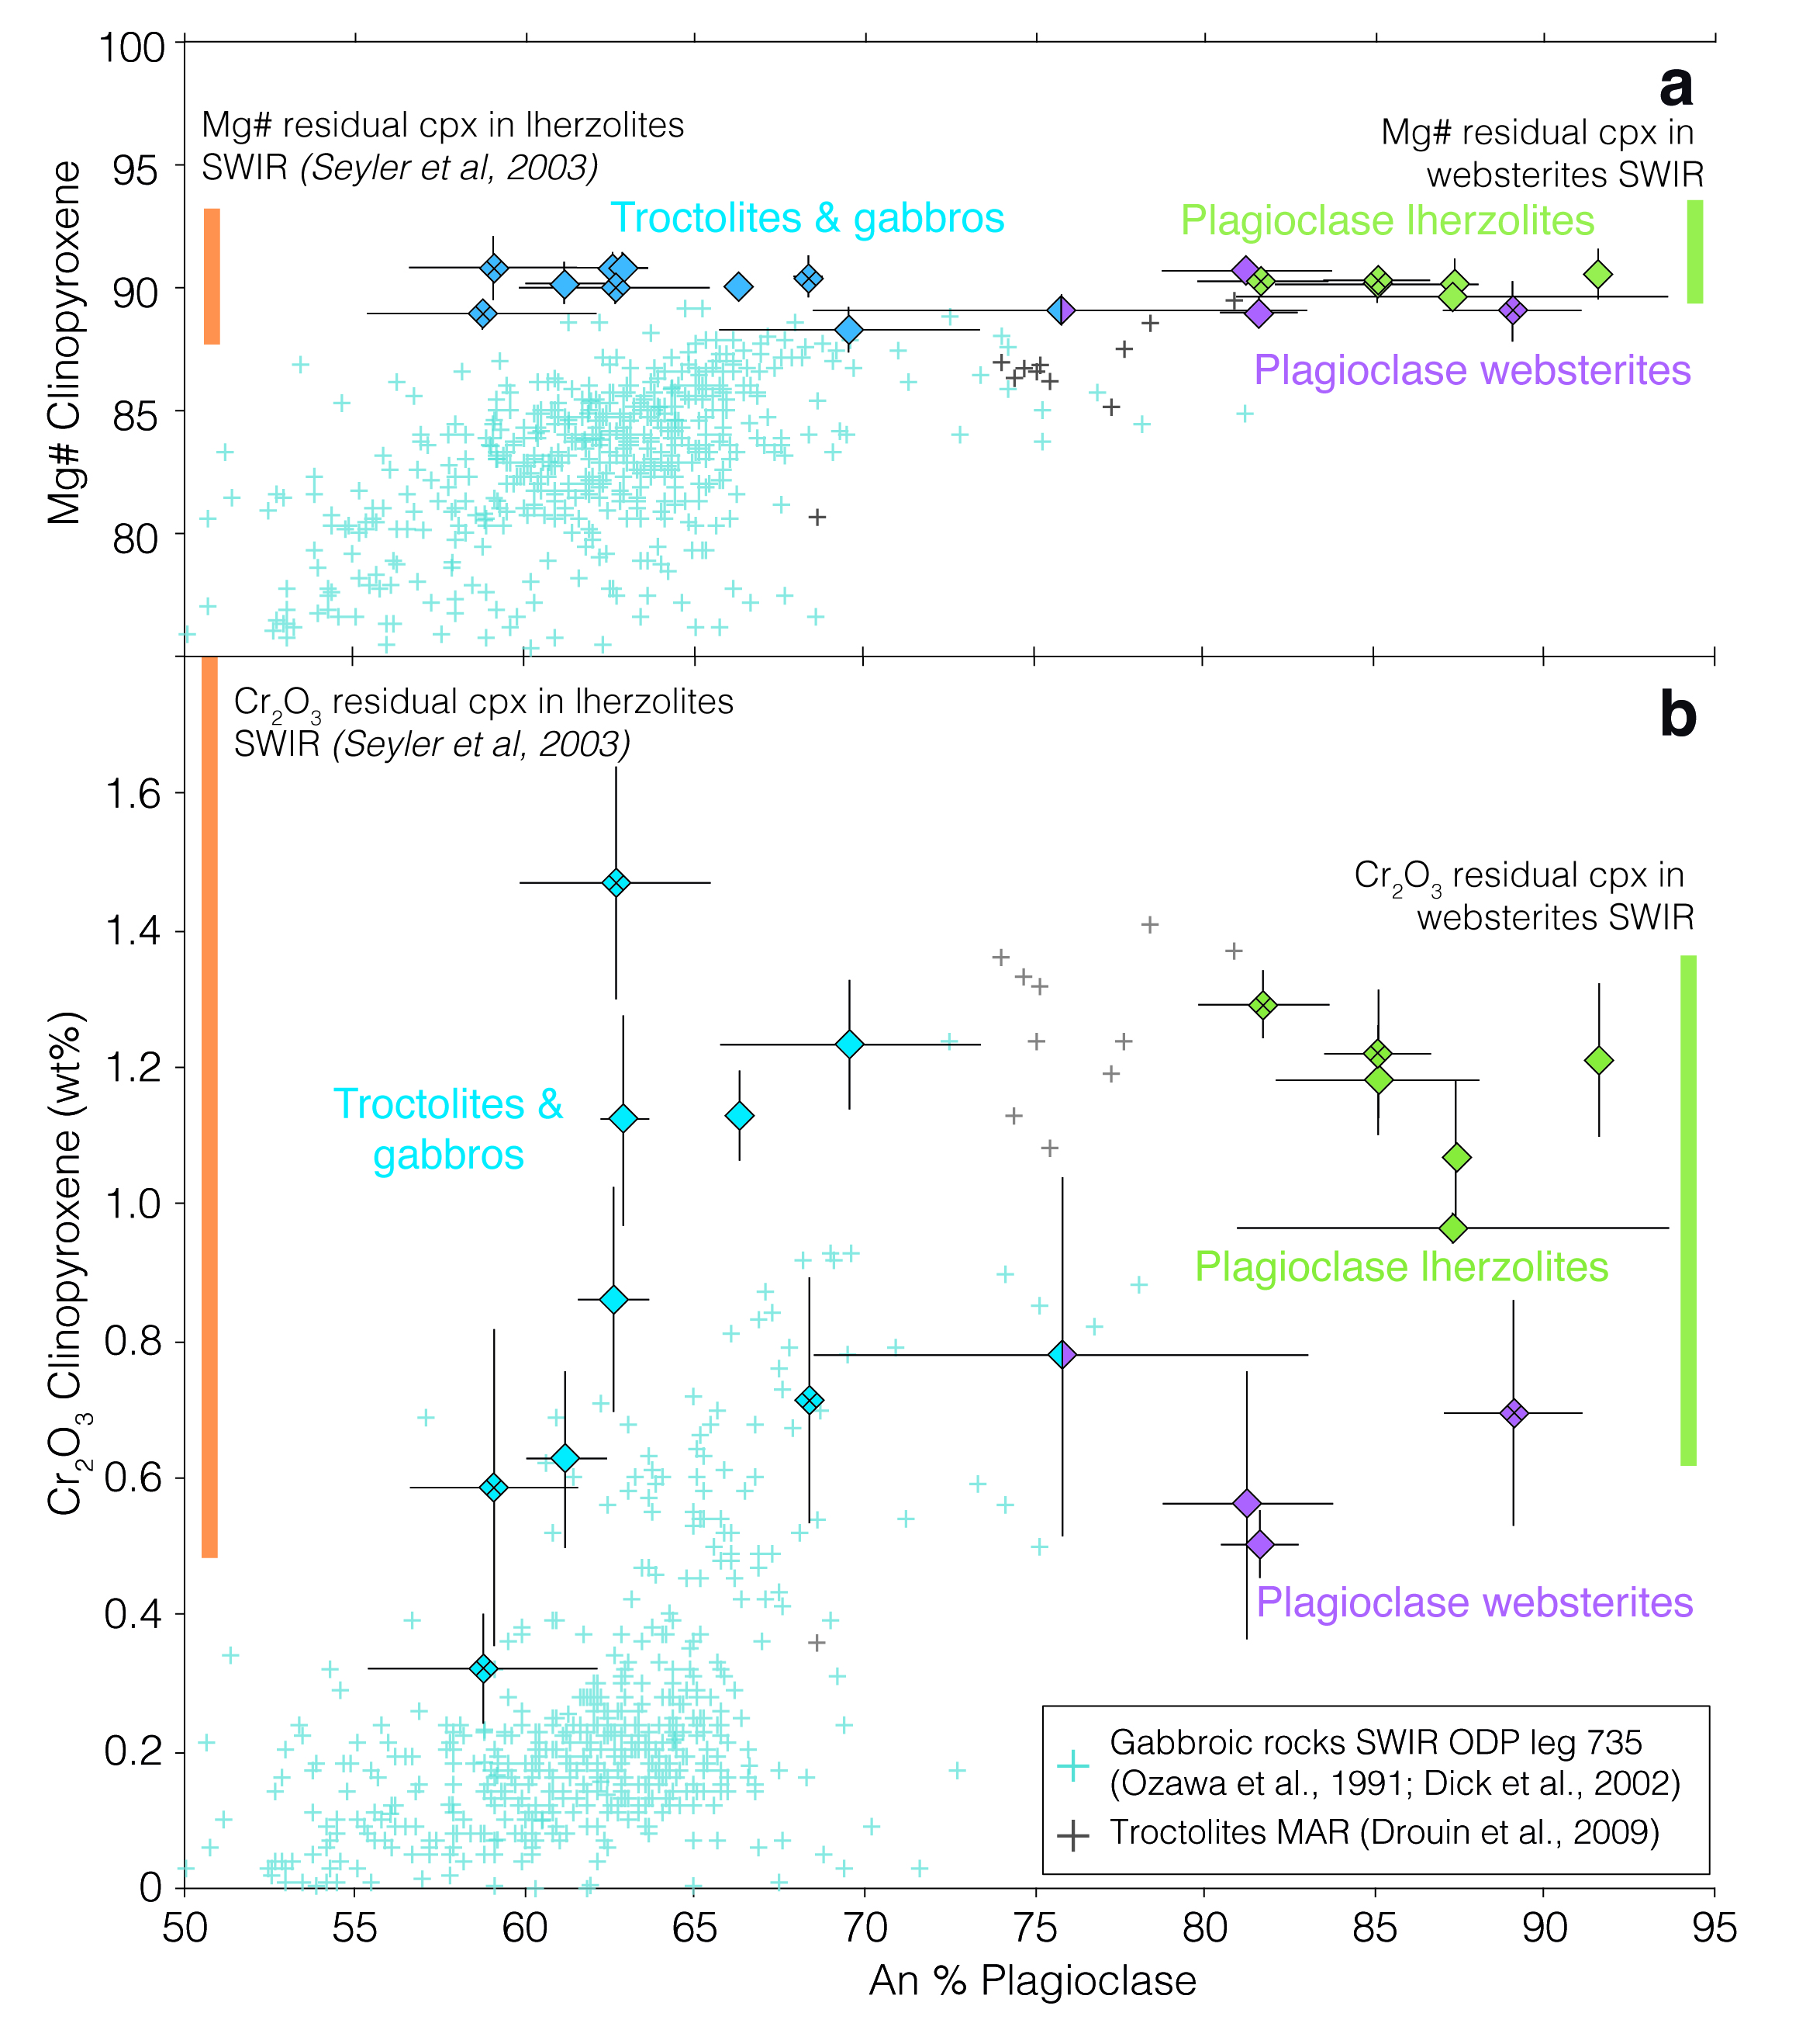
Figure 8. Clinopyroxene and plagioclase major element composition in samples of the plagioclase-bearing ultramafic to gabbroic suite. (a) Clinopyroxene Mg# as a function of plagioclase anorthite content. (b) Clinopyroxene Cr₂O₃ content as a function of plagioclase anorthite content. Diamond data point corresponds to the average composition of several grains in each sample (n values in Tables 3 and 4). Error bars: ±1 std. Diamonds are colored according to modal minaralogy: plagioclase-bearing lherzolites in green, plagioclase-bearing websterites in purple, troctolites, olivine gabbros and gabbros in blue. The blue-purple diamond corresponds to hybrid sample SMS6-5-7 described in Figure 9b. Diamonds with a cross inside correspond to samples for which we also analyzed in-situ trace elements. Orange and green bars show ranges of composition reported for residual clinopyroxene in plagioclase-free peridotite samples [Seyler et al., 2003] and in plagioclase-free websterites [Brunelli et al., unpublished data] respectively. The Mg# of clinopyroxenes in the plagioclase-bearing samples appears buffered by that of the reacted residual peridotite. The Cr₂O₃ content of clinopyroxenes shows a greater variability, with lower values in the plagioclase-bearing websterites, and in some troctolites, olivine gabbros and gabbros. Points for ODP Site 735 correspond to a subset of the data with plagioclase An contents > 55%.

Table 5. Major element compositions (wt%) of plagioclases of representative plagioclase-bearing ultramafic rocks. Average composition of several plagioclase grains in each sample. Error bars: ±1 std.

 | SMS6-2-1 |  |  | SMS6-5-2 |  |  | SMS6-5-7 |  |  | SMS7-4-2 |  |  | SMS17-4-22 |  |  | SMS17-5-6 |  |  | SMS29-3-9 |  |  | ED21-10-3 |  |  | ED23-3-6
 | Core |  |  | Core |  |  | Core |  |  | Core |  |  | Core |  |  | Core |  |  | Core |  |  | Core |  |  | Core
 | (n=26) | ± |  | (n=13) | ± |  | (n=40) | ± |  | (n=2) | ± |  | (n=10) | ± |  | (n=11) | ± |  | (n=3) | ± |  | (n=14) | ± |  | (n=12) | ±
SiO₂ | 52.9 | 1.0 |  | 46.1 | 1.7 |  | 48.5 | 2.0 |  | 52.1 | 0.7 |  | 47.0 | 0.5 |  | 50.3 | 1.1 |  | 45.1 | 0.7 |  | 51.0 | 0.9 |  | 47.6 | 0.9
TiO₂ | 0.1 | 0.0 |  | 0.0 | 0.0 |  | 0.0 | 0.0 |  | 0.0 | 0.0 |  | 0.0 | 0.0 |  | 0.0 | 0.0 |  | 0.0 | 0.0 |  | 0.0 | 0.0 |  | 0.0 | 0.0
Al₂O₃ | 30.3 | 0.6 |  | 34.8 | 1.2 |  | 32.8 | 1.2 |  | 30.7 | 0.1 |  | 33.5 | 0.5 |  | 31.7 | 0.7 |  | 35.2 | 0.3 |  | 31.4 | 0.4 |  | 33.9 | 0.3
FeO_{tot} | 0.1 | 0.1 |  | 0.1 | 0.0 |  | 0.1 | 0.0 |  | 0.2 | 0.0 |  | 0.1 | 0.0 |  | 0.2 | 0.1 |  | 0.2 | 0.0 |  | 0.1 | 0.0 |  | 0.2 | 0.1
MnO | 0.0 | 0.0 |  | 0.0 | 0.0 |  | 0.0 | 0.0 |  | 0.0 | 0.0 |  | 0.0 | 0.0 |  | 0.0 | 0.0 |  | 0.0 | 0.0 |  | 0.0 | 0.0 |  | 0.0 | 0.0
MgO | 0.0 | 0.1 |  | 0.0 | 0.0 |  | 0.0 | 0.0 |  | 0.0 | 0.0 |  | 0.0 | 0.0 |  | 0.0 | 0.0 |  | 0.0 | 0.0 |  | 0.0 | 0.0 |  | 0.0 | 0.0
CaO | 12.3 | 0.7 |  | 17.9 | 1.2 |  | 15.7 | 1.4 |  | 13.3 | 0.2 |  | 16.7 | 0.5 |  | 14.4 | 0.8 |  | 18.2 | 0.4 |  | 14.0 | 0.4 |  | 16.8 | 0.4
Na₂O | 4.8 | 0.4 |  | 1.4 | 0.7 |  | 2.8 | 0.8 |  | 4.4 | 0.1 |  | 2.1 | 0.3 |  | 3.5 | 0.4 |  | 1.2 | 0.2 |  | 3.6 | 0.2 |  | 2.1 | 0.2
K₂O | 0.0 | 0.0 |  | 0.0 | 0.0 |  | 0.0 | 0.0 |  | 0.0 | 0.0 |  | 0.0 | 0.0 |  | 0.0 | 0.0 |  | 0.0 | 0.0 |  | 0.0 | 0.0 |  | 0.0 | 0.0
Cr₂O₃ | 0.0 | 0.0 |  | 0.0 | 0.0 |  | 0.0 | 0.0 |  | 0.0 | 0.0 |  | 0.0 | 0.0 |  | 0.0 | 0.0 |  | 0.0 | 0.0 |  | 0.0 | 0.0 |  | 0.0 | 0.0
NiO | 0.0 | 0.0 |  | 0.0 | 0.0 |  | 0.0 | 0.0 |  | 0.0 | 0.0 |  | 0.0 | 0.0 |  | 0.0 | 0.0 |  | 0.0 | 0.0 |  | 0.0 | 0.0 |  | 0.0 | 0.1
Cl | 0.0 | 0.0 |  | 0.0 | 0.0 |  | 0.0 | 0.0 |  | 0.0 | 0.0 |  | 0.0 | 0.0 |  | 0.0 | 0.0 |  | 0.0 | 0.0 |  | 0.0 | 0.0 |  | 0.0 | 0.0
F | 0.1 | 0.1 |  | 0.0 | 0.1 |  | 0.1 | 0.1 |  | 0.0 | 0.0 |  | 0.1 | 0.1 |  | 0.0 | 0.0 |  | 0.1 | 0.1 |  | 0.0 | 0.0 |  | 0.0 | 0.0
Total | 100.6 | 0.4 |  | 100.5 | 0.9 |  | 100.0 | 0.9 |  | 100.7 | 0.7 |  | 99.5 | 0.4 |  | 100.1 | 0.3 |  | 100.2 | 0.5 |  | 100.3 | 0.7 |  | 100.7 | 0.6
Ab % | 41.1 | 3.3 |  | 12.7 | 6.4 |  | 24.1 | 7.3 |  | 37.2 | 1.1 |  | 18.7 | 2.5 |  | 30.3 | 3.8 |  | 10.9 | 2.0 |  | 31.6 | 1.9 |  | 18.2 | 1.6
An % | 58.8 | 3.4 |  | 87.3 | 6.4 |  | 75.8 | 7.3 |  | 62.6 | 1.0 |  | 81.3 | 2.5 |  | 69.6 | 3.8 |  | 89.1 | 2.0 |  | 68.4 | 1.9 |  | 81.7 | 1.6
Or % | 0.1 | 0.1 |  | 0.1 | 0.0 |  | 0.1 | 0.1 |  | 0.2 | 0.0 |  | 0.1 | 0.1 |  | 0.1 | 0.1 |  | 0.1 | 0.1 |  | 0.1 | 0.1 |  | 0.1 | 0.1

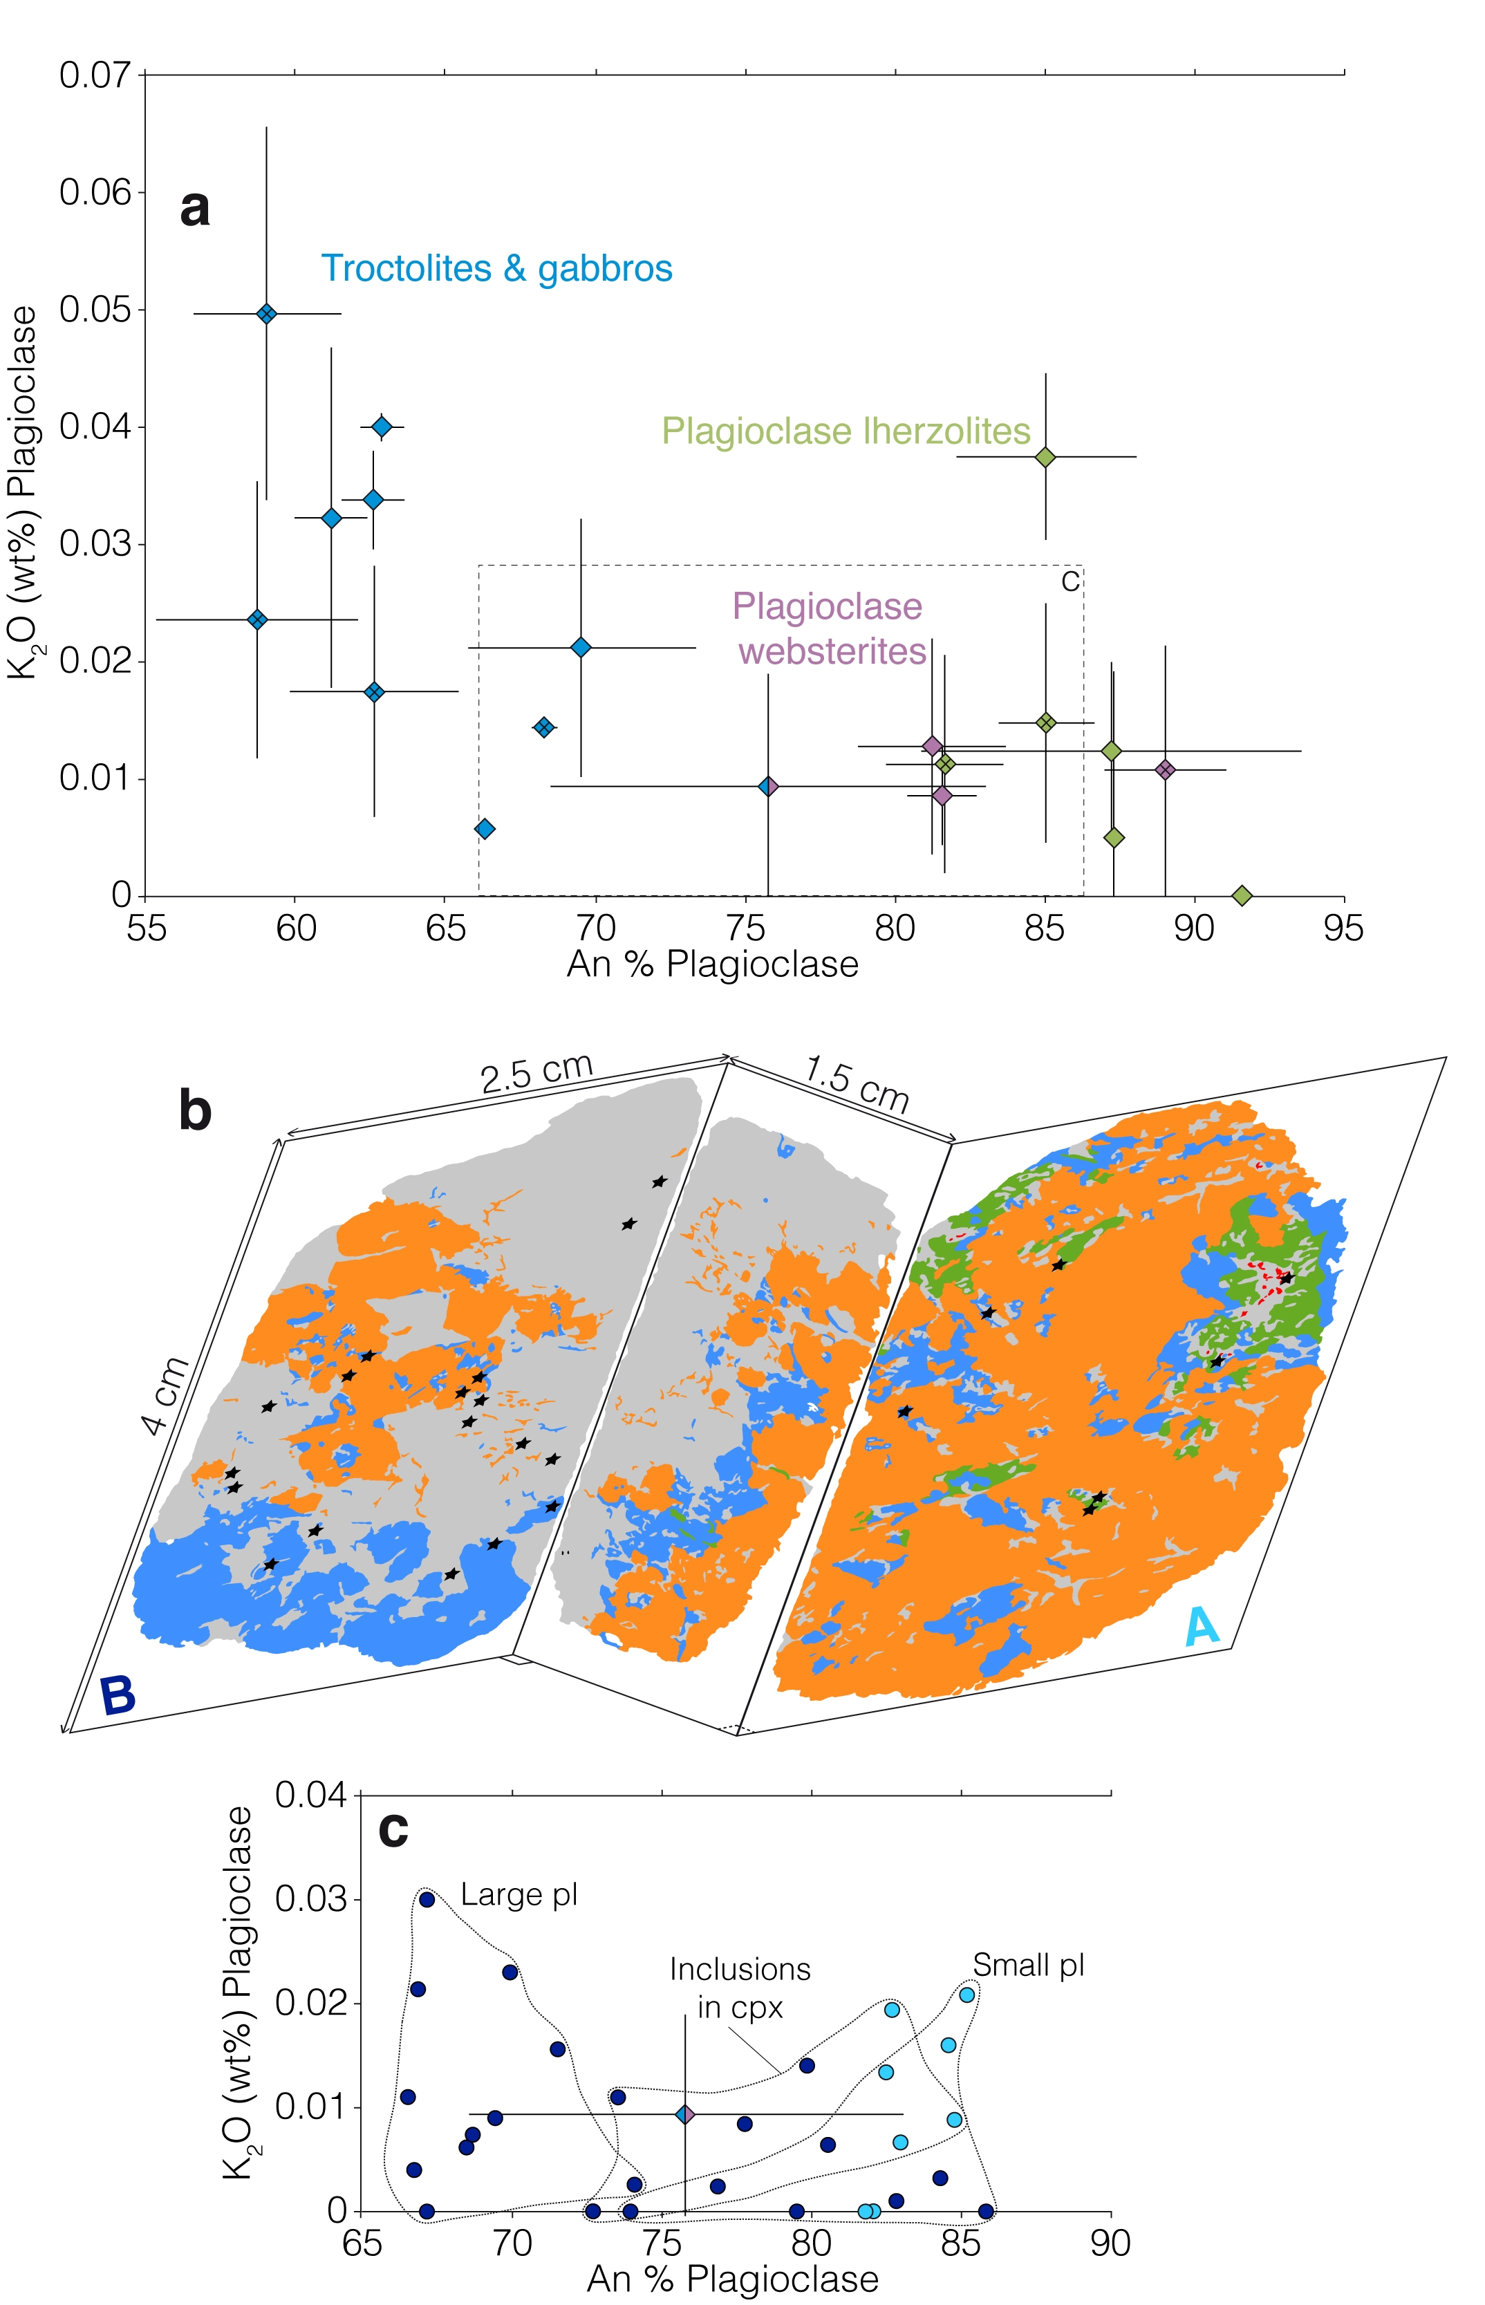
Figure 9. Plagioclase compositional variations in samples of the plagioclase-bearing ultramafic to gabbroic suite. (a) Plagioclase K₂O content as a function of An content. Diamond data point corresponds to the average composition of several plagioclase grains in each sample (n values in Table 5). Error bars: ±1 std. Samples for which we analyzed plagioclase and/or clinopyroxene trace element data are available are shown as diamonds with a cross inside. Same symbols as in Figure 8. (b) Line drawing showing mineral modal abundances (plagioclase or altered plagioclase in grey, olivine or serpentine after olivine in green, orthopyroxene or serpentine after orthopyroxene in blue, clinopyroxene in orange) in three orthogonal thin sections cut in sample SMS6-5-7. Plagioclase abundances in this sample vary significantly over scales of a few centimeters: modal mineralogy corresponds to a plagioclase-bearing websterite in thin section A (light blue), and to a gabbronorite in thin section B (dark blue). Plagioclase occurs as small interstitial grains in thin section A, and as small inclusions in clinopyroxene or as larger grains in thin section B. Dots correspond to microprobe measurements plotted in (c). Small plagioclase grains (interstitial or inclusions in cpx) have higher An contents than the larger plagioclase grains. This spread of An contents explains the large standard deviation obtained for the average plagioclase An content in this sample (diagram a).

Clinopyroxene. The Mg# of clinopyroxene remains in a very narrow range (88.3 to 90.9%) over the wide range of plagioclase An contents (Figure 8a, Table 6). This range of Mg# is similar to that of clinopyroxene measured in plagioclase-free residual lherzolites in the same region (between 87.6 and 93.2%; [Seyler et al., 2003]). The Cr₂O₃ content of clinopyroxenes in these samples shows a greater variability (Figure 8b): Cr₂O₃ values between 1.0 and 1.3 wt% are measured in plagioclase-lherzolites, similar to values measured in clinopyroxenes from plagioclase-free residual lherzolites in the same region (between 0.5 and 1.8 wt%; [Seyler et al., 2003]). The Cr₂O₃ content of clinopyroxenes in plagioclase-websterites is lower (0.5 to 0.7 wt%), within the range of Cr₂O₃ contents measured in a selection of plagioclase-free websterites from the same region (between 0.6 and 1.4 wt%; Brunelli et al., in prep.). The Cr₂O₃ contents of clinopyroxenes in samples of troctolite, olivine gabbro and gabbro spans the whole 0.3 to 1.5 wt% range.
Clinopyroxenes Al₂O₃ and Na₂O contents (Table 6) in plagioclase-bearing samples vary respectively between 3.0 and 6.4 wt%, and between 0.3 and 0.6%. There is a systematic relation between these Al₂O₃ and Na₂O contents and the modal mineralogy of the sample. Clinopyroxenes of the plagioclase-bearing lherzolites and websterites have higher Al₂O₃ and (from 4.9 to 6.4 wt% for Al₂O₃) contents, and slightly lower Na₂O and TiO₂ (from 0.3 to 0.5 wt% for Na₂O, and from 0.3 to 0.7 wt% for TiO₂) than those of the troctolites, olivine gabbros and gabbros group (from 3.01 to 5.89 wt% for Al₂O₃; from 0.4 to 0.6 wt% for Na₂O; from 0.3 to 0. 8 wt% for TiO₂). Nevertheless, there is no systematic relation between clinopyroxenes in plagioclase-bearing lherzolites and plagioclase-bearing websterites. These values are within the range of values measured in residual clinopyroxenes from plagioclase-free peridotites of the region (between 3.4 and 8.8 wt% for Al₂O₃, between 0.1 and 1.5 wt% for Na₂O, between 0.1 to 0.7 wt% for TiO₂; [Seyler et al., 2003]). The values reported in Figure 9 and Table 6 correspond to crystal cores. Clinopyroxenes rims have very similar compositions except for lower CaO contents.

Table 6. Major element compositions (wt%) of clinopyroxenes of representative plagioclase-bearing ultramafic rocks. Average composition of several clinopyroxene grains in each sample. Error bars: ±1 std.

 | SMS6-2-1 |  |  | SMS6-5-2 |  |  | SMS6-5-7 |  |  | SMS7-4-2 |  |  | SMS17-4-22 |  |  | SMS17-5-6 |  |  | SMS29-3-9 |  |  | ED21-10-3 |  |  | ED23-3-6
 | Core |  |  | Core |  |  | Core |  |  | Core |  |  | Core |  |  | Core |  |  | Core |  |  | Core |  |  | Core
 | (n=17) | ± |  | (n=5) | ± |  | (n=36) | ± |  | (n=5) | ± |  | (n=13) | ± |  | (n=16) | ± |  | (n=16) | ± |  | (n=8) | ± |  | (n=7) | ±
SiO₂ | 51.7 | 0.5 |  | 50.9 | 1.0 |  | 51.5 | 1.1 |  | 52.5 | 0.7 |  | 50.9 | 1.0 |  | 50.8 | 0.5 |  | 51.1 | 0.6 |  | 52.8 | 0.8 |  | 51.2 | 0.6
TiO₂ | 0.8 | 0.1 |  | 0.5 | 0.0 |  | 0.4 | 0.1 |  | 0.4 | 0.1 |  | 0.7 | 0.2 |  | 0.6 | 0.1 |  | 0.5 | 0.1 |  | 0.3 | 0.1 |  | 0.3 | 0.0
Al₂O₃ | 4.2 | 0.6 |  | 6.0 | 1.1 |  | 4.4 | 1.5 |  | 3.4 | 1.0 |  | 5.5 | 1.4 |  | 5.7 | 0.7 |  | 4.9 | 1.1 |  | 3.0 | 0.8 |  | 5.8 | 0.4
FeO_{tot} | 3.5 | 0.3 |  | 3.1 | 0.1 |  | 3.4 | 0.3 |  | 2.9 | 0.2 |  | 2.8 | 0.1 |  | 3.8 | 0.8 |  | 3.6 | 0.8 |  | 3.1 | 0.2 |  | 3.1 | 0.4
MnO | 0.1 | 0.0 |  | 0.1 | 0.0 |  | 0.1 | 0.0 |  | 0.1 | 0.0 |  | 0.1 | 0.0 |  | 0.1 | 0.0 |  | 0.1 | 0.0 |  | 0.1 | 0.1 |  | 0.1 | 0.1
MgO | 16.2 | 0.5 |  | 15.6 | 0.6 |  | 16.0 | 0.8 |  | 16.9 | 0.4 |  | 15.8 | 0.6 |  | 16.2 | 2.1 |  | 16.9 | 1.6 |  | 17.1 | 0.6 |  | 16.7 | 1.5
CaO | 22.6 | 0.8 |  | 22.8 | 0.6 |  | 22.5 | 1.0 |  | 22.2 | 0.7 |  | 22.4 | 0.4 |  | 21.0 | 3.0 |  | 21.2 | 2.7 |  | 22.2 | 0.7 |  | 21.1 | 1.4
Na₂O | 0.5 | 0.1 |  | 0.5 | 0.0 |  | 0.4 | 0.1 |  | 0.4 | 0.1 |  | 0.5 | 0.0 |  | 0.6 | 0.1 |  | 0.4 | 0.0 |  | 0.4 | 0.1 |  | 0.5 | 0.1
K₂O | 0.0 | 0.0 |  | 0.0 | 0.0 |  | 0.0 | 0.0 |  | 0.0 | 0.0 |  | 0.0 | 0.0 |  | 0.0 | 0.0 |  | 0.0 | 0.0 |  | 0.0 | 0.0 |  | 0.0 | 0.0
Cr₂O₃ | 0.3 | 0.1 |  | 1.0 | 0.0 |  | 0.8 | 0.3 |  | 0.9 | 0.2 |  | 0.6 | 0.2 |  | 1.2 | 0.1 |  | 0.7 | 0.2 |  | 0.7 | 0.2 |  | 1.3 | 0.0
NiO | 0.0 | 0.0 |  | 0.0 | 0.0 |  | 0.1 | 0.0 |  | 0.1 | 0.0 |  | 0.0 | 0.0 |  | 0.1 | 0.0 |  | 0.0 | 0.0 |  | 0.0 | 0.0 |  | 0.1 | 0.0
Cl | 0.0 | 0.0 |  | 0.0 | 0.0 |  | 0.0 | 0.0 |  | 0.0 | 0.0 |  | 0.0 | 0.0 |  | 0.0 | 0.0 |  | 0.0 | 0.0 |  | 0.0 | 0.0 |  | 0.0 | 0.0
F | 0.0 | 0.1 |  | 0.1 | 0.2 |  | 0.0 | 0.1 |  | 0.0 | 0.0 |  | 0.0 | 0.0 |  | 0.0 | 0.1 |  | 0.1 | 0.1 |  | 0.0 | 0.0 |  | 0.0 | 0.0
Total | 100.0 | 0.5 |  | 100.5 | 0.6 |  | 99.8 | 0.5 |  | 99.8 | 0.2 |  | 99.3 | 0.5 |  | 100.0 | 0.5 |  | 99.5 | 0.3 |  | 99.7 | 0.6 |  | 100.2 | 0.2
X_{Mg} | 88.9 | 0.6 |  | 89.7 | 0.3 |  | 89.1 | 0.6 |  | 90.8 | 0.7 |  | 90.7 | 0.5 |  | 88.3 | 0.9 |  | 89.1 | 1.2 |  | 90.5 | 0.9 |  | 90.2 | 0.3
X_{Fe} | 10.7 | 0.6 |  | 10.1 | 0.3 |  | 10.6 | 0.6 |  | 8.9 | 0.7 |  | 8.9 | 0.5 |  | 11.4 | 0.9 |  | 10.6 | 1.2 |  | 9.2 | 0.8 |  | 9.5 | 0.4
X_{Cr} | 0.1 | 0.0 |  | 0.1 | 0.0 |  | 0.1 | 0.0 |  | 0.1 | 0.0 |  | 0.1 | 0.0 |  | 0.1 | 0.0 |  | 0.1 | 0.0 |  | 0.1 | 0.0 |  | 0.1 | 0.0
Cr# | 9.0 | - |  | 17.2 | - |  | 18.5 | - |  | 24.9 | - |  | 11.7 | - |  | 21.8 | - |  | 15.4 | - |  | 23.4 | - |  | 22.5 | -

Orthopyroxene. Orthopyroxenes are present as porphyroclasts, as inclusions in clinopyroxenes, as small grains that are probably relicts of partially reacted porphyroclasts, and as reaction rims between olivine and plagioclase. Mg# are similar for all orthopyroxene types (from 86.1 to 90.1 wt%), and similar to those reported for orthopyroxenes in plagioclase-free peridotites of the same region (from 89.3 to 92.1 wt%, Seyler et al. [2003]). Orthopyroxene reaction rims stand out by distinctly lower Al₂O₃ and TiO₂ contents (Table 7). The other types of orthopyroxenes are compositionally similar. As in clinopyroxenes, the Cr₂O₃ content of orthopyroxenes is lower in plagioclase websterites than in plagioclase lherzolites, and spans the whole range (0.2 to 0.9 wt%) in plagioclase-rich samples (troctolites, olivine gabbros, gabbros). Also similar to clinopyroxenes, orthopyroxene rims are similar in composition to orthopyroxene cores, except for lower CaO contents. The values reported in Table 7 correspond to crystal cores.
Olivine. Fo contents in olivine (cores and rims) range between 87.0 and 90.1% (Table 8). As in the case of clinopyroxenes and orthopyroxenes, there is no correlation between olivine Fo and plagioclase An content in the same sample. Several samples, including two olivine gabbros, contain olivine with Fo contents in the range of values measured in olivine from plagioclase-free peridotites from the same region (89.3 to 90.7%; [Seyler et al., 2003]). Other samples contain olivine with slightly lower Fo contents (87.0 to 88.7%). Fo contents in plagioclase lherzolites show the higher range (87.9 to 90.1%); Fo contents in plagioclase websterites range from between 87.9 to 89.7%; Fo values in troctolites and olivine gabbros are between 87.0 and 89.6% (Table 8). Olivine NiO (0.3-0.4 wt%) and MnO (0.1-0.2 wt%) contents are similar in all samples and within the range measured in olivine from plagioclase-free peridotites from the same region (between 0.3 and 0.4 wt% for NiO, and between 0.1 and 0.2 wt% for MnO; [Seyler et al., 2003]).
Spinel. The Mg# of spinel in the plagioclase-bearing ultramafic samples spans a range from 49.4 to 76.1% (Figure 10 and Table 9). As in the case of pyroxenes and olivine, there is no correlation between the Mg# of the spinels and plagioclase An contents. In terms of their Mg#, Cr# and TiO₂ content, most spinels in these samples plot between the spinels of plagioclase-free lherzolites in the same region [Seyler et al., 2003], and the spinels of troctolites from the MAR [Drouin et al., 2009]. They have lower Mg# (49.4 to 64.1%), Al₂O₃ (31.7 to 37.4 wt%) and MgO (11.9 to 15.7 wt%) contents, and higher Cr# (33.7 to 41.0%), TiO₂ (0.3 to 0.8 wt%) and FeO (15.5 to 21.6 wt%) contents, than spinels from plagioclase-free lherzolites [Seyler et al., 2003]. However, spinels in three samples (two plagioclase-bearing websterites: SMS17-4-22 and SMS29-3-9, and an olivine gabbro: SMS6-2-1) plot within the ranges of plagioclase-free lherzolites (Figure 10).

Table 7. Major element compositions (wt%) of orthopyroxenes of representative plagioclase-bearing ultramafic rocks. Average composition of several orthopyroxene grains in each sample. Error bars: ±1 std.

 | SMS6-2-1 |  |  |  |  | SMS6-5-2 |  |  |  |  | SMS6-5-7 |  |  |  |  | SMS17-4-22 |  |  | SMS17-5-6 |  |  | SMS29-3-9 |  |  | ED23-3-6
 | Core |  | Secondary rim |  |  | Core |  | Secondary rim |  |  | Core |  | Secondary rim |  |  | Core |  |  | Core |  |  | Core |  |  | Core
 | (n=12) | ± | (n=3) | ± |  | (n=11) | ± | (n=4) | ± |  | (n=48) | ± | (n=4) | ± |  | (n=13) | ± |  | (n=14) | ± |  | (n=1) | ± |  | (n=8) | ±
SiO₂ | 55.8 | 0.9 | 57.3 | 0.3 |  | 55.2 | 1.0 | 57.9 | 0.5 |  | 55.1 | 1.0 | 53.9 | 0.4 |  | 55.3 | 0.8 |  | 54.6 | 0.9 |  | 53.0 | 0.5 |  | 55.6 | 0.8
TiO₂ | 0.2 | 0.1 | 0.1 | 0.0 |  | 0.2 | 0.0 | 0.0 | 0.0 |  | 0.2 | 0.0 | 0.1 | 0.1 |  | 0.2 | 0.1 |  | 0.2 | 0.0 |  | 0.1 | 0.0 |  | 0.2 | 0.0
Al₂O₃ | 2.1 | 1.1 | 0.6 | 0.4 |  | 4.1 | 1.5 | 0.6 | 0.3 |  | 2.9 | 0.8 | 1.4 | 1.0 |  | 3.4 | 1.0 |  | 4.0 | 1.2 |  | 6.8 | 0.1 |  | 3.5 | 0.8
FeO_{tot} | 9.0 | 0.8 | 7.9 | 0.1 |  | 7.2 | 0.3 | 7.5 | 0.2 |  | 7.8 | 0.5 | 7.7 | 0.3 |  | 6.4 | 0.3 |  | 7.8 | 0.3 |  | 7.1 | 0.4 |  | 6.5 | 0.2
MnO | 0.2 | 0.0 | 0.2 | 0.0 |  | 0.1 | 0.0 | 0.2 | 0.0 |  | 0.2 | 0.0 | 0.3 | 0.1 |  | 0.2 | 0.0 |  | 0.2 | 0.0 |  | 0.2 | 0.0 |  | 0.1 | 0.0
MgO | 32.1 | 0.5 | 34.1 | 0.2 |  | 32.3 | 1.0 | 34.5 | 0.3 |  | 32.0 | 0.5 | 32.8 | 0.8 |  | 32.6 | 0.6 |  | 31.7 | 0.6 |  | 30.2 | 1.7 |  | 33.4 | 0.6
CaO | 0.8 | 0.3 | 0.1 | 0.0 |  | 1.0 | 0.5 | 0.3 | 0.0 |  | 1.0 | 0.4 | 0.5 | 0.2 |  | 1.1 | 0.4 |  | 0.9 | 0.3 |  | 2.3 | 2.6 |  | 0.9 | 0.2
Na₂O | 0.0 | 0.0 | 0.0 | 0.0 |  | 0.0 | 0.0 | 0.0 | 0.0 |  | 0.0 | 0.0 | 0.0 | 0.0 |  | 0.0 | 0.0 |  | 0.0 | 0.0 |  | 0.0 | 0.0 |  | 0.0 | 0.0
K₂O | 0.0 | 0.0 | 0.0 | 0.0 |  | 0.0 | 0.0 | 0.0 | 0.0 |  | 0.0 | 0.0 | 0.0 | 0.0 |  | 0.0 | 0.0 |  | 0.0 | 0.0 |  | 0.0 | 0.0 |  | 0.0 | 0.0
Cr₂O₃ | 0.2 | 0.1 | 0.0 | 0.0 |  | 0.6 | 0.2 | 0.0 | 0.0 |  | 0.6 | 0.1 | 0.2 | 0.2 |  | 0.3 | 0.1 |  | 0.9 | 0.1 |  | 0.3 | 0.0 |  | 0.8 | 0.2
NiO | 0.1 | 0.0 | 0.1 | 0.0 |  | 0.1 | 0.0 | 0.1 | 0.0 |  | 0.1 | 0.0 | 0.1 | 0.0 |  | 0.1 | 0.0 |  | 0.1 | 0.0 |  | 0.1 | 0.0 |  | 0.1 | 0.0
Cl | 0.0 | 0.0 | 0.0 | 0.0 |  | 0.0 | 0.0 | 0.0 | 0.0 |  | 0.0 | 0.0 | 0.0 | 0.0 |  | 0.0 | 0.0 |  | 0.0 | 0.0 |  | 0.0 | 0.0 |  | 0.0 | 0.0
F | 0.0 | 0.0 | 0.0 | 0.0 |  | 0.0 | 0.0 | 0.2 | 0.2 |  | 0.0 | 0.1 | 0.0 | 0.0 |  | 0.0 | 0.0 |  | 0.0 | 0.0 |  | 0.0 | 0.0 |  | 0.0 | 0.0
Total | 100.6 | 0.3 | 100.5 | 0.2 |  | 100.8 | 0.4 | 101.4 | 0.1 |  | 100.0 | 0.8 | 98.9 | 0.4 |  | 99.7 | 0.4 |  | 100.4 | 0.8 |  | 100.2 | 0.8 |  | 101.1 | 0.3
X_{Mg} | 86.1 | 1.1 | 88.2 | 0.2 |  | 88.6 | 0.4 | 88.9 | 0.3 |  | 87.7 | 0.7 | 88.0 | 0.6 |  | 89.9 | 0.4 |  | 87.6 | 0.4 |  | 88.2 | 0.2 |  | 90.0 | 0.3
X_{Fe} | 13.6 | 1.1 | 11.5 | 0.2 |  | 11.2 | 0.5 | 10.9 | 0.3 |  | 12.0 | 0.7 | 11.6 | 0.5 |  | 9.8 | 0.4 |  | 12.1 | 0.4 |  | 11.5 | 0.2 |  | 9.8 | 0.3
X_{Cr} | 0.1 | 0.0 | 0.0 | 0.0 |  | 0.1 | 0.0 | 0.0 | 0.0 |  | 0.1 | 0.0 | 0.1 | 0.0 |  | 0.1 | 0.0 |  | 0.1 | 0.0 |  | 0.0 | 0.0 |  | 0.1 | 0.0
Cr# | 10.9 |  | 2.2 |  |  | 16.4 |  | 4.8 |  |  | 21.4 |  | 14.6 |  |  | 10.0 |  |  | 21.8 |  |  | 5.5 |  |  | 22.2

Table 8. Major element compositions (wt%) of olivines of representative plagioclase-bearing ultramafic rocks. Average composition of several olivine grains in each sample. Error bars: ±1 std.

 | SMS6-2-1 |  |  | SMS6-5-2 |  |  | SMS6-5-7 |  |  | SMS7-4-2 |  |  | SMS17-4-22 |  |  | SMS17-5-6 |  |  | ED21-10-3 |  |  | ED23-3-6
 | Core |  |  | Core |  |  | Core |  |  | Core |  |  | Core |  |  | Core |  |  | Core |  |  | Core
 | (n=17) | ± |  | (n=23) | ± |  | (n=10) | ± |  | (n=10) | ± |  | (n=6) | ± |  | (n=4) | ± |  | (n=4) | ± |  | (n=15) | ±
SiO₂ | 40.6 | 0.4 |  | 40.9 | 0.2 |  | 40.3 | 0.2 |  | 40.9 | 0.3 |  | 40.8 | 0.3 |  | 41.0 | 0.4 |  | 40.3 | 0.4 |  | 41.1 | 0.4
TiO₂ | 0.0 | 0.0 |  | 0.0 | 0.0 |  | 0.0 | 0.0 |  | 0.0 | 0.0 |  | 0.0 | 0.0 |  | 0.0 | 0.0 |  | 0.0 | 0.0 |  | 0.0 | 0.0
Al₂O₃ | 0.0 | 0.0 |  | 0.0 | 0.0 |  | 0.0 | 0.0 |  | 0.0 | 0.0 |  | 0.0 | 0.0 |  | 0.0 | 0.0 |  | 0.0 | 0.0 |  | 0.0 | 0.0
FeO_{tot} | 12.4 | 1.0 |  | 11.1 | 0.3 |  | 11.2 | 0.4 |  | 10.9 | 0.2 |  | 9.7 | 0.3 |  | 11.4 | 0.3 |  | 11.5 | 0.2 |  | 9.6 | 0.2
MnO | 0.2 | 0.0 |  | 0.1 | 0.0 |  | 0.2 | 0.0 |  | 0.2 | 0.0 |  | 0.2 | 0.0 |  | 0.2 | 0.0 |  | 0.2 | 0.0 |  | 0.1 | 0.0
MgO | 47.3 | 0.8 |  | 48.2 | 0.5 |  | 47.5 | 0.8 |  | 47.6 | 0.4 |  | 48.4 | 0.3 |  | 47.2 | 0.5 |  | 47.5 | 0.3 |  | 49.8 | 0.3
CaO | 0.0 | 0.0 |  | 0.0 | 0.0 |  | 0.0 | 0.0 |  | 0.0 | 0.0 |  | 0.0 | 0.0 |  | 0.0 | 0.0 |  | 0.0 | 0.0 |  | 0.0 | 0.0
Na₂O | 0.0 | 0.0 |  | 0.0 | 0.0 |  | 0.0 | 0.0 |  | 0.0 | 0.0 |  | 0.0 | 0.0 |  | 0.0 | 0.0 |  | 0.0 | 0.0 |  | 0.0 | 0.0
K₂O | 0.0 | 0.0 |  | 0.0 | 0.0 |  | 0.0 | 0.0 |  | 0.0 | 0.0 |  | 0.0 | 0.0 |  | 0.0 | 0.0 |  | 0.0 | 0.0 |  | 0.0 | 0.0
Cr₂O₃ | 0.0 | 0.0 |  | 0.0 | 0.0 |  | 0.0 | 0.0 |  | 0.0 | 0.0 |  | 0.0 | 0.0 |  | 0.0 | 0.0 |  | 0.0 | 0.0 |  | 0.0 | 0.0
NiO | 0.4 | 0.0 |  | 0.4 | 0.1 |  | 0.4 | 0.1 |  | 0.3 | 0.0 |  | 0.4 | 0.0 |  | 0.3 | 0.0 |  | 0.3 | 0.0 |  | 0.4 | 0.0
Cl | 0.0 | 0.0 |  | 0.0 | 0.0 |  | 0.0 | 0.0 |  | 0.0 | 0.0 |  | 0.0 | 0.0 |  | 0.0 | 0.0 |  | 0.0 | 0.0 |  | 0.0 | 0.0
F | 0.0 | 0.0 |  | 0.0 | 0.1 |  | 0.0 | 0.0 |  | 0.0 | 0.1 |  | 0.0 | 0.0 |  | 0.0 | 0.0 |  | 0.0 | 0.0 |  | 0.0 | 0.0
Total | 101.0 | 0.4 |  | 100.8 | 0.6 |  | 99.6 | 1.0 |  | 100.1 | 0.5 |  | 99.6 | 0.3 |  | 100.1 | 0.6 |  | 99.8 | 0.5 |  | 101.1 | 0.3
Fo % | 87.0 | 1.1 |  | 88.5 | 0.3 |  | 88.1 | 0.5 |  | 88.5 | 0.2 |  | 89.7 | 0.3 |  | 88.0 | 0.4 |  | 87.9 | 0.2 |  | 90.1 | 0.1

Table 9. Major element compositions (wt%) of spinels of representative plagioclase-bearing ultramafic rocks. Average composition of several spinel grains in each sample. Error bars: ±1 std.

 | SMS6-2-1 |  |  | SMS6-5-2 |  |  | SMS6-5-7 |  |  | SMS17-4-22 |  |  | SMS17-5-6 |  |  | SMS29-3-9 |  |  | ED23-3-6
 | Core |  |  | Core |  |  | Core |  |  | Core |  |  | Core |  |  | Core |  |  | Core
 | (n=1) | ± |  | (n=15) | ± |  | (n=7) | ± |  | (n=2) | ± |  | (n=4) | ± |  | (n=3) | ± |  | (n=5) | ±
SiO₂ | 0.0 | - |  | 0.0 | 0.0 |  | 0.0 | 0.0 |  | 0.1 | 0.0 |  | 0.0 | 0.0 |  | 0.0 | 0.0 |  | 0.1 | 0.0
TiO₂ | 0.1 | - |  | 0.3 | 0.1 |  | 0.4 | 0.1 |  | 0.2 | 0.2 |  | 0.5 | 0.1 |  | 0.3 | 0.1 |  | 0.3 | 0.1
Al₂O₃ | 56.6 | - |  | 37.4 | 3.5 |  | 37.2 | 4.3 |  | 54.8 | 3.5 |  | 36.0 | 2.1 |  | 43.7 | 2.2 |  | 35.8 | 2.6
FeO_{tot} | 15.3 | - |  | 19.2 | 1.3 |  | 18.8 | 2.5 |  | 11.0 | 0.9 |  | 18.6 | 0.6 |  | 17.3 | 0.8 |  | 18.5 | 1.4
MnO | 0.0 | - |  | 0.0 | 0.0 |  | 0.0 | 0.0 |  | 0.0 | 0.0 |  | 0.0 | 0.0 |  | 0.0 | 0.0 |  | 0.2 | 0.1
MgO | 18.0 | - |  | 13.8 | 1.1 |  | 13.6 | 1.7 |  | 19.8 | 0.9 |  | 14.8 | 0.6 |  | 16.4 | 0.8 |  | 14.3 | 0.9
CaO | 0.0 | - |  | 0.0 | 0.0 |  | 0.0 | 0.0 |  | 0.0 | 0.0 |  | 0.0 | 0.0 |  | 0.0 | 0.0 |  | 0.0 | 0.0
Na₂O | 0.0 | - |  | 0.0 | 0.0 |  | 0.0 | 0.0 |  | 0.0 | 0.0 |  | 0.0 | 0.0 |  | 0.0 | 0.0 |  | 0.0 | 0.0
K₂O | 0.0 | - |  | 0.0 | 0.0 |  | 0.0 | 0.0 |  | 0.0 | 0.0 |  | 0.0 | 0.0 |  | 0.0 | 0.0 |  | 0.0 | 0.0
Cr₂O₃ | 8.8 | - |  | 28.1 | 3.2 |  | 28.2 | 3.4 |  | 12.4 | 4.1 |  | 28.2 | 1.8 |  | 21.3 | 1.7 |  | 30.5 | 1.8
NiO | 0.3 | - |  | 0.2 | 0.1 |  | 0.2 | 0.1 |  | 0.3 | 0.0 |  | 0.2 | 0.0 |  | 0.2 | 0.0 |  | 0.1 | 0.0
Cl | 0.0 | - |  | 0.0 | 0.0 |  | 0.0 | 0.0 |  | 0.0 | 0.0 |  | 0.0 | 0.0 |  | 0.0 | 0.0 |  | 0.0 | 0.0
Total | 99.2 | - |  | 99.2 | 0.8 |  | 98.4 | 0.4 |  | 98.7 | 0.4 |  | 98.5 | 0.5 |  | 99.3 | 0.3 |  | 99.8 | 0.3
X_{Mg} | 67.6 | - |  | 56.1 | 3.6 |  | 56.4 | 6.4 |  | 76.2 | 2.3 |  | 58.7 | 1.7 |  | 62.7 | 2.2 |  | 57.7 | 3.3
X_{Cr} | 9.4 | - |  | 33.7 | 4.6 |  | 33.9 | 5.3 |  | 13.2 | 4.5 |  | 34.5 | 2.8 |  | 24.8 | 2.6 |  | 36.5 | 3.0

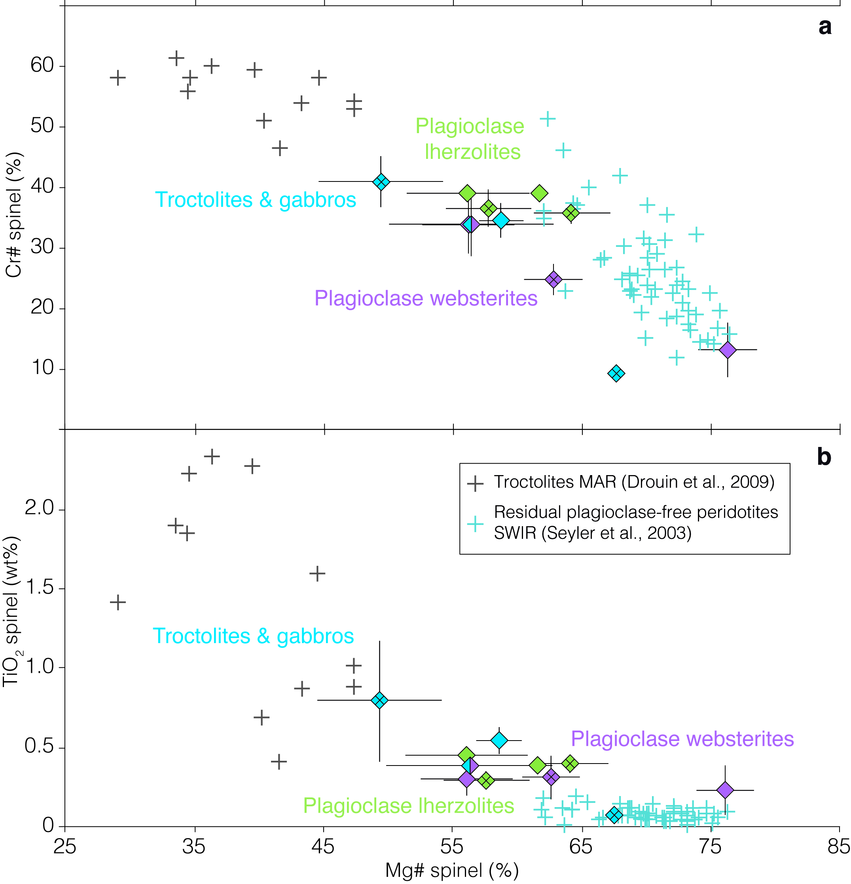
Figure 10. Spinel major element composition in samples of the plagioclase-bearing ultramafic to gabbroic suite. (a) Cr# as a function of Mg#. (b) TiO₂ content as a function of Mg#. Diamond data point corresponds to the average composition of several spinel grains in each sample (n values in Table 9). Error bars: ±1 std. Same symbols as in Figure 8a. Spinels in the samples describe the whole range defined by the spinels in residual plagioclase-free peridotites from the SWIR and in troctolites from the MAR, with an increase of Cr#, and TiO₂ content as the Mg# decreases.

5.3 Mineral trace element composition
Clinopyroxene. Clinopyroxenes in the plagioclase-bearing ultramafic to gabbroic suite have LREE-depleted REE patterns, with (La/Sm)_{n} between 0.01 and 0.16 (Figure 11a, Table 10). The HREE part of these patterns is nearly flat, with (Sm/Yb)_{n} ratios between 0.79 and 0.91. These clinopyroxene REE patterns are enriched in LREE relative to plagioclase-free residual lherzolites from the same region ((La/Sm)_{n} from 0.009 to 0.035; [Seyler et al., 2011]). Clinopyroxenes in the plagioclase-bearing lherzolites and websterites have very similar patterns, with no Eu anomaly. They are more depleted than clinopyroxenes from most analyzed troctolites, olivine gabbros and gabbros (Figure 11a). These plagioclase-rich lithologies have parallel REE patterns with distinct Eu anomalies. They also have higher Sr and Zr contents (9.8 to 25.4 ppm for Sr; 8.3 to 24.2 ppm for Zr) than the analyzed plagioclase-bearing websterite and lherzolite (5.5 ppm and 6.2 ppm respectively for Sr; 7.7 ppm and 8.7 ppm respectively for Zr; Table 8). The highest Sr contents correspond to the lowest Zr contents, and to the most depleted REE patterns.
Orthopyroxene. Orthopyroxenes have LREE-depleted patterns, characterized by a steep decrease from HREE to LREE (Figure 11a, Table 10). These patterns are similar in all the analyzed rock types (plagioclase-bearing lherzolites, plagioclase-bearing websterites, troctolites, olivine gabbros, and gabbros) and also similar to the REE composition of orthopyroxenes from plagioclase-free residual lherzolites from the same region [Seyler et al., 2011]. Orthopyroxenes in the plagioclase-bearing samples also have positive anomalies in Zr and Ti which are typical in orthopyroxenes from residual peridotites [Rampone et al., 1991].

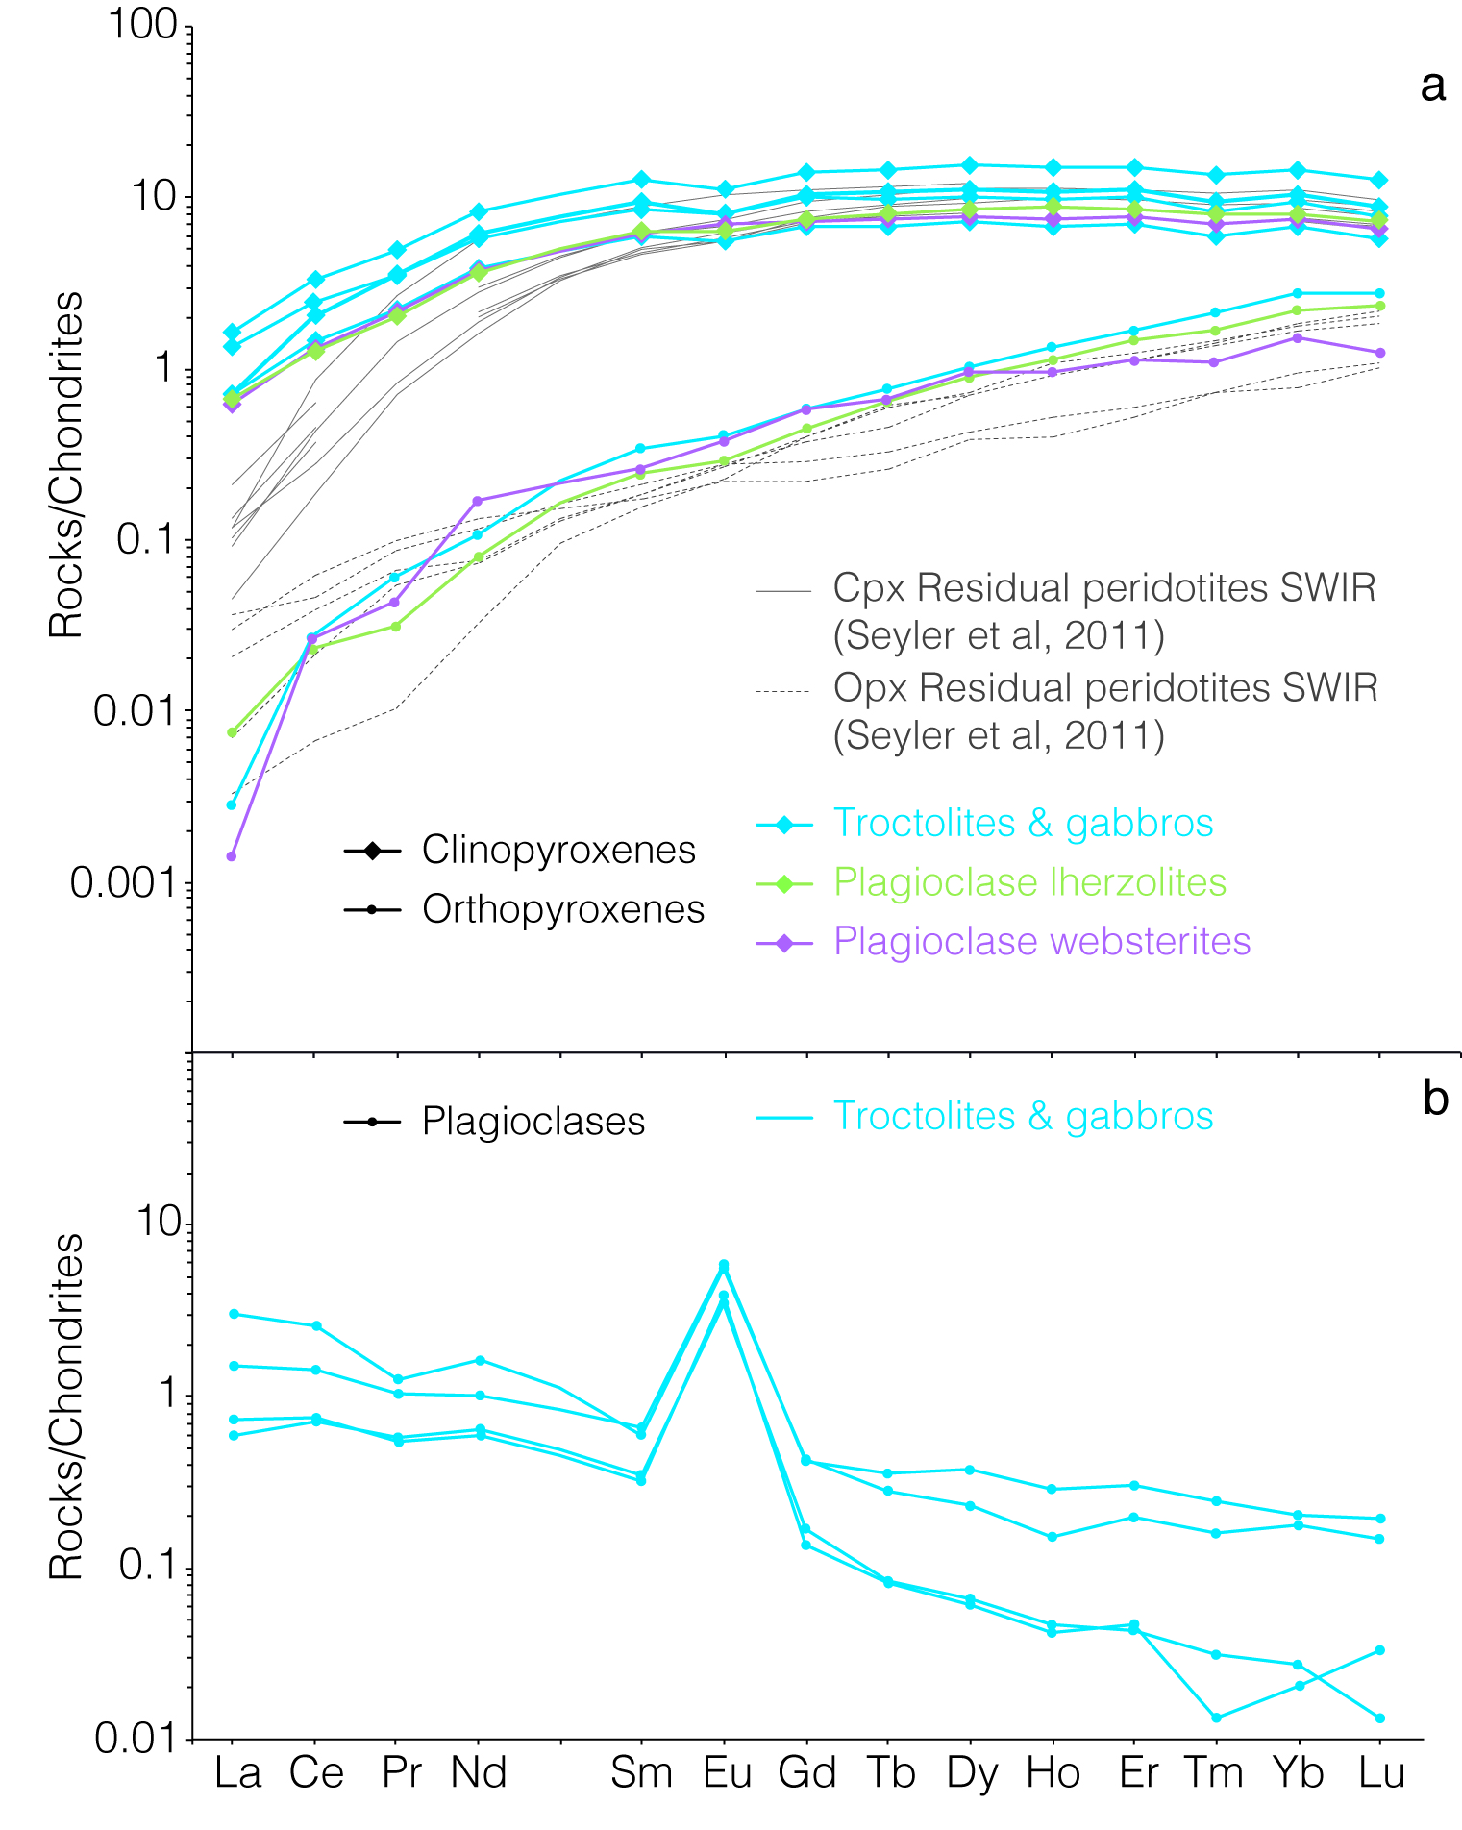
Figure 11. Chondrites-normalized Rare Earth Element (REE) diagrams for clinopyroxenes and orthopyroxenes (a), and for plagioclases (b) in samples of the plagioclase-bearing ultramafic to gabbroic suite for the 61°-65°E SWIR region. Each line corresponds to the average composition of several grains (n values in Table 10) in each sample. Normalizing values of McDonough and Sun [1995]. Data are colored according to modal mineralogy of the sample: plagioclase-bearing lherzolites in green, plagioclase-bearing websterites in purple, troctolites, olivine gabbros and gabbros in blue. Thin grey lines in (a) show the composition of clinopyroxenes and orthopyroxenes in plagioclase-free ultramafic rocks from the same region [Seyler et al., 2011]. Orthopyroxenes in the plagioclase-bearing samples have LREE-depleted compositions similar to orthopyroxenes in these plagioclase-free samples. By contrast, clinopyroxenes compositions in the plagioclase-bearing ultramafic to gabbroic rock suite are enriched in LREE compared to clinopyroxenes in plagioclase-free samples. Plagioclase REE diagrams have been measured only in the plagioclase-rich rock types (troctolites, olivine gabbros and gabbros).

Table 10. Trace element compositions (ppm) of clinopyroxenes, orthopyroxenes and plagioclases of plagioclase-bearing ultramafic rocks. Average composition of several grains in each sample. Error bars: ±1 std.
 | SMS6-2-1 |  |  |  |  |  | SMS15-3-20 |  |  |  |  |  |  |  |  | SMS21-3-1
 | Cpx |  |  | Pl |  |  | Cpx |  |  | Opx |  |  | Pl |  |  | Cpx |  |  | Pl
 | Core |  |  | Core |  |  | Core |  |  | Core |  |  | Core |  |  | Core |  |  | Core
 | (n=11) | ± |  | (n=2) | ± |  | (n=10) | ± |  | (n=1) | ± |  | (n=3) | ± |  | (n=6) | ± |  | (n=1) | ±
Sc | 75.7 | 11.0 |  | 0.8 | 0.2 |  | 73.2 | 6.8 |  | 35.9 | - |  | 0.7 | 0.3 |  | 78.7 | 3.0 |  | 0.8 | -
Ti | 3126.5 | 203.9 |  | 436.8 | 228.7 |  | 2308.8 | 255.6 |  | 861.7 | - |  | 157.0 | 69.6 |  | 2288.9 | 391.8 |  | 321.1 | -
V | 348.6 | 36.6 |  | 3.8 | 4.3 |  | 284.6 | 28.1 |  | 142.0 | - |  | 0.6 | 0.5 |  | 332.4 | 4.1 |  | 1.9 | -
Cr | 2938.0 | 1601.2 |  | 0.2 | 0.2 |  | 8950.3 | 670.5 |  | 5432.8 | - |  | 0.1 | 0.1 |  | 1668.0 | 522.9 |  | 0.0 | -
Mn | 927.6 | 97.4 |  | 67.9 | 82.4 |  | 840.1 | 100.9 |  | 1217.5 | - |  | 18.4 | 23.1 |  | 940.9 | 99.0 |  | 22.6 | -
Co | 25.8 | 1.6 |  | 1.5 | 2.1 |  | 23.8 | 3.0 |  | 54.6 | - |  | 0.4 | 0.6 |  | 28.8 | 2.1 |  | 0.0 | -
Ni | 315.1 | 13.6 |  | 25.1 | 35.5 |  | 321.8 | 38.1 |  | 606.7 | - |  | 6.0 | 10.3 |  | 398.7 | 33.4 |  | 0.0 | -
Zn | 7.3 | 0.8 |  | 0.8 | 0.8 |  | 5.1 | 1.6 |  | 15.6 | - |  | 0.2 | 0.1 |  | 16.9 | 2.4 |  | 1.3 | -
Rb | 0.0 | 0.0 |  | 0.2 | 0.1 |  | 0.0 | 0.1 |  | 0.0 | - |  | 0.2 | 0.1 |  | 0.0 | 0.0 |  | 0.6 | -
Sr | 9.8 | 0.5 |  | 265.1 | 8.7 |  | 8.0 | 1.2 |  | 0.3 | - |  | 276.0 | 45.5 |  | 12.8 | 1.5 |  | 329.7 | -
Y | 20.4 | 1.5 |  | 0.5 | 0.5 |  | 14.9 | 2.0 |  | 1.9 | - |  | 0.1 | 0.0 |  | 13.6 | 1.8 |  | 0.4 | -
Zr | 24.2 | 3.8 |  | 0.1 | 0.1 |  | 16.1 | 3.2 |  | 1.7 | - |  | 0.0 | 0.0 |  | 11.7 | 6.1 |  | 3.8 | -
Nb | 0.0 | 0.0 |  | 0.0 | 0.0 |  | 0.0 | 0.0 |  | 0.0 | - |  | 0.0 | 0.0 |  | 0.0 | 0.0 |  | 0.0 | -
Ba | 0.0 | 0.0 |  | 1.2 | 0.1 |  | 0.1 | 0.1 |  | 0.0 | - |  | 4.5 | 5.1 |  | 0.4 | 0.6 |  | 14.3 | -
La | 0.4 | 0.1 |  | 0.4 | 0.1 |  | 0.2 | 0.0 |  | 0.0 | - |  | 0.1 | 0.0 |  | 0.3 | 0.1 |  | 0.7 | -
Ce | 2.0 | 0.3 |  | 0.9 | 0.1 |  | 1.2 | 0.1 |  | 0.0 | - |  | 0.4 | 0.1 |  | 1.5 | 0.4 |  | 1.6 | -
Pr | 0.5 | 0.1 |  | 0.1 | 0.0 |  | 0.3 | 0.0 |  | 0.0 | - |  | 0.1 | 0.0 |  | 0.3 | 0.1 |  | 0.1 | -
Nd | 3.7 | 0.4 |  | 0.5 | 0.1 |  | 2.8 | 0.3 |  | 0.0 | - |  | 0.3 | 0.1 |  | 2.6 | 0.6 |  | 0.7 | -
Sm | 1.9 | 0.2 |  | 0.1 | 0.0 |  | 1.4 | 0.2 |  | 0.1 | - |  | 0.1 | 0.0 |  | 1.3 | 0.3 |  | 0.1 | -
Eu | 0.6 | 0.1 |  | 0.3 | 0.0 |  | 0.4 | 0.0 |  | 0.0 | - |  | 0.2 | 0.0 |  | 0.4 | 0.0 |  | 0.3 | -
Gd | 2.8 | 0.2 |  | 0.1 | 0.0 |  | 2.1 | 0.3 |  | 0.1 | - |  | 0.0 | 0.0 |  | 2.0 | 0.3 |  | 0.1 | -
Tb | 0.5 | 0.0 |  | 0.0 | 0.0 |  | 0.4 | 0.1 |  | 0.0 | - |  | 0.0 | 0.0 |  | 0.4 | 0.0 |  | 0.0 | -
Dy | 3.8 | 0.2 |  | 0.1 | 0.1 |  | 2.8 | 0.4 |  | 0.3 | - |  | 0.0 | 0.0 |  | 2.5 | 0.3 |  | 0.1 | -
Ho | 0.8 | 0.1 |  | 0.0 | 0.0 |  | 0.6 | 0.1 |  | 0.1 | - |  | 0.0 | 0.0 |  | 0.5 | 0.1 |  | 0.0 | -
Er | 2.4 | 0.2 |  | 0.0 | 0.0 |  | 1.8 | 0.3 |  | 0.3 | - |  | 0.0 | 0.0 |  | 1.6 | 0.2 |  | 0.0 | -
Tm | 0.3 | 0.0 |  | 0.0 | 0.0 |  | 0.2 | 0.0 |  | 0.1 | - |  | 0.0 | 0.0 |  | 0.2 | 0.0 |  | 0.0 | -
Yb | 2.4 | 0.1 |  | 0.0 | 0.0 |  | 1.7 | 0.2 |  | 0.4 | - |  | 0.0 | 0.0 |  | 1.5 | 0.2 |  | 0.0 | -
Lu | 0.3 | 0.0 |  | 0.0 | 0.0 |  | 0.2 | 0.0 |  | 0.1 | - |  | 0.0 | 0.0 |  | 0.2 | 0.0 |  | 0.0 | -
Hf | 0.8 | 0.1 |  | 0.0 | 0.0 |  | 0.6 | 0.1 |  | 0.1 | - |  | 0.0 | 0.0 |  | 0.5 | 0.2 |  | 0.1 | -
Pb | 0.0 | 0.0 |  | 0.2 | 0.1 |  | 0.0 | 0.0 |  | 0.0 | - |  | 0.0 | 0.0 |  | 0.0 | 0.0 |  | 0.3 | -
Ta | 0.0 | 0.0 |  | 0.0 | 0.0 |  | 0.0 | 0.0 |  | 0.0 | - |  | 0.0 | 0.0 |  | 0.0 | 0.0 |  | 0.0 | -
Th | 0.0 | 0.0 |  | 0.0 | 0.0 |  | 0.0 | 0.0 |  | 0.0 | - |  | 0.0 | 0.0 |  | 0.0 | 0.0 |  | 0.1 | -
U | 0.0 | 0.0 |  | 0.0 | 0.0 |  | 0.0 | 0.0 |  | 0.0 | - |  | 0.0 | 0.0 |  | 0.0 | 0.0 |  | 0.0 | -

 | SMS29-3-9 |  |  |  |  |  | ED21-10-3 |  |  |  |  |  | ED23-3-6
 | Cpx |  |  | Opx |  |  | Cpx |  |  | Pl |  |  | Cpx |  |  | Opx
 | Core |  |  | Core |  |  | Core |  |  | Core |  |  | Core |  |  | Core
 | (n=7) | ± |  | (n=1) | ± |  | (n=9) | ± |  | (n=2) | ± |  | (n=4) |  |  | (n=6) | ±
Sc | 53.1 | 21.7 |  | 17.1 | - |  | 62.1 | 22.0 |  | 0.9 | 0.3 |  | 53.0 | 9.0 |  | 29.1 | 2.2
Ti | 1822.8 | 362.3 |  | 868.0 | - |  | 1552.7 | 544.8 |  | 152.3 | 3.6 |  | 1618.2 | 176.9 |  | 752.0 | 44.5
V | 255.4 | 108.4 |  | 103.3 | - |  | 264.3 | 101.6 |  | 1.1 | 0.1 |  | 237.4 | 22.0 |  | 136.2 | 8.1
Cr | 2824.9 | 722.1 |  | 2444.2 | - |  | 4115.9 | 1691.9 |  | 0.7 | 0.7 |  | 7691.1 | 167.5 |  | 5105.3 | 451.8
Mn | 1076.8 | 59.8 |  | 1080.3 | - |  | 773.0 | 190.3 |  | 17.5 | 0.8 |  | 694.0 | 68.7 |  | 993.5 | 60.5
Co | 25.8 | 2.4 |  | 57.1 | - |  | 23.0 | 8.6 |  | 0.2 | 0.0 |  | 23.8 | 3.1 |  | 50.2 | 1.7
Ni | 313.8 | 29.6 |  | 642.9 | - |  | 290.4 | 161.3 |  | 1.7 | 2.4 |  | 386.4 | 26.5 |  | 674.7 | 23.3
Zn | 5.2 | 0.6 |  | 12.7 | - |  | 14.4 | 3.5 |  | 1.2 | 0.2 |  | 5.1 | 1.5 |  | 15.4 | 0.4
Rb | 0.0 | 0.0 |  | 0.0 | - |  | 0.1 | 0.2 |  | 0.1 | 0.0 |  | 0.0 | 0.0 |  | 0.0 | 0.0
Sr | 5.5 | 3.6 |  | 0.2 | - |  | 25.4 | 50.9 |  | 232.8 | 7.0 |  | 6.2 | 2.0 |  | 0.1 | 0.0
Y | 10.2 | 2.2 |  | 1.5 | - |  | 9.5 | 4.0 |  | 0.1 | 0.0 |  | 11.9 | 1.3 |  | 1.8 | 0.2
Zr | 7.7 | 1.7 |  | 2.7 | - |  | 8.3 | 4.0 |  | 0.1 | 0.1 |  | 8.7 | 1.5 |  | 1.5 | 0.2
Nb | 0.0 | 0.0 |  | 0.0 | - |  | 0.0 | 0.0 |  | 0.0 | 0.0 |  | 0.0 | 0.0 |  | 0.0 | 0.0
Ba | 0.1 | 0.1 |  | 0.0 | - |  | 0.4 | 0.7 |  | 2.6 | 0.3 |  | 0.0 | 0.0 |  | 0.0 | 0.0
La | 0.1 | 0.0 |  | 0.0 | - |  | 0.2 | 0.0 |  | 0.2 | 0.0 |  | 0.2 | 0.0 |  | 0.0 | 0.0
Ce | 0.8 | 0.2 |  | 0.0 | - |  | 0.9 | 0.2 |  | 0.5 | 0.0 |  | 0.8 | 0.1 |  | 0.0 | 0.0
Pr | 0.2 | 0.0 |  | 0.0 | - |  | 0.2 | 0.1 |  | 0.1 | 0.0 |  | 0.2 | 0.0 |  | 0.0 | 0.0
Nd | 1.7 | 0.3 |  | 0.1 | - |  | 1.8 | 0.7 |  | 0.3 | 0.0 |  | 1.6 | 0.2 |  | 0.0 | 0.0
Sm | 0.9 | 0.1 |  | 0.0 | - |  | 0.9 | 0.4 |  | 0.0 | 0.0 |  | 0.9 | 0.0 |  | 0.0 | 0.0
Eu | 0.4 | 0.0 |  | 0.0 | - |  | 0.3 | 0.1 |  | 0.2 | 0.0 |  | 0.4 | 0.0 |  | 0.0 | 0.0
Gd | 1.4 | 0.3 |  | 0.1 | - |  | 1.3 | 0.6 |  | 0.0 | 0.0 |  | 1.5 | 0.2 |  | 0.1 | 0.0
Tb | 0.3 | 0.1 |  | 0.0 | - |  | 0.2 | 0.1 |  | 0.0 | 0.0 |  | 0.3 | 0.0 |  | 0.0 | 0.0
Dy | 1.9 | 0.4 |  | 0.2 | - |  | 1.8 | 0.8 |  | 0.0 | 0.0 |  | 2.1 | 0.2 |  | 0.2 | 0.0
Ho | 0.4 | 0.1 |  | 0.1 | - |  | 0.4 | 0.2 |  | 0.0 | 0.0 |  | 0.5 | 0.1 |  | 0.1 | 0.0
Er | 1.2 | 0.3 |  | 0.2 | - |  | 1.1 | 0.5 |  | 0.0 | 0.0 |  | 1.4 | 0.2 |  | 0.2 | 0.0
Tm | 0.2 | 0.0 |  | 0.0 | - |  | 0.1 | 0.1 |  | 0.0 | 0.0 |  | 0.2 | 0.0 |  | 0.0 | 0.0
Yb | 1.2 | 0.3 |  | 0.2 | - |  | 1.1 | 0.4 |  | 0.0 | 0.0 |  | 1.3 | 0.2 |  | 0.4 | 0.0
Lu | 0.2 | 0.0 |  | 0.0 | - |  | 0.1 | 0.1 |  | 0.0 | 0.0 |  | 0.2 | 0.0 |  | 0.1 | 0.0
Hf | 0.4 | 0.1 |  | 0.1 | - |  | 0.3 | 0.2 |  | 0.0 | 0.0 |  | 0.4 | 0.1 |  | 0.1 | 0.0
Pb | 0.0 | 0.0 |  | 0.0 | - |  | 0.0 | 0.0 |  | 0.1 | 0.0 |  | 0.0 | 0.0 |  | 0.0 | 0.0
Ta | 0.0 | 0.0 |  | 0.0 | - |  | 0.0 | 0.0 |  | 0.0 | 0.0 |  | 0.0 | 0.0 |  | 0.0 | 0.0
Th | 0.0 | 0.0 |  | 0.0 | - |  | 0.0 | 0.0 |  | 0.0 | 0.0 |  | 0.0 | 0.0 |  | 0.0 | 0.0
U | 0.0 | 0.0 |  | 0.0 | - |  | 0.0 | 0.0 |  | 0.0 | 0.0 |  | 0.0 | 0.0 |  | 0.0 | 0.0

Plagioclase. Plagioclase REE compositions have been measured only in the plagioclase-rich rock types (troctolites, olivine gabbros and gabbros) because plagioclase grains in the plagioclase-bearing lherzolites and plagioclase-bearing websterites were too small to be analysed by LA-ICP-MS. The four analyzed samples have low plagioclase HREE contents (Yb_{n} = 0.01 – 0.2), LREE-enriched patterns with strong Eu anomalies. Two samples display more enriched patterns, with slightly flatter HREE portions ((Sm/Yb)_{n} = 3.313 – 3.314). The other two samples show more depleted plagioclase REE patterns, with steeper slopes for the HREE parts of the patterns ((Sm/Yb)_{n} = 12.565 – 15.502). The most enriched REE patterns correspond to plagioclase with An contents ≤60% (Figure 8) and to samples with the most REE-enriched clinopyroxenes (Figure 11a).
The range of REE composition for melts calculated to be in equilibrium with the clinopyroxenes of the plagioclase-bearing ultramafic rocks (using clinopyroxene/liquid partition coefficients from Lee et al. [2007]) is shown in Figure 12. Melts calculated to be in equilibrium with the least enriched clinopyroxenes (Figure 12) have flat REE patterns and abundances similar to those of most basalts sampled in the study area (all of the ultramafic seafloor basalts and most basalts from the volcanic seafloor domains; Figure 4a). The REE compositions of melts calculated to be in equilibrium with plagioclase (using plagioclase/liquid partition coefficients from Bédard et al. [1994]) are inconsistent for HREE. We note that a similar inconsistency was found for melt REE compositions calculated from clinopyroxene and plagioclase REE patterns in troctolites and olivine gabbros from other abyssal [Drouin et al., 2009] and ophiolitic (data not shown: Kelemen et al. [1997], Borghini et al. [2007], Borghini and Rampone [2007], Renna and Tribuzio [2011]) locations. This suggests that the available plagioclase/liquid partition coefficients are possibly not appropriate for HREE.

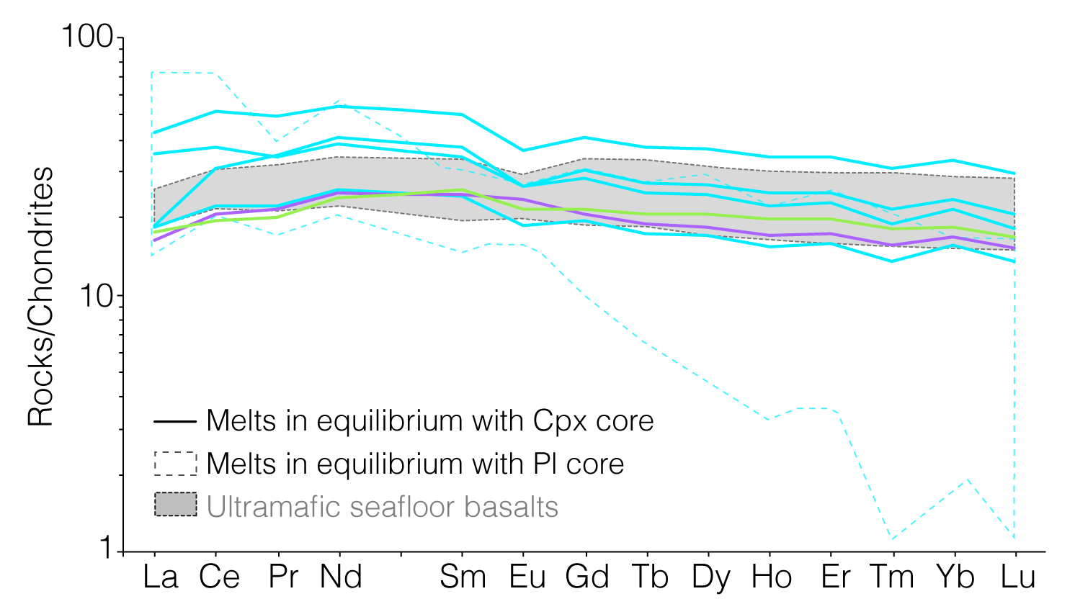
Figure 12. Chondrite-normalized REE concentrations in melts calculated to be in equilibrium with the clinopyroxenes and plagioclases (clinopyroxene/liquid partition coefficients from Lee et al. [2007]; plagioclase/liquid partition coefficients from Bédard et al. [1994]). Normalizing values of McDonough and Sun [1995]. The field of ultramafic seafloor basalts (Figure 4a) is shown for comparison.

6 Discussion
In this study we have shown that most basalts dredged from the sparse volcanic cover of the nearly amagmatic corridors ("ultramafic seafloor basalts") have significantly lower CaO contents at a given MgO (Figure 3b) than most basalts dredged from the intervening, more volcanically active domains ("volcanic seafloor basalts"). Ultramafic seafloor basalts also tend to have higher Na₂O and TiO₂ contents (Figures 3a and f), and lower Al₂O₃ and FeO contents (Figures 3c and d) at a given MgO content. These characteristics cannot be collectively explained by invoking a lower degree of mantle melting beneath the nearly amagmatic spreading corridors: Na₂O and TiO₂ contents would then indeed be higher, but so would Al₂O₃ contents. Moreover, ultramafic seafloor basalts also have isotopic and trace element compositions similar to most volcanic seafloor basalts (Tables 2 and 3, and Figure 4), which is consistent with the idea that these two groups of basalts derive from similar degrees of melting of a common mantle source.
We also examined the petrology and chemistry of plagioclase-bearing ultramafic and gabbroic rocks dredged at several locations in the nearly amagmatic spreading corridors (Figure 1). These samples represent a small fraction of the rocks dredged in these corridors (4% in volume; Sauter et al., [2013]). They show impregnation and melt-rock reaction textures such as interstitial plagioclase lenses, rims of secondary orthopyroxene between olivine and plagioclase (Figure 7e), replacement of primary orthopyroxene by clinopyroxene (Figures 7b, c and d), and clinopyroxenes with plagioclase and orthopyroxene inclusions. Olivines and orthopyroxenes have major and trace compositions similar to those measured in plagioclase-free residual lherzolites and websterites of the same region [Seyler et al., 2003, 2011; Brunelli et al., 2014]. Clinopyroxenes by contrast have LREE-enriched trace element compositions (Figure 11a). Melts calculated to be in equilibrium with these clinopyroxenes have trace element compositions similar to those of the basalts (Figure 12).
In the first part of the discussion we propose that the differences in major element composition between ultramafic and volcanic seafloor basalts could result from different degrees of reaction between plagioclase-free residual lherzolites and websterites and a common parental melt. We also discuss the implications of this hypothesis in terms of the ridge's magma plumbing system. Being aware that the 61°-67°E region of the SWIR represents a very low melt budget end-member for mid-ocean ridges, we then introduce a discussion of the extent to which our observations in this region may be significant for other, more magmatically active ridges.

6.1 A mass balance model of the effect of melt-rock interactions on the major element composition of ultramafic seafloor basalts
Textural relations and mineral chemistry in the plagioclase-bearing ultramafic and gabbroic sample suite indicate that:
- melt infiltration and the resulting melt-rock reactions mostly occurred in centimeter to decimeter-scale irregular veins and impregnations in plagioclase-free lherzolites and websterites. These small scales of melt infiltration are supported by the observation that the transition from plagioclase-free to plagioclase-rich lithologies is commonly observed within a single small sample (for example Figures 5b and c).
- plagioclase and clinopyroxene are the principal mineral products of melt-rock interactions, while olivine, and most orthopyroxene (to the exception of small orthopyroxenes in olivine-plagioclase reaction rims; Figure 7e) are relicts of the plagioclase-free protolith. Spinel has amoeboid to vermicular shapes, which is texturally different from residual poikilitic spinel in plagioclase-free ultramafic rocks of the same region [Seyler et al., 2003], and has, with few exceptions, higher Cr# and TiO₂ contents, and lower Mg# (Figure 10). These chemical differences most likely result from partial destabilization of the peridotite's spinel into plagioclase and re-equilibration with the melt.
- melt infiltration and crystallization of plagioclase and clinopyroxene postdate a strain episode that produced kink bands in relicts of formerly larger orthopyroxene porphyroclasts now enclosed in undeformed or weakly deformed clinopyroxene (Figure 7c). This early deformation shows that the melt infiltration occurred in ultramafic rocks that had been cooled and submitted to deformation in the axial lithosphere. Most plagioclase-bearing samples also show evidence for a later stage of deformation that also affects clinopyroxene and plagioclase (plagioclase grains are mechanically twinned and partially recrystallized, while clinopyroxene grains are kinked, Figures 6c and d).
- although clinopyroxene is clearly secondary (it encloses relicts of orthopyroxene and small plagioclase grains) and has enriched trace element compositions (consistent with crystallization from a melt with trace element compositions similar to those of the basalts; Figure 12), it also has high Mg# (Figure 9). These high Mg# values are measured even in samples of troctolite, olivine gabbro and gabbro with plagioclase An contents lower than 65% (Figure 9), a value that typically corresponds in abyssal gabbros to the co-crystallization of clinopyroxene with Mg# between 80 and 85% [e.g. Bloomer et al., 1991; Cannat et al., 1997a, 1997b; Ross and Elthon, 1997; Dick et al., 2002; Miller et al., 2009 and Figure 9]. The clinopyroxene Mg# in the plagioclase-bearing samples can be interpreted as buffered by that of the plagioclase-free protolith, as proposed for clinopyroxene in gabbroic veins drilled in serpentinized peridotites next to the Kane Fracture zone (MAR; [Cannat et al., 1997a]), implying that the documented melt-rock interactions occurred at very low melt-rock ratio.
Taking these observations into account, we now want to test whether the major element composition of the ultramafic seafloor basalts could retain a signature of the documented melt-rock interactions, and what would then be the range of possible major element compositions for the parent melt. To this aim, we develop a simple mass balance model in which we use the modal abundances and the major and trace element composition of the mineral phases in the inferred products of melt-rock interaction (plagioclase-bearing ultramafic to gabbroic rocks and ultramafic seafloor basalt), and in plagioclase-free residual lherzolites (inferred solid prior to reaction), to reconstruct the initial composition of the reacting melt.
In the model results shown in Figure 13, we selected the spinel lherzolite sample ED21-5-1 [Seyler et al., 2003] as the starting rock material. For the reacted rock, we used the modal and chemical composition of olivine gabbro sample SMS17-5-6 (Figures 5c and 7a; Tables 2, 3, 4, 5, 6, 7). For the reacted melt, we used sample SMS16-3-5 that has the most MgO-rich composition among ultramafic seafloor basalts (Figures 3 and 4; Table 1). We made the calculations assuming that the reactions (dissolution of orthopyroxene and olivine and crystallization of clinopyroxene and plagioclase) occurred with either no solid mass change, or with a solid mass change of 100%. In this second case, which corresponds to more liquid being trapped in the reaction zone, calculated results change in absolute values but not in the general trends (Figure 13). The principal variable in the calculations is the melt-rock ratio expressed as the mass of liquid after the reaction over the initial mass of ultramafic reacted rock. We allow this ratio to vary between 30 and 500 (Figure 13). For this range of melt-rock ratios, the trace element and TiO₂ contents of the melt are not modified. For melt-rock ratios above 100, the reconstructed initial major element composition of the reacting melt is not substantially different from that of the erupted ultramafic seafloor basalt. However, for melt-rock ratios of ≤50, the reconstructed initial major element composition of the reacting melt has substantially lower MgO, and higher CaO and Al₂O₃ contents than the erupted ultramafic seafloor basalt. It therefore plots within the range of the volcanic seafloor basalts (Figure 13).
This leads us to propose that the ultramafic seafloor basalts and the volcanic seafloor basalts are derived from similar parental melts, but that the ultramafic seafloor basalts are more affected by reactions between these parent melts and the mantle rocks in the lithosphere below the ridge. This interpretation is supported by the observation that the REE patterns of the ultramafic seafloor basalts are similar to those of most volcanic seafloor basalts (Figure 4), and that there are no differences between ultramafic and volcanic seafloor basalts for isotopic indicators of mantle source composition (Table 3). Ultramafic seafloor basalt SMS16-3-14, that has a REE pattern similar to those of the other basalts in the same dredge (Figure 4 and Table 2), yet plots at lower MgO contents (Figure 3), could represent the initial composition of the reacting melt for the other basalts in this dredge, assuming melt-rock reaction ratios ≤30. Furthermore, a few volcanic seafloor basalts in the study area have higher MgO and FeO contents, lower Na₂O, TiO₂ and SiO₂ contents (grey dots in Figure 3) and LREE-depleted signatures (Figure 4). We have not recovered ultramafic seafloor basalts with such depleted REE patterns (Figure 4).
The mass balance model shown in Figure 13 is calculated with ultramafic seafloor basalt SMS16-3-5 as a proposed reacted melt. Ultramafic seafloor basalts recovered in dredges SMS24, 26 and 31 (Figure 1) have relatively enriched REE and trace compositions and show negative Eu anomalies (Figure 4). This suggests that these basalts result from significant fractional crystallization of a parental melt. By contrast, ultramafic seafloor dredges SMS23 and 28 (Figure 1) contain basalts that have REE and trace element compositions similar to dredge SMS16. However, basalts from these two other dredges have lower Na₂O and Al₂O₃ contents, and higher CaO and FeO contents, than the MgO-rich samples in dredge SMS16 (Figure 13). Using basalts from these dredges as the proposed reacted melts instead of sample SMS16-3-5 and keeping the same composition for the reacted mantle and for the solid product of the reaction yields calculated mass balance trends for each element that are simply offset but otherwise identical. For melt-rock ratios around 50, these trends therefore also predict initial compositions of the reacting melts that plot within the range of volcanic seafloor basalts, at lower Al₂O₃ and Na₂O, and at slightly higher CaO and FeO contents than the initial compositions of the reacting melt proposed for dredge SMS16 (Figure 13).

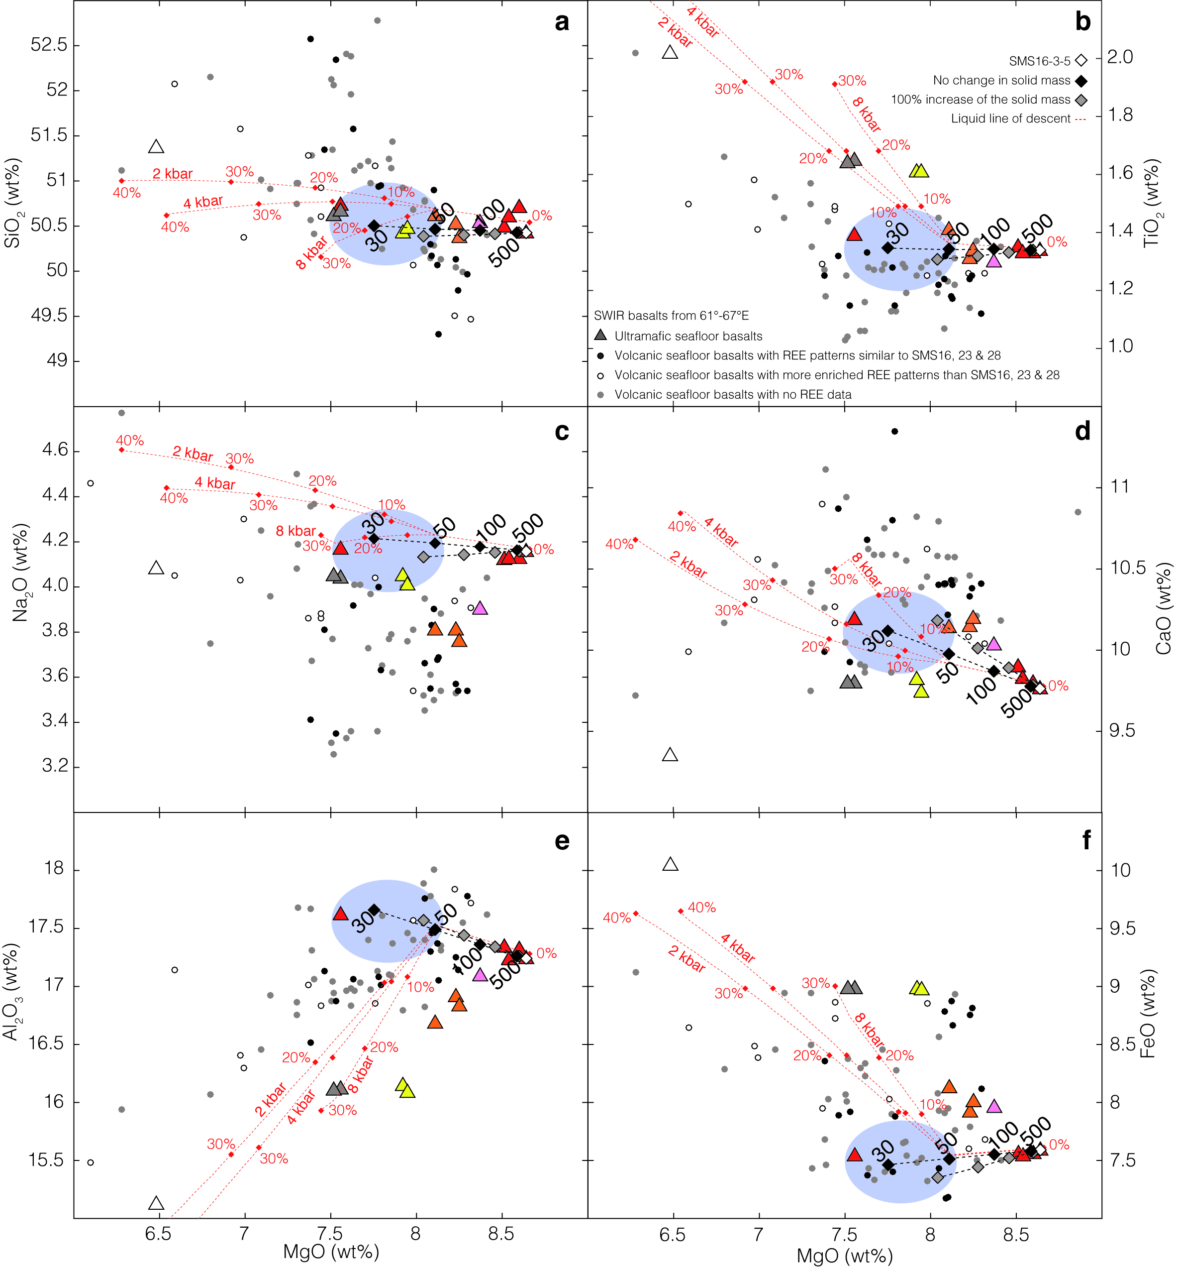
Figure 13. Mass balance model of the possible effect of melt-rock interactions in the mantle lithosphere on the major element composition of basalts in the easternmost Southwest Indian Ridge. In this model, we use the modal abundances and major element composition of the mineral phases in the inferred products of melt-rock interaction (olivine gabbro sample SMS17-5-6 and ultramafic seafloor basalt sample SMS16-3-5), and in plagioclase-free residual lherzolite (inferred solid prior to reaction: sample ED21-5-1; Seyler et al. [2003]), to reconstruct the initial composition of the reacting melt (black diamonds: no change in solid mass; grey diamonds: 100% increase of the solid mass) for a range of melt-rock ratios (see text; Matlab code is available on request). Blue ellipses correspond to the hypothetical compositional range of the initial reacting melts. SiO₂ (a), TiO₂ (b), Na₂O (c), CaO (d), Al₂O₃ (e) and FeO (f) contents in function of MgO content. Dotted lines correspond to the liquid lines of descent for different crystallization pressures of 2, 4 and 8 kbar calculated with the Petrolog code [Danyushevsky and Plechov, 2011] for a starting composition similar to ultramafic seafloor basalt SMS16-3-5. Dots along these trends correspond to percent of crystallization. The details of these calculations are given in the Supplementary material Text S2. The model trends are plotted over the composition of easternmost SWIR basalts shown as dots. White dots correspond to samples with REE patterns that are more enriched than ultramafic seafloor basalts from dredges SMS16, 23 and 28. Dark grey dots correspond to samples with REE patterns similar to ultramafic seafloor basalts from dredges SMS16, 23 and 28. The very primitive, LREE-depleted basalts that are shown in grey symbols in Figure 3, are not represented here.

6.2 Melt-rock reactions and fractional crystallization
In Figure 13 we also show the liquid lines of descent (LLD) calculated with the Petrolog code [Danyushevsky and Plechov, 2011] for fractional crystallization of olivine, plagioclase and clinopyroxene for a range of pressures (2, 4 and 8 kbar). The starting melt composition is that of basalt sample SMS16-3-5. LLDs calculated for the more calcium-rich ultramafic seafloor basalts in dredges SMS23 and 28 (pink and orange triangles in Figure 13) are similar to those calculated for sample SMS16-3-5, except that they predict that clinopyroxene starts crystallizing a bit earlier (for example clinopyroxene is in at 13.6% and 19.1% fractional crystallization, respectively, at 8 kbar, against 26.3% with basalt sample SMS16-3-5 as a starting melt).
We see that the melt-mantle reaction trends, calculated with this mass balance approach using basalt sample SMS16-3-5 as the composition of the reacted melt, are comparable to the early portions of these LLDs. This is understandable because in these early portions of the LLDs, Petrolog predicts fractional crystallization of olivine, then of olivine and plagioclase (Figure 13), while olivine dissolution leading to higher MgO content of the reacted melt clearly dominates the calculated melt-rock reaction trends. The similarity between LLDs and melt-mantle reaction trends is strong over the full range of investigated melt-rock ratios for SiO₂, CaO and Na₂O. For Al₂O₃, FeO and TiO₂, the similarity does not persist for the lowest melt-rock ratios because these three elements vary rapidly in LLDs as plagioclase kicks in and as crystallization rates increase (for basalt sample SMS16-3-5 as a starting melt, plagioclase is in at only 1.4% fractional crystallization over the range of investigated crystallization pressures; Figure 13).
Because of the similarity between the early portions of the LLDs and the melt-mantle reaction trends, basalts with intermediate MgO contents in the sample set can be interpreted either as parent melts that have escaped the effects of melt-mantle interactions on their way to the seafloor (or have been involved in such reactions but at melt-rock ratios >100), or as the product of small (<10%; Figure 13) degrees of fractional crystallization from parent melts that would instead have been similar in composition to the more Mg-rich ultramafic seafloor samples. Trace element composition is key to discriminate between these two interpretations. Figure 13 shows that volcanic seafloor basalts that have enriched REE patterns with negative Eu anomalies indicative of plagioclase fractionation (Figure 4), have MgO content between 6.6 and 8.3 wt% and TiO₂ contents between 1.3 and 1.6 wt%. By contrast, volcanic seafloor basalts with REE patterns similar to those of the ultramafic seafloor basalts in dredges SMS-DR16, 23 and 28 have MgO content between 7.4 and 8.3 wt% and TiO₂ contents between 1.1 and 1.3 wt%.

6.3 Magma plumbing system at a melt-poor and ultraslow mid-ocean ridge
Our interpretation links the plagioclase-bearing reacted ultramafic and gabbroic rocks sampled in the nearly amagmatic corridors of the study area, to interactions with basaltic melts that have then been erupted at the seafloor. In this interpretation, ultramafic seafloor basalts and most volcanic seafloor basalts result from similar degrees of melting of a common mantle source and the inferred composition of the parental melts for these two groups of basalts (shaded domains in Figure 13) is close to that of those volcanic seafloor basalts that have flat REE patterns similar to those of the ultramafic seafloor basalts from dredges SMS16, 23 and 28.
The melt-rock reactions documented in this study occur in the deep (and hot) levels of the axial lithosphere, yet they affect mantle rocks that had already undergone some degree of semi-plastic deformation (kinking of orthopyroxene). In the sketch of Figure 14, we therefore infer that these reactions occurred in the ductile to semi-brittle part of the axial lithosphere, at temperatures between the liquidus of the aggregated MORB and the base of the brittle lithosphere. We propose that such reactions occur beneath both the volcanic and the ultramafic seafloor domains, but that they result in substantial major element compositional changes of the upflowing melt only below the ultramafic seafloor domains because the melt-rock ratio there is very low. The mass balance calculations suggest that melt-rock ratios ≤50 are required in order to transform a parental melt with the composition of a volcanic seafloor basalt, into an ultramafic seafloor basalt composition. Such low ratios would be consistent with the very small volume of erupted basalt in ultramafic seafloor domains: the isolated basaltic construction imaged in Figure 2 is about 2.5 by 1 km and less than 150m-high and would therefore require less than 0.008 km³ of reacted mantle forming in the deep axial lithosphere.
In the conceptual sketch of Figure 14, we show these melt-rock reactions as occurring in the walls of the conduits that allow the aggregated melts extracted from the melting mantle to rise through the axial lithosphere and to the eruption sites. This is in contrast to previous interpretations that have proposed that similar reacted mantle rocks in other ridge settings result from melt trapping in the deep lithosphere [Godard et al., 2009; Drouin et al., 2009; Renna and Tribuzio, 2011; Sanfilippo et al., 2014]. Microseismicity data recorded at the SWIR axis near 66°E [Schlindwein et al., 2014], indicate that the seismogenic (i.e. brittle) part of the axial lithosphere there is substantially thicker than at the faster-spreading Mid-Atlantic Ridge (15 to 20 km-thick against about 8 km-thick at the MAR; [Toomey et al., 1988; Wolfe et al., 1995; de Martin et al., 2007]). In this thick lithosphere context, focusing of the melts toward volcanic areas can be enhanced [Cannat et al., 2003; Standish et al., 2008], favoring the formation of large axial volcanoes and further depleting the intervening nearly amagmatic ridge domains (Figure 14).

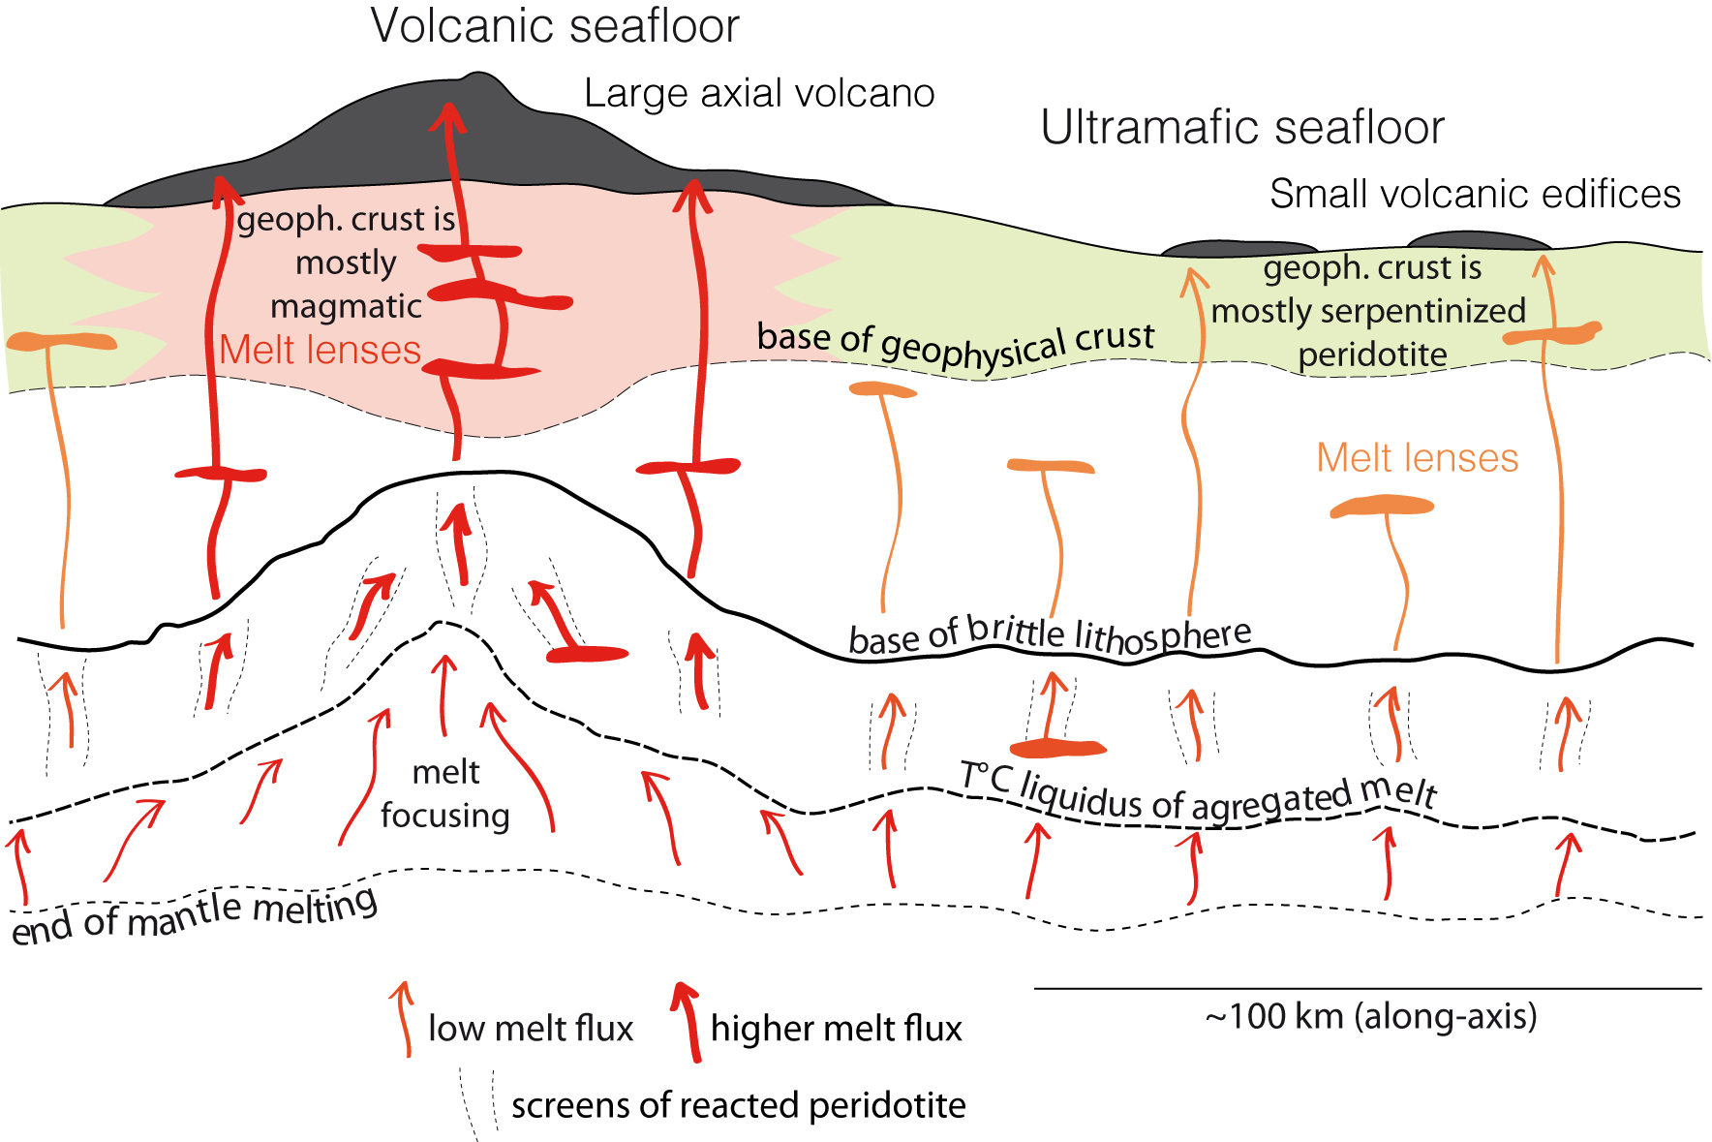
Figure 14. Cartoon showing the geological context proposed for melt-mantle interactions and for the melt plumbing system at the easternmost Southwest Indian Ridge. Along-axis section, not to scale. In this conceptual sketch, we propose that melting of a common mantle source occurs to a similar degree below volcanic seafloor and ultramafic seafloor domains. The extracted melts are then focused preferentially toward volcanic domains, generating higher melt fluxes and leading to the formation of large axial volcanos, as proposed by Cannat et al. [2003], and by Standish et al. [2008]. The melt-mantle reactions documented in this paper are proposed to occur in the walls of melt conduits, at temperatures lower than the liquidus temperature of the agregated parent melt and below the basis of the brittle axial lithosphere. Microseismic data suggests that this brittle lithosphere is >15 km-thick in the ultramafic seafloor domains [Schlindwein et al., 2014]. Arrows figure the flux of melt at each "structural level" above the melting mantle. Low fluxes in the reactive domains result in low overall melt-rock ratios and in a more modified major element composition (Figure 13) of the reacted melt (orange). Subsequent fractional crystallization may occur in melt lenses emplaced at various levels through the axial lithosphere.
The conceptual sketch in Figure 14 also includes melt lenses located at various depths in the axial lithosphere (in the mantle or in the crust). These melt lenses have not been imaged seismically yet in the study area. Their existence is, however likely, beneath the large axial volcanoes by analogy with what is known of the melt plumbing system of large volcanoes in other geodynamic contexts [Gudmundsson et al., 1994; Okubo et al., 1997]. The major and trace element composition of both the volcanic and ultramafic seafloor basalts (Figures 3 and 4) indicates variable degrees of fractional crystallization that could take place in such lenses.
Clinopyroxene compositions of the plagioclase-bearing ultramafic and gabbroic reacted rocks indicate that most samples result from reactions with a melt that had the trace element composition of the most primitive erupted basalts in the area (not considering the very primitive, LREE-depleted basalts that are shown in grey symbols in Figure 3). However, a few samples of troctolites and olivine gabbros appear to result from reactions with a melt that was more enriched in trace elements (Figure 12) and that crystallized plagioclase with lower An and higher TiO₂, K₂O contents (Figure 8a). This suggests that limited fractional crystallization of some of the upflowing melt did occur in the deepest levels of the axial lithosphere, prior to melt-mantle interactions.
These constraints on the axial magma plumbing system of the ultraslow and melt-depleted study area are based on the joined study of erupted basalts and of the plagioclase-bearing ultramafic and gabbroic reacted rock suite. In addition, it is important to stress that the data on basalt composition alone indicates that the melts erupted on the exhumed ultramafic rocks in the nearly amagmatic corridors are distinct from those erupted in the volcanic domains and could not have evolved from the volcanic seafloor melts in dikes feeding lateral eruptions (as proposed for Kilauea or for the MAR; [Fialko and Rubin, 1998; Smith and Cann, 1999]. This suggests instead that eruptions in volcanic seafloor domains and in ultramafic seafloor domains are primarily fed by dikes that convey melts vertically (Figure 14).

6.4 Reacting melt composition and the An content of plagioclase in plagioclase-bearing ultramafic and gabbroic samples
The An content of plagioclase in plagioclase-bearing ultramafic rocks, troctolites and gabbros varies over a wide range (58.8 to 91.6%; Figure 9a). The highest An values (74 to 91.6%) are measured in small plagioclase grains that are either isolated in ultramafic rocks with low modal abundances of plagioclase, or found as inclusions in clinopyroxenes. Gabbroic samples that contain such An-rich inclusions, also contain larger plagioclase grains with An contents <74%.
LLDs calculated with Petrolog (Figure 13; Danyushevsky and Plechov, [2011]) predict that the first plagioclase to crystallize from a melt with the major element composition of ultramafic seafloor basalt SMS16-3-5 should have an An content of 62.7% at 2 kbar, 59.3% at 4 kbar, and 52.5% at 8 kbar. Using the composition we calculate for the reacting melt at a melt-rock ratio of 30 (lower MgO and higher CaO and Al₂O₃; Figure 13) as initial composition, we obtain An values of 63.3% at 2 kbar, 59.9% at 4 kbar, and 53.1% at 8 kbar. These ranges of An values are comparable to those measured in the larger plagioclase grains in most samples of troctolites and gabbros (An contents between 55 and 67%; Figure 8). This supports our interpretation of these larger plagioclases as having crystallized from the reacting melt.
By contrast, we propose that the higher An and smaller plagioclase grains in the plagioclase-bearing ultramafic rocks are the result reactions between the melt and the peridotite minerals, leading to the destabilization of spinel and to the replacement of preexisting orthopyroxene, olivine and spinel by orthopyroxene and plagioclase. Plagioclases with similarly high An contents have been reported in several suites of plagioclase-bearing abyssal peridotites [e.g. Tartarotti et al., 2002; Dick et al., 2010; Warren and Shimizu, 2010]. Experimental data on the spinel to plagioclase transition in lherzolites suggest that there is an inverse relation between pressure and the An content of the metamorphic plagioclase [Borghini et al., 2010, 2011]. However, in this study, melt is clearly involved in the formation of the plagioclase and the An contents measured are therefore not equilibrium metamorphic compositions.

6.5 Parental melts
If our interpretation is correct, ultramafic seafloor basalts and most volcanic seafloor basalts are derived from parental melts similar to those volcanic seafloor basalts that have flat REE patterns comparable to those of the ultramafic seafloor basalts from dredges SMS16, 23 and 28. These basalts have lower MgO contents (7.4 to 8.3%; Figure 13) than commonly proposed for MORB parental melts [e.g. Kinzler and Grove, 1993]. Low MgO content in the melts is consistent with the low degrees of mantle melting indicated for the 61°-67°E region of the SWIR by the composition of both peridotites [Seyler et al., 2003; Brunelli et al., 2014] and basalts [Meyzen et al., 2003]. However, current partial melting models using commonly accepted upper mantle source compositions [e.g. McDonough and Sun, 1995; Salters and Stracke, 2004; Workman and Hart, 2005] produce higher melt MgO contents even for the very low degrees of mantle melting inferred in our study area. This is the case for the MELTs model, based on thermodynamics and decompression melting [e.g. Hirschmann et al., 1998], and for the non-modal incremental melting model of Kinzler and Grove [1992a, 1992b, 1993], which is based on batch melting experiments. For example, using the non modal incremental melting model of Kinzler and Grove [1992a, 1992b, 1993], their H&Z dep. 1 depleted upper mantle composition, and a constant melting pressure of 10 kbar, we obtain a MgO content of 9.6 wt% in the melt, for a total melting rate of 4%.
A possible way to obtain parental melts with lower MgO values is to mix these low degree mantle melts with melts produced from basaltic heterogeneities (pyroxenites or eclogites) in the subaxial mantle. The existence of these heterogeneities is supported by basalt petrology and geochemistry [e.g. Hofmann and White, 1982; Hirschmann and Stolper, 1996; Sobolev et al., 2007]. While this mixing is used to explain some aspects of the trace and isotopic composition of MORBs [e.g. Lundstrom et al., 1995; Hirschmann and Stolper, 1996; Salters and Dick, 2002; Pertermann and Hirschmann, 2003], it may only have a significant effect on major element compositions if the proportion of pyroxenitic melt over depleted mantle melt is itself significant. This is of course more likely to be the case in the melt-poor ridge environment considered in this study. Such bimodal melting has also been proposed to explain the composition of the so-called low K/Ti basalts in the melt-poor 9° to 25°E SWIR region [Standish et al., 2008]. The pertinence of pyroxenite/peridotite bimodal melting in the study area is further supported by clinopyroxene trace element composition in the dredged spinel peridotites [Seyler et al., 2011]. These trace element compositions can be modeled with open-system melting of the peridotites accompanied by influx of garnet field-generated enriched melts [Brunelli et al., 2014]. Pyroxenites are good candidates for the source of these deep and enriched melts [Brunelli et al., 2015].
To test the potential of this bimodal melting process to produce the low MgO contents measured in primitive volcanic seafloor basalts, we mixed the mantle melts produced with the non modal incremental melting model of Kinzler and Grove [1992a, 1992b and 1993] for 4% melting, with a melt produced by melting of a pyroxenite component representing 10 wt% of the mantle by 10% (composition A284 obtained experimentally at 2GPa and 1250°C by Pertermann and Hirschmann [2003]). The resulting melt provides a better fit to the range of inferred parental melts (shaded domains in Figure 13) than the low degree mantle melt alone. It fits in terms of MgO (8.2%), CaO (9.8%), Na₂O (3.9%) and FeO (7.5%) contents. However, it is too high in TiO₂ (2.3%) and SiO₂ (51.5%), and a little too low in Al₂O₃ (16.7%). While these misfits can be partly explained by our choice of the degree of melting, hence composition, for the pyroxenitic melt component, they could also undoubtedly arise from using melting models that are too simplistic. Indeed, the Kinzler and Grove partial melting model is not designed for very low degrees of mantle melting and is based on batch melting experiments while decompression melting in the mantle is more likely to be open system and fractional [Johnson and Dick, 1990; Aharonov et al., 1995; Ozawa and Shimizu, 1995; Shaw, 2000]. Also, the bulk mixing approach of the melts derived from the mantle and pyroxenitic components does not take into account the effect of melt-rock disequilibrium in the melting domain [e.g. Aharonov et al., 1995; Ozawa and Shimizu, 1995; Shaw, 2000; Spiegelman and Kelemen, 2003; Liang and Parmentier, 2010; Brunelli et al., 2014].
A few basalts, so far sampled only in volcanic seafloor domains, have LREE-depleted signatures (Figure 4), higher MgO and FeO contents, and lower Na₂O, TiO₂ and SiO₂ contents (grey dots in Figure 3). These basalts, occurring in dredges ED20, ED22 and ED26 (Figure 1), could derive from mantle melts with very little to no mixed pyroxenitic component.

6.6. Are the effects of melt-mantle reactions seen in MORBs from more magmatically robust slow-spreading ridges?

The easternmost SWIR study area is a low melt supply end-member for the global MOR system and the nearly amagmatic spreading corridors there are indeed exceptional settings. The more common case is for slow and ultraslow spreading ridges to receive sufficient melt, averaged over the 30 to 100 km length of a ridge segment, to produce a 6 km-thick magmatic crust (see review in Carbotte et al. [2015]). In this more common slow spreading ridge setting, mantle exhumation and detachment faulting characterize the least magmatically active domains [Cannat et al., 1995; Dick et al., 2008; Escartin et al., 2008]. Microseismicity studies in these detachment-dominated contexts indicates that the brittle part of the axial lithosphere is about 8 km-thick [Toomey et al., 1988; Wolfe et al., 1995; deMartin et al., 2007]. This is less than inferred for the eastern SWIR (Figure 14), but mantle melts still have to travel up through a substantial thickness of lithospheric mantle before they can crystallize in the crust or be erupted as basalts [Cannat et al., 1995]. Gabbroic impregnations and veins, and reacted ultramafic rocks have been sampled at numerous MAR locations and bear witness to melt-mantle reactions that are comparable to those described in this paper [Cannat, 1993; Cannat and Casey, 1995; Cannat et al., 1995, 1997b; Seyler et al., 2007; Dick et al., 2008; Suhr et al., 2008; Drouin et al., 2009].
Figure 15 shows results of the same mass balance model as in Figure 13, using a MgO and CaO-rich MAR basalt as the reacted melt, a moderately depleted spinel lherzolite from south of the Kane Fracture Zone for the reacting mantle, and an olivine-rich troctolite drilled during leg IODP304/305 for the reacted rock. As calculated for the SWIR case (Figure 13), the initial composition predicted for the reacting melt, for no change in the solid mass, is lower in MgO, and higher in CaO and Al₂O₃, compared to the reacted melt composition and the trace element and TiO₂ contents of the melt are not modified, regardless of the melt-rock ratio (Figure 15).
If they occur at sufficiently low melt-rock ratios in conduits that channel melts through the deep lithosphere, melt-mantle reactions could thus be expected to increase the MgO and to lower the CaO and Al₂O₃ contents of MAR asthenospheric parent melts in much the same way as proposed for the ultramafic seafloor basalts at the easternmost SWIR. If this were the case, some of the highest MgO content MAR basalts (Figure 15) would not in fact be closer to parental melt composition than less MgO-rich basalts collected in the same regions. However, there are at least two reasons why this effect should be subdued. One reason is that the ratio of erupted melt to reacted mantle (i.e. the melt-rock ratio as defined in our mass balance model) would be much higher even in detachment-dominated portions of the MAR that at the nearly amagmatic corridors of the eastern SWIR [although probably lower than at the eastern SWIR volcanic centers where the magmatic crust may be up to 8 km-thick; Muller et al., 1999; Cannat et al., 2006]. The other reason is that in this higher melt supply context melts are more likely to undergo significant fractionation and melt-mush interactions that would overprint the earlier chemical effects of melt-mantle interactions. In the following paragraph and in Figure 15, we use the PetDB compilation of MAR basalts to look for a possible major element signature of melt-mantle reactions.
Figure 15 shows the PetDB compilation of MAR basalts and identifies those that have non Eu-depleted REE patterns and have therefore crystallized only minor amounts of plagioclase prior to being erupted. Most of these least fractionated basalts have 8.5% < MgO < 9.5%, with a spread in MgO, CaO and Al₂O₃ that could be interpreted in three ways: as a result of regional variations in the degree of mantle melting; as due to variations in the degree of early olivine and plagioclase fractionation; or as due to variations in the contribution of melt-mantle reactions in the axial lithosphere. Refining the interpretation requires the study of more local datasets, allowing for intersegment and intra-segment variations to be identified. Numerous studies have performed this more local approach of MAR basalts and identified intra-segment calcium and calcium/aluminum versus magnesium trends [Tormey et al., 1987; Grove et al., 1993; Michael and Cornell, 1998; Escartin et al., 2008] that run at right angle to the CaO vs. MgO trend predicted for melt-mantle reaction (Figure 15). These local trends have been proposed to characterize detachment-dominated ridge segments [Escartin et al., 2008]. They are best interpreted as due to significant pre-eruption crystallization of clinopyroxene, which could result from a deeper onset of fractional crystallization [e.g. Michael and Cornell, 1998; Herzberg, 2004], or from extensive interactions between MORB-type melts and olivine gabbros in the lower, mushy magmatic crust, at moderate pressure [Lissenberg and Dick, 2008]. These trends are not found at the eastern SWIR, because basalts there are substantially lower in MgO and CaO, preventing the early crystallization of clinopyroxene, even at relatively high pressure (Figure 13). Whatever their cause (deep fractional crystallization or more shallow melt-gabbro mush reactions), these early clinopyroxene crystallization local trends obscure any effect melt-mantle reactions of the type documented in this paper could have had on the Mg, Ca and Al content of primitive MORBs. Although this would deserve further examination, we therefore conclude that while such melt-mantle reactions are known to occur at the MAR [Godard et al., 2009; Drouin et al., 2009; Renna and Tribuzio, 2011; Sanfilippo et al., 2014], their effect does not appear prominent on primitive MAR basalt compositions.

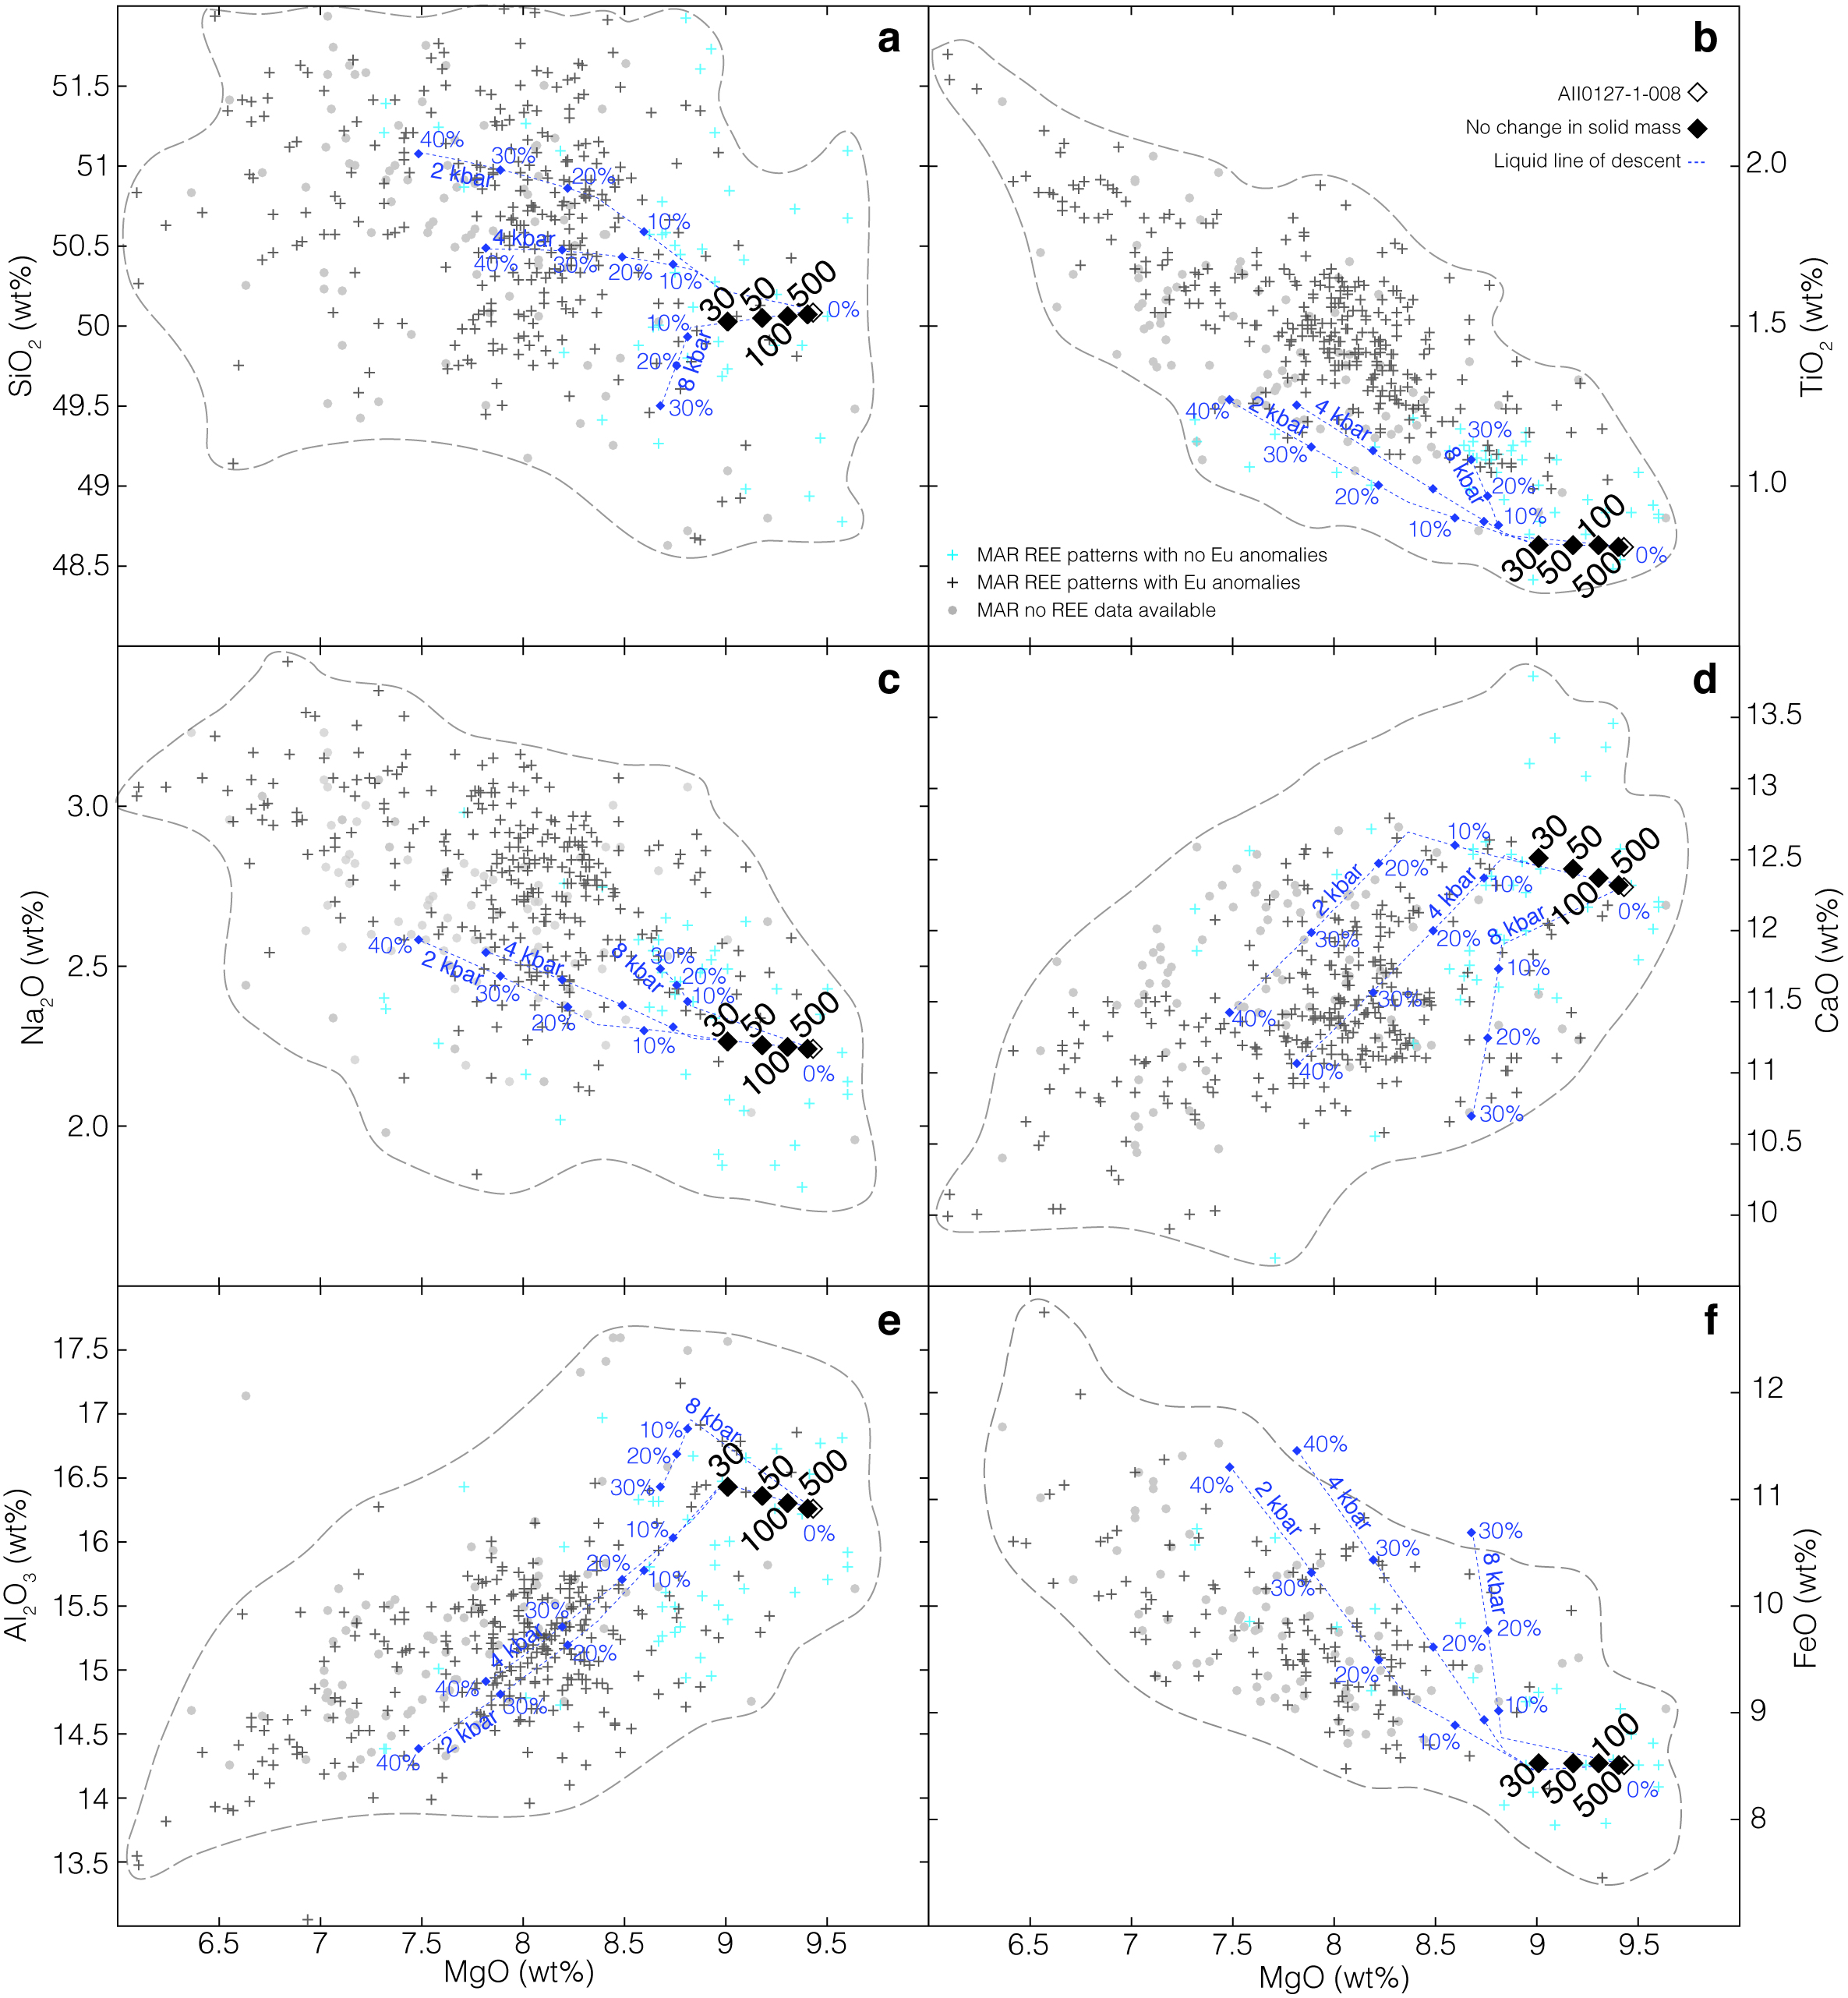
Figure 15. Mass balance model of the possible effect of melt-rock interactions in the mantle lithosphere on the major element composition of basalts in the Mid-Altantic Ridge. In this model, we use the modal abundances and major element composition of the mineral phases in the inferred products of melt-rock interaction (troctolite sample IODP304/305-U1309D-63R2-28-30, Drouin et al. [2009]; and MAR basalt sample AII0127-1-008 (white diamond), Gale et al. [2013]), and in plagioclase-free residual lherzolite (inferred solid prior to reaction: sample SDM-D2-2-2, Ghose et al. [1996]), to reconstruct the initial composition of the reacting melt (black diamonds: no change in solid mass) for a range of melt-rock ratios (see text). SiO₂ (a), TiO₂ (b), Na₂O (c), CaO (d), Al₂O₃ (e) and FeO (f) contents in function of MgO content. Dotted lines correspond to the liquid lines of descent calculated for crystallization pressures of 2, 4 and 8 kbar with the Petrolog code ([Danyushevsky and Plechov, 2011]; parameters used for these calculations are similar to those used for Figure 13 and detailed in the Supplementary material Text S3) for a starting composition similar to basalt sample AII0127-1-008. The model trends are shown over a compilation of MAR basalts (in grey) collected between 60°N and 55°S (PetDB, Lehnert et al. [2000]; details in Supplementary material Text S2). Dark grey crosses correspond to samples with pronounced Eu anomaly. Blue crosses correspond to samples with no Eu anomaly. Light grey dots correspond to samples for which trace element data are not available.

6 Conclusions
The eastern SWIR between 61 and 67°E has a very low melt supply and comprises several corridors of nearly amagmatic spreading that expose mantle-derived serpentinized peridotite [Cannat et al., 2003; 2006; Sauter et al., 2013]. More volcanically active ridge portions separate these corridors. Basalts from this melt-poor ridge represent a global MORB end-member for major element compositions [Meyzen et al., 2003], with higher Na₂O and Al₂O₃ contents, and lower CaO and FeO contents at a given MgO. Within this end-member group, basalts from the nearly amagmatic corridors have significantly lower CaO and Al₂O₃ contents at a given MgO than basalts from the volcanic areas. They are, however, similar in terms of trace elements and isotopic ratios.
Serpentinized mantle-derived peridotites represent 96% in volume of the material dredged in the nearly amagmatic corridors [Sauter et al., 2013]. Yet in addition to rare basalts, these dredges have also recovered small amounts of plagioclase-bearing ultramafic rocks, and of olivine gabbros. These rocks present textural and chemical characteristics that are best interpreted as due to reactions between a peridotite or websterite host rock and basaltic melts in the deep axial lithosphere. These reactions involved dissolution of olivine and orthopyroxene, and crystallization of clinopyroxene and plagioclase. The trace element composition of clinopyroxene indicates that the reacting melt had the same trace element signature as the basalts erupted at the ridge. Because we observe the transition between the ultramafic host and the most plagioclase-rich lithologies within a single decimeter-sized sample, we infer that these reactions occurred in the walls of veins or narrow dikes that formed conduits for primitive MORB melts, allowing them to rise through the axial lithosphere and to the eruption sites.
In order to assess the possible effect of these reactions on the composition of the reacted melt, we develop a simple mass balance model in which we use the modal abundances and the major and trace element composition of the mineral phases in the inferred products of melt-mantle interaction (the plagioclase-bearing ultramafic to gabbroic rocks and the basalt erupted in nearly amagmatic corridors), and in plagioclase-free residual lherzolites (inferred solid prior to reaction), to reconstruct the initial composition of the reacting melt. We find that for low (≤50) values of the ratio of erupted melt to reacted mantle, the initial composition of the reacting melt is significantly lower in Mg, and higher in Ca and Al, resembling the composition of the basalts dredged in the volcanic portions of the study area. This, and their similarity in terms of trace element composition and isotopic ratio leads us to propose that the two groups of basalts derive from similar parental melts, with low MgO contents (7.5 – 8.25 wt%). We propose that the ultramafic seafloor basalts are more affected by reactions between these parent melts and the mantle rocks in the deep lithosphere below the ridge because the ratio of erupted melt to reacted mantle is very low in the nearly amagmatic corridors. We also propose that the range of major element compositions inferred for the asthenospheric parental melts involved in these reactions could result from very low degrees of melting (4%) of a mantle that also contains about 10% of a more fusible pyroxenite component.
Although this would deserve further study, we predict that melt-mantle reactions that have been documented at detachment-dominated portions of the more magmatically active MAR [Godard et al., 2009; Drouin et al., 2009; Renna and Tribuzio, 2011; Sanfilippo et al., 2014] should have a lesser effect on the composition of the basalts erupted there.

Acknowledgments and Data
The text ends with an acknowledgment section and statement that includes:
- All funding sources related to this work from all authors (funder and grant number)
- Any real or perceived financial conflicts of interests for any author
- Other affiliations for any author that may be perceived as having a conflict of interest with respect to the results of this paper.
- A statement that indicates to the reader where the data supporting the conclusions can be obtained (for example, in the references, tables, supporting information, and other databases).
It is also the appropriate place to thank colleagues and other contributors. AGU does not normally allow dedications.

References
Aharonov E, Whitehead JA, Kelemen PB, Spiegelman M (1995) Channeling instability of upwelling melt in the mantle. J Geophys Res Solid Earth 100(B10):20,433–20,450.
Bottinga, Y., & Allegre, C. J. (1973). Thermal aspects of sea-floor spreading and the nature of the oceanic crust. Tectonophysics, 18(1), 1-17.
Bédard, J. H. (1994). A procedure for calculating the equilibrium distribution of trace elements among the minerals of cumulate rocks, and the concentration of trace elements in the coexisting liquids. Chemical Geology, 118(1), 143-153.
Bloomer, S. H., Meyer, P. S., Dick, H. J. B., Ozawa, K., & Natland, J. H. (1991). Textural and mineralogic variations in gabbroic rocks from Hole 735B. In Von Herzen, RP, Robinson, PT, et al., Proc. ODP, Sci. Results (Vol. 118, pp. 21-39).
Borghini, G., & Rampone, E. (2007). Postcumulus processes in oceanic-type olivine-rich cumulates: the role of trapped melt crystallization versus melt/rock interaction. Contributions to Mineralogy and Petrology, 154(6), 619-633.
Borghini, G., Rampone, E., Crispini, L., De Ferrari, R., & Godard, M. (2007). Origin and emplacement of ultramafic–mafic intrusions in the Erro-Tobbio mantle peridotite (Ligurian Alps, Italy). Lithos, 94(1), 210-229.
Borghini, G., Fumagalli, P., & Rampone, E. (2010). The stability of plagioclase in the upper mantle: subsolidus experiments on fertile and depleted lherzolite. Journal of Petrology, 51(1-2), 229-254.
Borghini, G., Fumagalli, P., & Rampone, E. (2011). The geobarometric significance of plagioclase in mantle peridotites: A link between nature and experiments. Lithos, 126(1), 42-53.
Brunelli, D., Paganelli, E., & Seyler, M. (2014). Percolation of enriched melts during incremental open-system melting in the spinel field: A REE approach to abyssal peridotites from the Southwest Indian Ridge. Geochimica et Cosmochimica Acta, 127, 190-203.
Brunelli, D., Cannat, M., Paquet, M., Sforna, M., Seyler, M. (2015, December). Sodium Inverse Relationships During Melting in Ultraslow Spreading Regions: Insights from SWIR-Smoothseafloor Peridotites. In AGU Fall Meeting Abstracts.
Cannat, M., Bideau, D., & Hébert, R. (1990). Plastic deformation and magmatic impregnation in serpentinized ultramafic rocks from the Garrett transform fault (East Pacific Rise). Earth and Planetary Science Letters, 101(2), 216-232.
Cannat, M. (1993). Emplacement of mantle rocks in the seafloor at mid‐ocean ridges. Journal of Geophysical Research: Solid Earth, 98(B3), 4163-4172.
Cannat, M., & Casey, J. F. (1995). An ultramafic lift at the Mid-Atlantic Ridge: successive stages of magmatism in serpentinized peridotites from the 15 N region. In Mantle and lower crust exposed in oceanic ridges and in ophiolites (pp. 5-34). Springer Netherlands.
Cannat, M., Mevel, C., Maia, M., Deplus, C., Durand, C., Gente, P., Agrinier, P., Belarouchi, A., Dubuisson, G. Humler, E., Reynolds, J. (1995). Thin crust, ultramafic exposures, and rugged faulting patterns at the Mid-Atlantic Ridge (22–24 N). Geology, 23(1), 49-52.
Cannat, M., Ceuleneer, G., & Fletcher, J. (1997a). 5. Localization of ductile strain and the magmatic evolution of gabbroic rocks drilled at the Mid-Atlantic Ridge (23°N). Proceedings of the Ocean Drilling Program, Scientific Results, 153, 77–98.
Cannat, M., Chatin, F., Whitechurch, H., & Ceuleneer, G. (1997b). 11. Gabbroic rocks trapped in the upper mantle at the Mid-Atlantic Ridge. Proceedings of the Ocean Drilling Program, Scientific Results, 153, 243–264.
Cannat, M., Rommevaux-Jestin, C., Sauter, D., Deplus, C., & Mendel, V. (1999). Formation of the axial relief at the very slow spreading Southwest Indian Ridge (49° to 69°E). Journal of Geophysical Research, 104(B10), 22,825–22,843.
Cannat, M. (2003). Melt supply variations to a magma-poor ultra-slow spreading ridge (Southwest Indian Ridge 61° to 69°E). Geochemistry Geophysics Geosystems, 4(8), 9104. http://doi.org/10.1029/2002GC000480
Cannat, M., Sauter, D., Mendel, V., Ruellan, E., Okino, K., Escartin, J., et al. (2006). Modes of seafloor generation at a melt-poor ultraslow-spreading ridge. Geology, 34(7), 605–608. http://doi.org/10.1130/G22486.1
Cannat, M., Sauter, D., Bezos, A., Meyzen, C., Humler, E., & Le Rigoleur, M. (2008). Spreading rate, spreading obliquity, and melt supply at the ultraslow spreading Southwest Indian Ridge. Geochemistry Geophysics Geosystems, 9(4), Q04002. http://doi.org/10.1029/2007GC001676
Carbotte, S. M., Smith, D. K., Cannat, M., & Klein, E. M. (2015). Tectonic and magmatic segmentation of the Global Ocean Ridge System: a synthesis of observations. Geological Society, London, Special Publications, 420, SP420-5.

Carmichael, I. S., Turner, F. J., & Verhoogen, J. (1974). Igneous petrology. McGraw-Hill.
Catanzaro, E.J., Murphy, T.J., Shields, W.R., Garner, E.L., 1968. Absolute isotopic abundance ratios of common, equal-atom, and radiogenic lead isotopic standards. Journal of Research of the National Bureau of Standards 72A (3), 261–267.
Danyushevsky, L. V., & Plechov, P. (2011). Petrolog3: Integrated software for modeling crystallization processes. Geochemistry Geophysics Geosystems, 12(7), Q07021. http://doi.org/10.1029/2011GC003516
deMartin, B.J., Sohn, R.A., Canales, J.P., Humphris, S., 2007. Kinematics and geometry of active detachment faulting beneath the Trans-Atlantic Geotraverse (TAG) hydrothermal field on the Mid-Atlantic Ridge:. Geology 35, 711–714.
Dick H. J. B. (1977) Evidence of partial melting in the Josephine Peridotite. In Magma Genesis (ed. H. J. B. Dick). Oregon Department of Geology and Mineral Industries, Portland, OR, pp. 59–62.
Dick, H. J. B., Fisher, R., & Bryan, W. (1984). Mineralogic variability of the uppermost mantle along mid-ocean ridges. Earth and Planetary Science Letters, 69(1), 88–106.
Dick, H. J., Ozawa, K., Meyer, P. S., Niu, Y., Robinson, P. T., Constantin, M., Hebert, R., Maeda, J., Natland, J.H., Hirth, J.G. & Mackie, S. M. (2002). 10. Primary silicate mineral chemistry of a 1.5-km section of very slow spreading lower ocean crust: ODP hole 735B, Southwest Indian ridge. Proceedings of the Ocean Drilling Program, Scientific Results’’, J. Natland, H. Dick, D. Miller, RP Von Herzen, eds. Online, 1-61.
Dick, H. J., Tivey, M. A., & Tucholke, B. E. (2008). Plutonic foundation of a slow‐spreading ridge segment: Oceanic core complex at Kane Megamullion, 23°30′ N, 45°20′ W. Geochemistry, Geophysics, Geosystems, 9(5).
Dick, H. J. B., Lissenberg, C. J., & Warren, J. M. (2010). Mantle Melting, Melt Transport, and Delivery Beneath a Slow-Spreading Ridge: The Paleo-MAR from 23 15'N to 23 45'N. Journal of Petrology, 51(1-2), 425–467. http://doi.org/10.1093/petrology/egp088
Drouin, M., Godard, M., Ildefonse, B., Bruguier, O., & Garrido, C. J. (2009). Geochemical and petrographic evidence for magmatic impregnation in the oceanic lithosphere at Atlantis Massif, Mid-Atlantic Ridge (IODP Hole U1309D, 30 N). Chemical Geology, 264(1), 71-88.
Escartin, J., Smith, D. K., Cann, J., Schouten, H., Langmuir, C. H., & Escrig, S. (2008). Central role of detachment faults in accretion of slow-spreading oceanic lithosphere. Nature, 455(7214), 790-794.
Fialko, Y. A., & Rubin, A. M. (1998). Thermodynamics of lateral dike propagation: Implications for crustal accretion at slow spreading mid‐ocean ridges. Journal of Geophysical Research: Solid Earth, 103(B2), 2501-2514.
Gale, A., Laubier, M., Escrig, S., & Langmuir, C. H. (2013). Constraints on melting processes and plume-ridge interaction from comprehensive study of the FAMOUS and North Famous segments, Mid-Atlantic Ridge. Earth and Planetary Science Letters, 365, 209-220.
Gale, A., Langmuir, C. H., & Dalton, C. A. (2014). The global systematics of ocean ridge basalts and their origin. Journal of Petrology, 55(6), 1051-1082.
Ghose, I., Cannat, M., & Seyler, M. (1996). Transform fault effect on mantle melting in the MARK area (Mid-Atlantic Ridge south of the Kane transform). Geology, 24(12), 1139-1142.
Godard, M., Awaji, S., Hansen, H., Hellebrand, E., Brunelli, D., Johnson, K., ... & Kato, Y. (2009). Geochemistry of a long in-situ section of intrusive slow-spread oceanic lithosphere: Results from IODP Site U1309 (Atlantis Massif, 30°N Mid-Atlantic-Ridge). Earth and Planetary Science Letters, 279(1), 110-122.
Grove, T. L., Kinzler, R. J., & Bryan, W. B. (1993). Fractionation of mid‐ocean ridge basalt (MORB). in: J.P Morgan, D.K. Blackman, J.M. Sinton (Eds.), Mantle Flow and Melt Generation at Mid-ocean Ridges, Geophys. Monogr. Ser., vol. 71, AGU, Washington, DC, pp. 281-310.
Gudmundsson, O., Brandsdottir, B., Menke, W., & Sigvaldason, G. E. (1994). The crustal magma chamber of the Katla volcano in south Iceland revealed by 2-D seismic undershooting. Geophysical Journal International, 119(1), 277-296.
Günther, D., & Heinrich, C. A. (1999). Enhanced sensitivity in laser ablation-ICP mass spectrometry using helium-argon mixtures as aerosol carrier. Journal of Analytical Atomic Spectrometry, 14(9), 1363-1368.
Hamelin, C., Bezos, A., Dosso, L., Escartin, J., Cannat, M., & Mevel, C. (2013). Atypically depleted upper mantle component revealed by Hf isotopes at Lucky Strike segment. Chemical Geology, 341, 128-139.
Herzberg, C. (2004). Partial Crystallization of Mid-Ocean Ridge Basalts in the Crust and Mantle. Journal of Petrology, 45(12), 2389–2405. http://doi.org/10.1093/petrology/egh040
Hirschmann, M. M., & Stolper, E. M. (1996). A possible role for garnet pyroxenite in the origin of the “garnet signature” in MORB. Contributions to Mineralogy and Petrology, 124(2), 185-208.
Hirschmann, M. M., Ghiorso, M. S., Wasylenki, L. E., Asimow, P. D., & Stolper, E. M. (1998). Calculation of peridotite partial melting from thermodynamic models of minerals and melts. I. Review of methods and comparison with experiments. Journal of Petrology, 39(6), 1091-1115.
Hofmann, A. W., & White, W. M. (1982). Mantle plumes from ancient oceanic crust. Earth and Planetary Science Letters, 57(2), 421-436.
Hopson, C. A., Coleman, R. G., Gregory, R. T., Pallister, J. S., & Bailey, E. H. (1981). Geologic section through the Samail Ophiolite and associated rocks along a Muscat‐Ibra Transect, southeastern Oman Mountains. Journal of Geophysical Research: Solid Earth, 86(B4), 2527-2544.
Jaques, A. L., & Green, D. H. (1980). Anhydrous melting of peridotite at 0–15 kb pressure and the genesis of tholeiitic basalts. Contributions to Mineralogy and Petrology, 73(3), 287-310.
Johnson, K., Dick, H. J., & Shimizu, N. (1990). Melting in the oceanic upper mantle: an ion microprobe study of diopsides in abyssal peridotites. Journal of Geophysical Research: Solid Earth, 95(B3), 2661-2678.
Kelemen, P. B. (1990). Reaction between ultramafic rock and fractionating basaltic magma I. Phase relations, the origin of calc-alkaline magma series, and the formation of discordant dunite. Journal of Petrology, 31(1), 51-98.
Kelemen, P. B., Joyce, D. B., Webster, J. D., & Holloway, J. R. (1990). Reaction between ultramafic rock and fractionating basaltic magma II. Experimental investigation of reaction between olivine tholeiite and harzburgite at 1150–1050 C and 5 kb. Journal of Petrology, 31(1), 99-134.
Kelemen, P. B., Shimizu, N., & Salters, V. J. (1995). Extraction of mid-ocean-ridge basalt from the upwelling mantle by focused flow of melt in dunite channels. Nature, 375(6534), 747-753.
Kelemen, P. B., Hirth, G., Shimizu, N., Spiegelman, M., & Dick, H. J. (1997). A review of melt migration processes in the adiabatically upwelling mantle beneath oceanic spreading ridges. Philosophical Transactions of the Royal Society of London A: Mathematical, Physical and Engineering Sciences, 355(1723), 283-318.
Kinzler, R. J., & Grove, T. L. (1992a). Primary magmas of mid‐ocean ridge basalts 1. Experiments and methods. Journal of Geophysical Research: Solid Earth, 97(B5), 6,885-6,906.
Kinzler, R., & Grove, T. (1992b). Primary Magmas of Mid-Ocean Ridge Basalts 2. Applications. Journal of Geophysical Research: Solid Earth, 97(B5), 6,907–6,926.
Kinzler, R. J., & Grove, T. L. (1993). Corrections and further discussion of the primary magmas of mid‐ocean ridge basalts, 1 and 2. Journal of Geophysical Research: Solid Earth, 98(B12), 22,339-22,347.
Klein, E. M., & Langmuir, C. H. (1987). Global correlations of ocean ridge basalt chemistry with axial depth and crustal thickness. Journal of Geophysical Research: Solid Earth, 92(B8), 8089-8115.
Langmuir, C. H., Klein, E. M., & Plank, T. (1993). Petrological systematics of mid‐ocean ridge basalts: Constraints on melt generation beneath ocean ridges. in: J.P Morgan, D.K. Blackman, J.M. Sinton (Eds.), Mantle Flow and Melt Generation at Mid-ocean Ridges, Geophys. Monogr. Ser., vol. 71, AGU, Washington, DC, pp. 180 – 280.
Lee, C. T. A., Harbert, A., & Leeman, W. P. (2007). Extension of lattice strain theory to mineral/mineral rare-earth element partitioning: an approach for assessing disequilibrium and developing internally consistent partition coefficients between olivine, orthopyroxene, clinopyroxene and basaltic melt. Geochimica et Cosmochimica Acta, 71(2), 481-496.
Lehnert, K., Su, Y., Langmuir, C. H., Sarbas, B., & Nohl, U. (2000). A global geochemical database structure for rocks. Geochemistry, Geophysics, Geosystems, 1(5).
Liang, Y., & Parmentier, E. M. (2010). A two-porosity double lithology model for partial melting, melt transport and melt–rock reaction in the mantle: mass conservation equations and trace element transport. Journal of Petrology, egp086.
Lissenberg, C. J., & Dick, H. J. (2008). Melt–rock reaction in the lower oceanic crust and its implications for the genesis of mid-ocean ridge basalt. Earth and Planetary Science Letters, 271(1), 311-325.
Lundstrom, C. C., Gill, J., Williams, Q., & Perfit, M. R. (1995). Mantle melting and basalt extraction by equilibrium porous flow. Science, 270(5244), 1958.
Manhes, G., Minster, J. F., & Allegre, C. J. (1978). Comparative uranium-thorium-lead and rubidium-strontium study of the Saint Severin amphoterite: Consequences for early solar system chronology. Earth and Planetary Science Letters, 39(1), 14-24.
McDonough, W. F., & Sun, S. S. (1995). The composition of the Earth. Chemical geology, 120(3), 223-253.
Mével, C., Agrinier, P., Cannat, M., Decitre, S., Dappoigny, A., Humler, E., ... & Oufi, O. (1997). Sampling the Southwest Indian Ridge: First results of the EDUL cruise (R/V Marion Dufresne II, August 1997). InterRidge News, 6(2), 25-26.

Meyzen, C. M., Toplis, M. J., Humler, E., Ludden, J. N., & Mével, C. (2003). A discontinuity in mantle composition beneath the southwest Indian ridge. Nature, 421(6924), 731-733.
Meyzen, C. M., Ludden, J. N., Humler, E., Luais, B., Toplis, M. J., Mével, C., & Storey, M. (2005). New insights into the origin and distribution of the DUPAL isotope anomaly in the Indian Ocean mantle from MORB of the Southwest Indian Ridge. Geochemistry, Geophysics, Geosystems, 6(11).
Michael, P. J., & Cornell, W. C. (1998). Influence of spreading rate and magma supply on crystallization and assimilation beneath mid‐ocean ridges: Evidence from chlorine and major element chemistry of mid‐ocean ridge basalts. Journal of Geophysical Research: Solid Earth, 103(B8), 18,325-18,356.
Miller, D.J., Abratis, M., Christie, D., Drouin, M., Godard, M., Ildefonse, B., Maeda, J., Weinsteiger, A., Yamasaki, T., Suzuki, Y., Niino, A., Sato, Y., and Takeda, F., in press. Data report: microprobe analyses of primary mineral phases from Site U1309, Atlantis Massif, IODP Expedition 304/305. In: Blackman, D.K., Ildefonse, B., John, B.E., Ohara, Y., Miller, D.J., MacLeod, C.J., and the Expedition 304/305 Scientists, Proc. IODP, 304/305: College Station, TX (Integrated Ocean Drilling Program Management International, Inc.).
Morishita, T., Ishida, Y., Arai, S., & Shirasaka, M. (2005). Determination of Multiple Trace Element Compositions in Thin (> 30 μm) Layers of NIST SRM 614 and 616 Using Laser Ablation‐Inductively Coupled Plasma‐Mass Spectrometry (LA‐ICP‐MS). Geostandards and Geoanalytical Research, 29(1), 107-122.
Muller, M. R., Minshull, T. A., & White, R. S. (1999). Segmentation and melt supply at the Southwest Indian Ridge. Geology, 27(10), 867–870.
Okubo, P. G., Benz, H. M., & Chouet, B. A. (1997). Imaging the crustal magma sources beneath Mauna Loa and Kilauea volcanoes, Hawaii. Geology, 25(10), 867-870.
Ozawa, K., Meyer, P. S., & Bloomer, S. H. (1991). Mineralogy and textures of iron-titanium oxide gabbros and associated olivine gabbros from Hole 735B. In Von Herzen, RP, Robinson, PT, et al., Proc. ODP, Sci. Results (Vol. 118, pp. 41-73).
Ozawa, K., & Shimizu, N. (1995). Open‐system melting in the upper mantle: Constraints from the Hayachine‐Miyamori ophiolite, northeastern Japan. Journal of Geophysical Research: Solid Earth, 100(B11), 22,315-22,335.
Patriat, P., & Segoufin, J. (1988). Reconstruction of the central Indian Ocean. Tectonophysics, 155(1), 211-234.
Paquet, M., Cannat, M., Hamelin, C., & Brunelli, D. (2014, December). The easternmost Southwest Indian Ridge: a laboratory to study MORB and oceanic gabbro petrogenesis in a very low melt supply context. In AGU Fall Meeting Abstracts (Vol. 1, p. 4754).
Pearce, N. J., Perkins, W. T., Westgate, J. A., Gorton, M. P., Jackson, S. E., Neal, C. R., & Chenery, S. P. (1997). A compilation of new and published major and trace element data for NIST SRM 610 and NIST SRM 612 glass reference materials. Geostandards newsletter, 21(1), 115-144.
Pertermann, M., & Hirschmann, M. M. (2003). Anhydrous partial melting experiments on MORB-like eclogite: phase relations, phase compositions and mineral–melt partitioning of major elements at 2–3 GPa. Journal of Petrology, 44(12), 2173-2201.
Quick, J. E. (1982). The origin and significance of large, tabular dunite bodies in the Trinity peridotite, northern California. Contributions to Mineralogy and Petrology, 78(4), 413-422.
Rampone, E., Bottazzi, P., & Ottolini, L. (1991). Complementary Ti and Zr anomalies in orthopyroxene and clinopyroxene from mantle peridotites, Nature 354, 518-520, doi:10.1038/354518a0
Renna, M. R., & Tribuzio, R. (2011). Olivine-rich troctolites from Ligurian ophiolites (Italy): evidence for impregnation of replacive mantle conduits by MORB-type melts. Journal of Petrology, 52(9), 1763-1790.
Ross, K., & Elthon, D. (1997). Cumulus and postcumulus crystallization in the oceanic crust: major-and trace-element geochemistry of Leg 153 gabbroic rocks. In Proceedings-Ocean Drilling Program Scientific Results (pp. 333-350). National Science Foundation.
Rubin, K. H., & Sinton, J. M. (2007). Inferences on mid-ocean ridge thermal and magmatic structure from MORB compositions. Earth and Planetary Science Letters, 260(1), 257-276.
Salters, V. J., & Dick, H. J. (2002). Mineralogy of the mid-ocean-ridge basalt source from neodymium isotopic composition of abyssal peridotites. Nature, 418(6893), 68-72.
Salters, V. J., & Stracke, A. (2004). Composition of the depleted mantle. Geochemistry, Geophysics, Geosystems, 5(5).
Sanfilippo, A., & Tribuzio, R. (2013). Origin of olivine-rich troctolites from the oceanic lithosphere: a comparison between the alpine Jurassic ophiolites and modern slow spreading ridges. Ofioliti, 38(1), 89-99.
Sanfilippo, A., Dick, H. J., & Ohara, Y. (2013). Melt–rock reaction in the mantle: mantle troctolites from the Parece Vela ancient back-arc spreading center. Journal of Petrology, 54(5), 861-885.
Sanfilippo, A., Tribuzio, R., & Tiepolo, M. (2014). Mantle–crust interactions in the oceanic lithosphere: Constraints from minor and trace elements in olivine. Geochimica et Cosmochimica Acta, 141, 423-439.
Saper, L., & Liang, Y. (2014). Formation of plagioclase-bearing peridotite and plagioclase-bearing wehrlite and gabbro suite through reactive crystallization: an experimental study. Contributions to Mineralogy and Petrology, 167(3), 1-16.
Sauter, D., Cannat, M., Rouméjon, S., Andreani, M., Birot, D., Bronner, A., ... & MacLeod, C. J. (2013). Continuous exhumation of mantle-derived rocks at the Southwest Indian Ridge for 11 million years. Nature Geoscience, 6(4), 314-320.
Schlindwein, V. S. N., Scholz, J. R., & Schmid, F. (2014, December). SWEAP: Southwest Indian Ridge Earthquakes and Plumes: First Results from a Comparative Seismicity Study of Magmatic and Amagmatic Spreading. In AGU Fall Meeting Abstracts (Vol. 1, p. 1064).
Seyler, M., Cannat, M., & Mevel, C. (2003). Evidence for major‐element heterogeneity in the mantle source of abyssal peridotites from the Southwest Indian Ridge (52° to 68°E). Geochemistry, Geophysics, Geosystems, 4(2).
Seyler, M., Lorand, J. P., Dick, H. J., & Drouin, M. (2007). Pervasive melt percolation reactions in ultra-depleted refractory harzburgites at the Mid-Atlantic Ridge, 15°20′ N: ODP Hole 1274A. Contributions to Mineralogy and Petrology, 153(3), 303-319.
Seyler, M., Brunelli, D., Toplis, M. J., & Mével, C. (2011). Multiscale chemical heterogeneities beneath the eastern Southwest Indian Ridge (52°E–68°E): Trace element compositions of along‐axis dredged peridotites. Geochemistry, Geophysics, Geosystems, 12(9).
Shaw, D. M. (2000). Continuous (dynamic) melting theory revisited. The Canadian Mineralogist, 38(5), 1041-1063.
Smith, D. K., & Cann, J. R. (1999). Constructing the upper crust of the Mid‐Atlantic Ridge: A reinterpretation based on the Puna Ridge, Kilauea Volcano. Journal of Geophysical Research: Solid Earth, 104(B11), 25,379-25,399.
Sobolev, A. V., Hofmann, A. W., Kuzmin, D. V., Yaxley, G. M., Arndt, N. T., Chung, S. L., ... & Gurenko, A. A. (2007). The amount of recycled crust in sources of mantle-derived melts. Science, 316(5823), 412-417.
Spiegelman, M., & Kelemen, P. B. (2003). Extreme chemical variability as a consequence of channelized melt transport. Geochemistry, Geophysics, Geosystems, 4(7).
Standish, J. J., Dick, H. J., Michael, P. J., Melson, W. G., & O'Hearn, T. (2008). MORB generation beneath the ultraslow spreading Southwest Indian Ridge (9–25 E): Major element chemistry and the importance of process versus source. Geochemistry, Geophysics, Geosystems, 9(5).
Suhr, G. (1999). Significance of upper mantle hosted dunite bodies for melt migration and extraction under oceanic spreading centres: inferences from reactive transport modelling. J Petrol, 40, 575-599.
Suhr, G., Hellebrand, E., Johnson, K., & Brunelli, D. (2008). Stacked gabbro units and intervening mantle: A detailed look at a section of IODP Leg 305, Hole U1309D. Geochemistry, Geophysics, Geosystems, 9(10).
Tartarotti, P., Susini, S., Nimis, P., & Ottolini, L. (2002). Melt migration in the upper mantle along the Romanche Fracture Zone (Equatorial Atlantic). Lithos, 63(3), 125-149.
Toomey, D. R., Solomon, S. C., and Purdy, G. (1988), Microearthquakes beneath Median Valley of Mid-Atlantic Ridge near 23°N: Tomography and Tectonics, Journal of Geophysical Research, 93 (B8), 9093–9112.
Tormey, D. R., Grove, T. L., & Bryan, W. B. (1987). Experimental petrology of normal MORB near the Kane Fracture Zone: 22–25°N, mid-Atlantic ridge. Contributions to Mineralogy and Petrology, 96(2), 121-139.
Tursack, E., & Liang, Y. (2012). A comparative study of melt-rock reactions in the mantle: laboratory dissolution experiments and geological field observations. Contributions to Mineralogy and Petrology, 163(5), 861-876.
Van Achterberg, E., Ryan, C.G., Jackson, S.E. and Griffin, W., 2001. Data reduction software for LA-ICP-MS. In: P. Sylvester (Editor), Laser ablation ICP-MS in the Earth Science. Mineralogical Association of Canada, (29) pp. 239-243.
Warren, J. M., & Shimizu, N. (2010). Cryptic variations in abyssal peridotite compositions: evidence for shallow-level melt infiltration in the oceanic lithosphere. Journal of Petrology, 51(1-2), 395-423.
Wolfe, C. J., Purdy, G. M., Toomey, D. R., & Solomon, S. C. (1995). Microearthquake characteristics and crustal velocity structure at 29° N on the Mid‐Atlantic Ridge: The architecture of a slow spreading segment. Journal of Geophysical Research: Solid Earth, 100(B12), 24449-24472.
Workman, R. K., & Hart, S. R. (2005). Major and trace element composition of the depleted MORB mantle (DMM). Earth and Planetary Science Letters, 231(1), 53-72.

