Raman study of artificially weathered medieval-type glass

L. de Ferri*, P.P. Lottici**, G. Vezzalini*
*Earth Science Department, Università di Modena e Reggio Emilia, L.go S. Eufemia 19, 41100 Modena
**Physics Department, Università degli Studi di Parma, V.le G. P. Usberti 7/a, Parco Area delle Scienze, 43124 Parma

Glass with Potash-Lime-Silica (PLS) composition were typically produced during the middle age in the central and northern Europe and are known to be very sensitive to the attack of the atmospheric pollutants. Since historical window glasses are in permanent contact with water in form of rain, fog, snow, or humidity, the alteration can easily take place initially through the leaching process. Consequently, the K⁺ extraction with the formation of a very strong dissociated base occurs in the liquid surface medium, leading to the dissolution of the glass network.
Medieval-type PLS glass samples, containing different amounts of K₂O (V1= ,V2=V3=) as fluxing agent, were produced and aged in concentrated boiling H₂SO₄ and in high temperature-high pressure water to simulate the two alteration processes (leaching and dissolution) separately. Aged samples were studied by Raman spectroscopy, performing linear sequences of spectra on their cross sections, and SEM-EDS technique, to identify the neo-formation crystalline phases and the alteration layer thickness.
The leached samples (aged in sulphuric acid) displayed in the external part of the alteration layer the co-existence of Gypsum, Bassanite and Anhydrite. SEM images and EDS maps of S and Ca enhanced the presence of the Ca-sulphates as elongated crystals.
The SEM observation of the glass samples subjected to the dissolution experiments generally showed the presence of abundant crystalline silicate phases, with different morphologies in the three chemically different samples. Moreover the EDS maps evidenced a slight impoverishment in Si and the accumulation of Ca in the surface layer. These samples displayed very complex Raman spectra where the contributions of different crystalline phases were found. V1 and V2 cross sections revealed, in addition to the glass signal, the features of the Ca- and K- phyllosilicates Gyrolite (Ca₂Si₃O₇(OH)₂) and Reyerite (KCa₁₄Si₂₄O₆₀(OH)₅•5H₂O). In the V3 alteration layer the phases of the reyerite group were found together with hydroxyapatite (Ca₅(PO₄)₃(OH)) and the hydrated Ca-K inosilicate charoite (K₅Ca₈(Si₆O₁₅)₂Si₂O₉(OH).3(H₂O)).
The ICP-MS measurements, carried out on both ageing liquid media, indicated that the Ca content is very low (0.003-0.03 wt%) and this can be attributed to the crystallization of phases enriched in Ca that entrapped part of the Ca ions released by the glass.
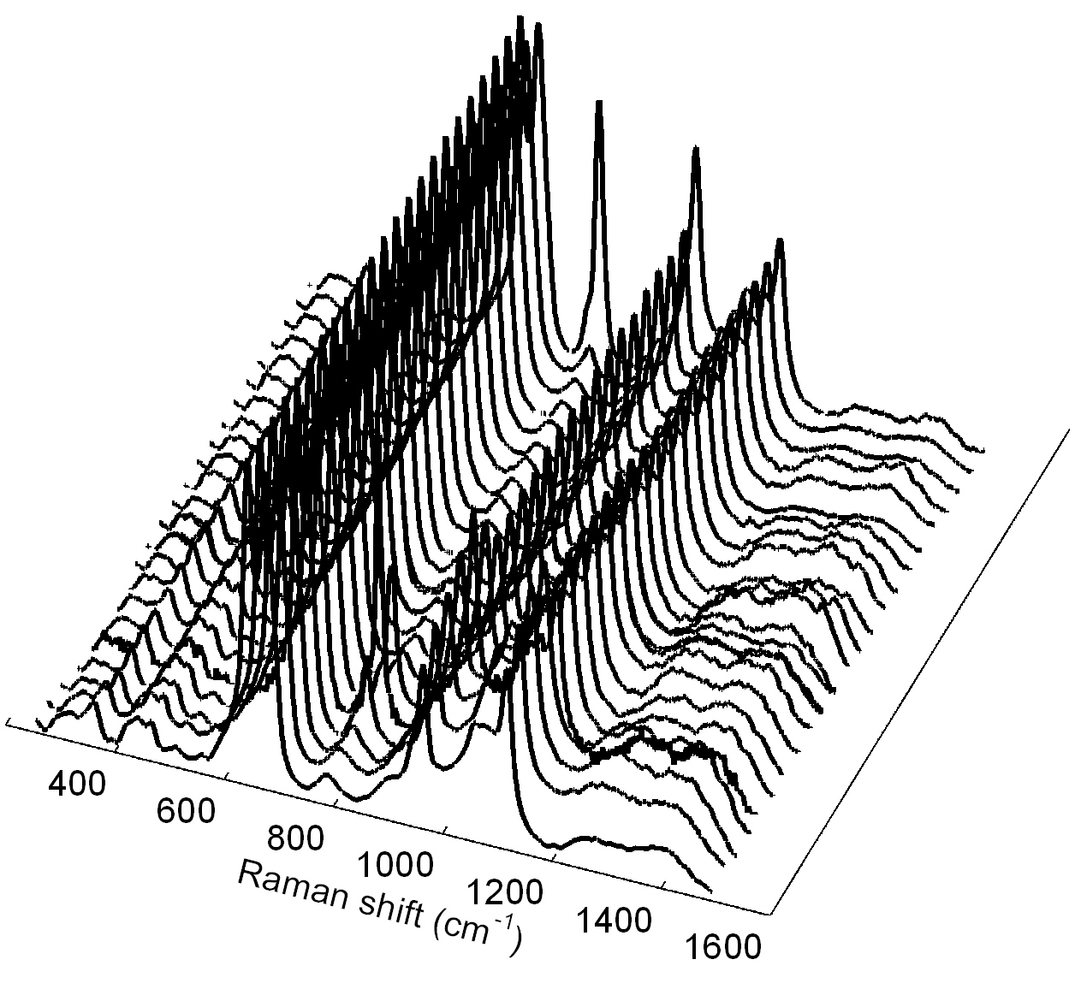
Linear sequence of Raman spectra taken on the V3 water-aged cross section.

